Attachment A: Photos of Site

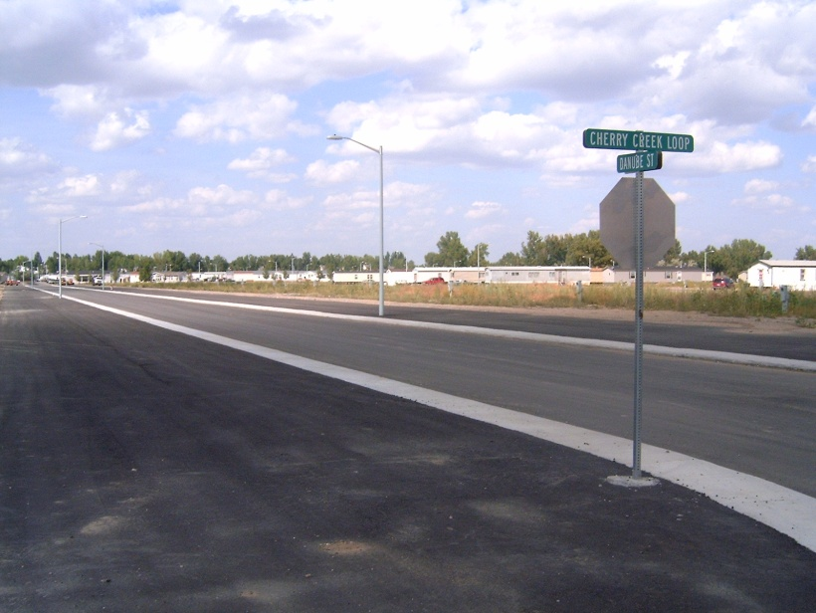
Figure 1: Looking northeast from the intersection of Cherry Creek Loop and Danube Street. The road infrastructure for the development is already in place. Manufactured homes in the Cherry Creek Manufactured Home Park are visible in the background.
Figure 2: Looking west toward Bitterroot Drive from the intersection of Cherry Creek Loop and Danube Street. The area behind the fence is an undeveloped property between Danube Court and existing residential development along Bitterroot Drive.
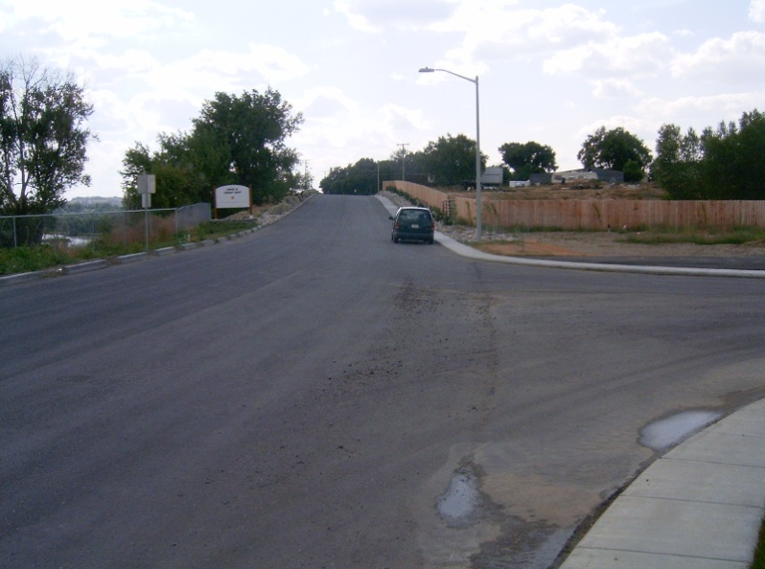

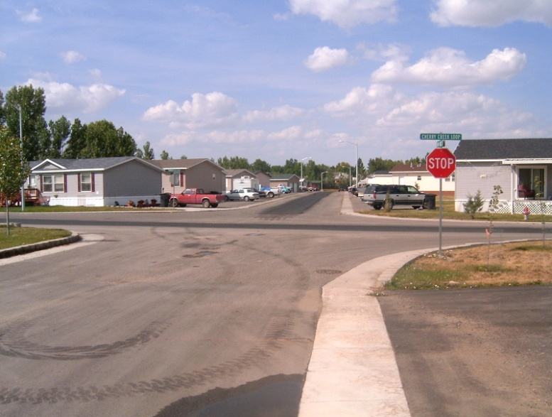
Figure 3: Looking north from the intersection of Danube Street and Cherry Creek Loop at the north end of the development. Cherry Creek Loop provides access from the development to Bitterroot Drive in two locations. Existing development in the Cherry Creek Manufactured Home Park is visible across Cherry Creek Loop to the north.

