Township 1N Range 26E
Red indicates easement
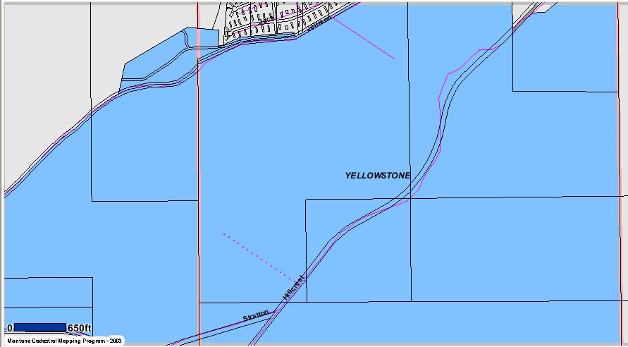
Exhibit “A”

