Memorandum of Understanding Between
Big Sky Economic Development Authority,
The City of billings
and
The billings industrial revitalization district, inc.
for the implementation of the Master Plan for the Revitalization of the East billings urban renewal district

This Memorandum of Understanding (“MOU”) is made and entered into on _______ ___, 2010 (the “Effective Date”) by and between the Big Sky Economic Development Authority (“BSEDA”), a local port authority created and funded by Yellowstone County, a political subdivision of the State of Montana, the City of Billings (“City”), and the Billings Industrial Revitalization District, Inc. (“BIRD”), a 501 c(6) tax exempt corporation of the land owners with property located within the boundaries East Billings Urban Renewal District (“EBURD”), that is managed with the purpose of assisting the City in revitalization of the EBURD for all projects, regulations and planning done in the EBURD and to render opinions and give recommendations to the City Council. For purposes of this MOU, BSEDA, the City, and the BIRD are each a “Party” and are sometimes collectively referred to as the “Parties.”

I. TERM & TERMINATION of this mou

This MOU shall be in effect for three (3) years from the Effective Date, and the parties agree to conduct an annual progress-review meeting to consider any necessary changes to the implementation strategies and roles and responsibilities as set forth in this Agreement. Any Party may terminate this MOU by giving the other Parties thirty (30) days written notice. Days are defined in this Agreement to be business days.

II. background and purpose of this mou

- The EBURD is defined in the attached is a map of the EBURD Exhibit “A”.

- This MOU is a cooperative effort among the City of Billings, BSEDA and the BIRD, with the mutual objective of enhancing economic development opportunities in the EBURD by promoting the ideals of sustainable industry, public infrastructure improvement, and fair, predictable land use decision-making embodied in the Master Plan for the EBURD Exhibit “B”.

- The Parties are actively working on annexation of County lands in and around the EBURD. Collectively the EBURD and relevant County Land shall be called (“The Study Area”) because development of infrastructure is required.

- A Master Plan for the Revitalization of the EBURD has been completed pursuant to a grant by the U.S. Department of Commerce – Economic Development Administration. The purpose of this MOU is to define the mutual understanding of BSEDA, the BIRD, and the City regarding the implementation of the Master Plan the Study Area.

- The EBURD has as its foundation the EBURD and a Tax Increment Financing District (TIFD”).

III. RELATIONSHIP OF THE PARTIES

- This MOU relates only to the cooperative efforts of BSEDA, the City, and the BIRD described herein in connection with the EBURD and the Study Area.

- This MOU is not intended to create or constitute any joint venture, partnership, joint powers agency, or other formal organization of any kind.

- Nothing herein shall be interpreted to require the Parties to exercise their discretion in any particular way or to require the Parties to take any future action regarding the EBURD.

- No Party is authorized herein to act as the agent of the other.

- This MOU is not intended to create any benefits, rights or entitlements for persons or entities not a party to this MOU.

- Sections IV through XII of this MOU describe a basic outline of roles and responsibilities related to the EBURD and the Study Area. These Sections identify lead organizations for each identified role and responsibility. All Parties shall collaborate with the identified lead organization to carry out these identified activities.

IV. TAX INCREMENT FINANCING AUTHORITY AND ADMINISTRATION

- The City Council shall have the ultimate decision making authority regarding any expenditure of TIFD Funds related to the EBURD. Recommendations for expenditures shall be presented by the BIRD to the City Council.

- The BIRD and the City has developed an application form and assistance guidelines for parties seeking the use of TIFD Funds.

- The BIRD will accept and review the application for TIFD Funds related to the EBURD within ten (10) days of receipt of a fully completed application, and then will submit said application to the City staff for review and recommendations. The City shall return the application with their comments within fifteen (15) days from the submittal of a complete application to the BIRD. The BIRD board shall review and meet with the applicant within twenty (20) days and then make advisory recommendations to the City Council regarding such expenditures in consultation with the Parties. The application shall be processed and sent to the City Council for action within 50 days after receipt of a properly completed application.

V. LAND USE DECISION AUTHORITY

- The City shall have final decision making authority regarding any land use or zoning decision related to the EBURD, provided those items are first reviewed by the BIRD which shall present its recommendation to the City Council for action.

- The City staff shall provide to the BIRD of any proposed land use regulation changes related to EBURD property within ten (10) days of receipt or consideration of such proposal for the review and approval by the BIRD. The BIRD shall submit its recommendation to the City Council within 10 days.

- Subject to existing land use law, the City may develop and administer land use and design regulations consistent with those proposed in the Master Plan as recommended by the BIRD. The City and the BIRD shall cooperatively explore potential incentives for developers and property owners subject to such regulations.

VI. BROWNFIELDS ASSESSMENT

- BSEDA is currently administering two (2) grants from the Environmental Protection Agency to undertake brownfields assessments of petroleum and hazardous substance contamination on sites within and surrounding the EBURD.

- BSEDA has assembled a steering committee to help make decisions about assessed sites. The City and BIRD have both contributed their time to this steering committee to help determine what criteria should be used to prioritize potential assessment sites. This steering committee will also apply these criteria in selecting assessment sites throughout the life of the project.

VII. SEEKING AND ADMINISTERING GRANT AND INCENTIVE FUNDING

- BSEDA will seek, apply for, and administer grant opportunities well-suited for the EBURD. Specifically, in development projects where there will be an increase of additional new jobs, BSEDA will apply on behalf of, or assist in the preparation of, applications to the Montana Department of Commerce New Worker Training Grant and Big Sky Economic Development Trust Fund incentive programs. All applications for grants and any acceptance of any grant awards must be approved by the City Council, if TIFD funds are used.

- When an appropriate grant or funding opportunity is not available to BSEDA, for eligibility reasons, BSEDA will identify a potential applicant among the Parties and will notify such Party of the funding opportunity. BSEDA will assist these Parties in preparing applications for these funding opportunities on a fee-for-service basis at the hourly rate normally charged by BSEDA for grant-writing services ($85 per hour through December 31, 2010) and the amount agreed to annually.

- Whenever possible, funds secured by BSEDA for implementation of Master Plan recommendations should be matched with local dollars, including TIFD funds, in order to maximize impact.

VIII. MAINTENANCE, PRIORITIZATION, AND IMPLEMENTATION OF THE EBURD MASTER PLAN

- BIRD will work to maintain, prioritize, and implement the EBURD Master Plan, as its staffing capacity will allow and in consultation with the Parties.

- The Parties, under BIRD leadership, will assemble a “Response Team” of Party representatives to meet with potential investors and to coordinate recruitment efforts on a case-by-case basis.

- BIRD will convene a committee of all Parties to discuss and make recommendations to the BIRD regarding work plan for the maintenance, prioritization, and implementation of the EBURD Master Plan.

- The Parties ultimate goal is an SID & RSID for the East end of the EBURD to complete necessary improvements in infrastructure.

VIV. RECRUITMENT OF PRIVATE INVESTORS AND DEVELOPERS TO
THE EBURD

  - BIRD will actively work to recruit private investment in the EBURD, as its staffing capacity will allow.

  - The Parties, under BIRD leadership, will assemble a “Response Team” of Party representatives to meet with potential investors and to coordinate recruitment efforts on a case-by-case basis.

X. IDENTIFY FUNDING SOURCES AND FACILITATE INFRASTRUCUTRE IMPROVEMENTS

- The City will identify and make application for appropriate funding sources in order to facilitate necessary infrastructure improvements as identified in the Master Plan and the Study Area.

- The Parties, under BIRD leadership and direction, will assemble an “Infrastructure Improvements Task Force” of Party representatives to guide infrastructure improvement efforts and assist the City with funding applications, as appropriate.

XI. OTHER SERVICES

    - BIRD may, at its sole option, contract professional services with an outside party or the City to potentially provide planning, security and maintenance services within the EBURD funded through property owner participation in a business improvement district or sub-district.

B. BIRD will work to potentially provide a marketing/branding plan and attendant materials for the EBURD, as staff and funding allows and in consultation with the Billings Chamber of Commerce and BSEDA.

XII. PUBLIC RELATIONS

Any news release, public announcement, advertisement or publicity proposed to be released by BSEDA, BIRD or the City regarding this MOU shall be subject to the approval of the other Parties prior to release. The Parties agree that such approval shall not be unreasonably withheld.

XIII. NOTICE

The Parties have identified the following individuals as point persons for all communication and coordination in connection with the construction and implementation of Phase 1. Any notice required hereunder shall be provided in writing.

BSEDA: | Steve Arveschoug  Executive Director  222 North 32nd Street, Suite 200  Billings, MT 59101  Arveschoug@bigskyeda.org  (406)256-6871 ext. 106 | Patty Nordlund  Community and Workforce Development Manager  222 North 32nd Street, Suite 200  Billings, MT 59102  Nordlund@bigskyeda.org  (406)256-6871 ext. 111
City: | Candi Beaudry  Director, City/County Planning and Community Services Department  4th Floor Parmly Billings Library Bldg.  510 N. Broadway  Billings, MT 59101  BeaudryC@ci.billings.mt.us  (406) 657-8249 | Wyeth Friday  Planning Manager  4th Floor Parmly Billings Library Bldg.  510 N. Broadway  Billings, MT 59101  FridayW@ci.billings.mt.us  (406) 247-8660
BIRD: | Marty Connell  President  BIRD, Inc.  P.O. Box 1397  Billings, MT 59103  (406) 252-4745 | Ken Kunkle  Vice President  BIRD, Inc.  3312 4th Avenue North  Billings, MT 59101-1205  (406) 256-5000

XIV. AUTHORITY AND EXECUTION

Each Party represents that it has the authority to enter into this MOU and to perform the functions stated herein, and that the persons executing this MOU on their respective behalf are authorized by law, resolution or other requisite action of the Party’s governing body.

IN WITNESS WHEREOF, the Parties hereto have executed this MOU on the dates indicated below.

- - BIG SKY ECONOMIC DEVELOPMENT AUTHORITY - -

Dated: _____________________________

By: _______________________________

Jim Gallup, President
Board of Commissioners
“BSEDA”

- - C I T Y O F BILLINGS - -

Dated: _____________________________

By: _______________________________

Thomas W. Hanel, Mayor
“City”

- - BILLINGS INDUSTRIAL REVITALIZATION DISTRICT, INCORPORATED - -

Dated: _____________________________

By: _______________________________

Martin R. Connell, President
“BIRD”

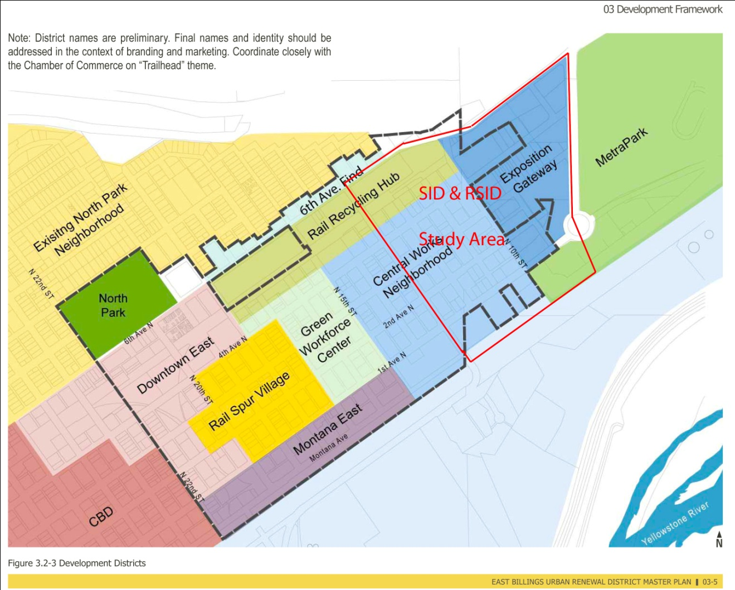
Exhibit “A”

