Site photos – Verizon Wireless
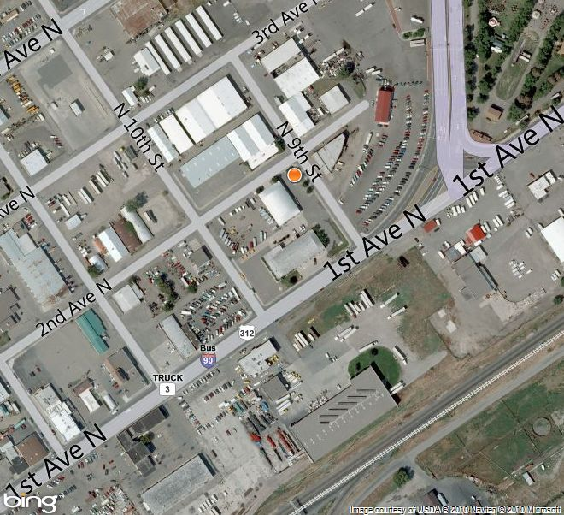

Subject property

Site photos – Verizon Wireless

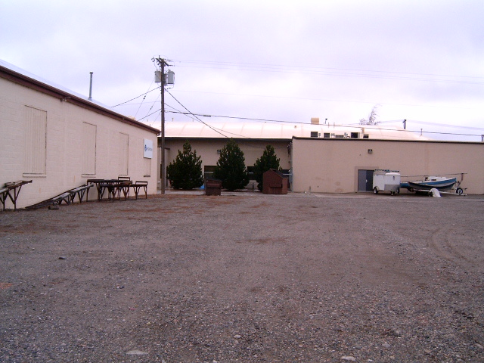

View from 2nd Avenue North

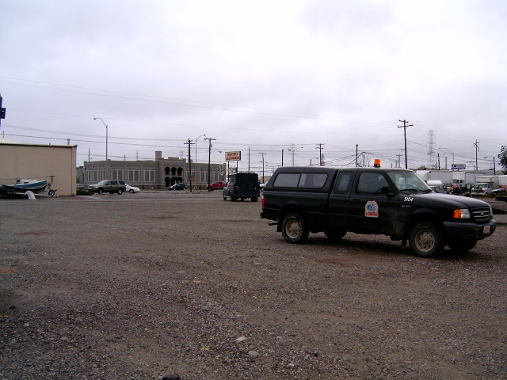

View south west from 2nd Avenue North

Site photos – Verizon Wireless

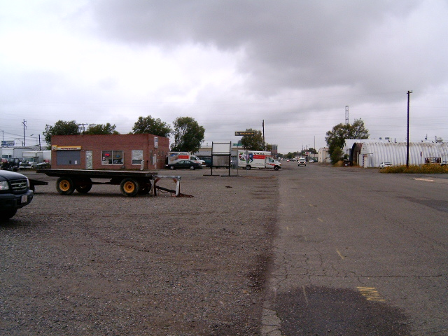

View west along 2nd Avenue North
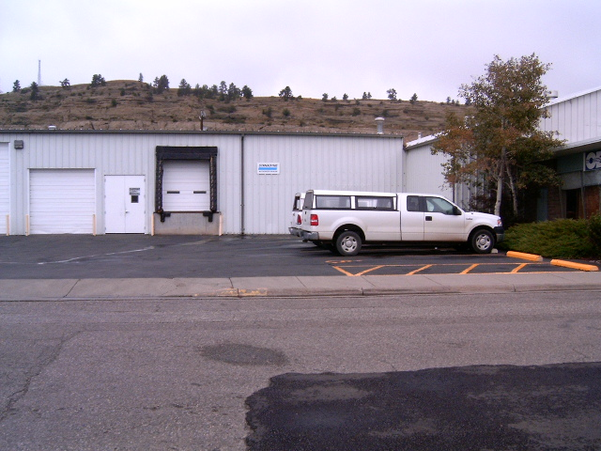
View north across 2nd Avenue North

