Zoning Map – Verizon Wireless communications tower

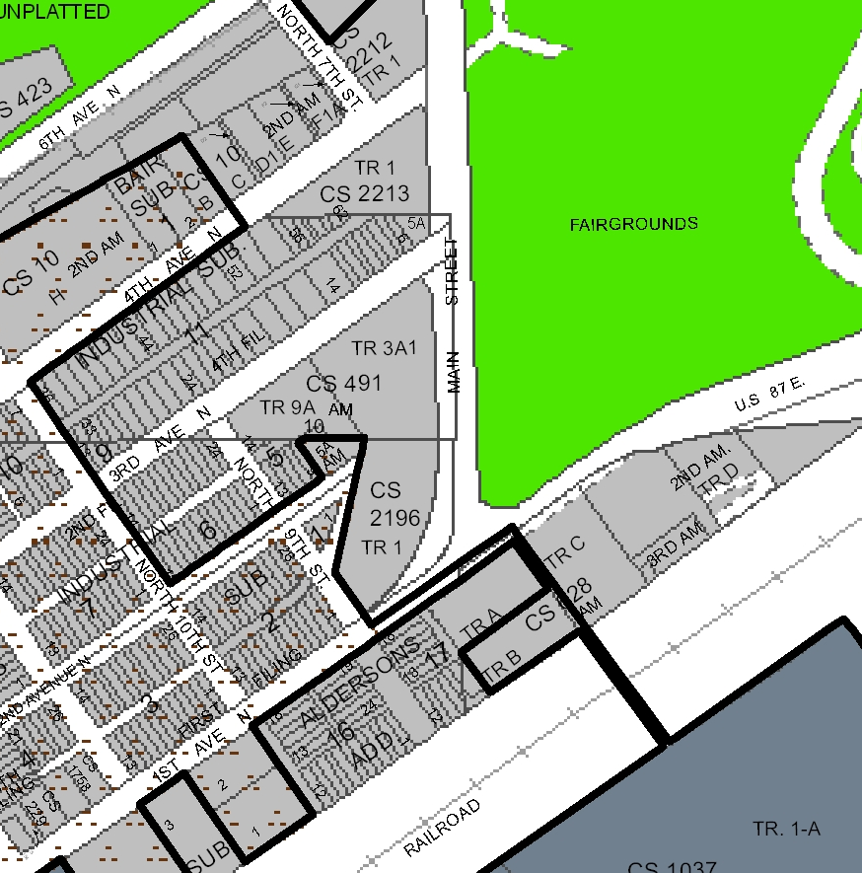
City Limits
HI
EBURD Parking Overlay
Metra Park
Subject Property
CI

