Site photos – SR #887- Multi-family dwellings

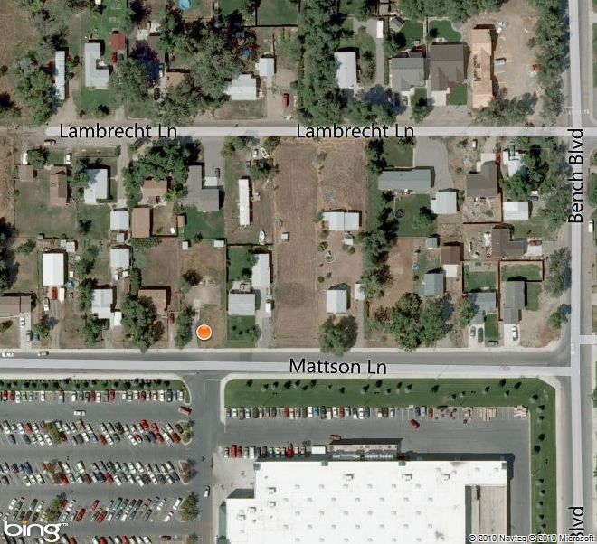Subject property

Site photos – SR #887- Multi-family dwellings
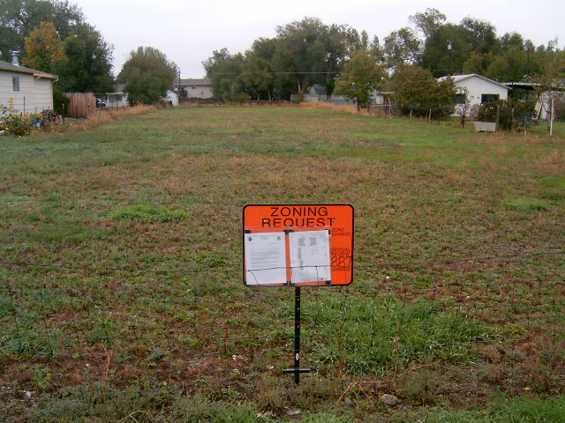

View from Mattson Lane
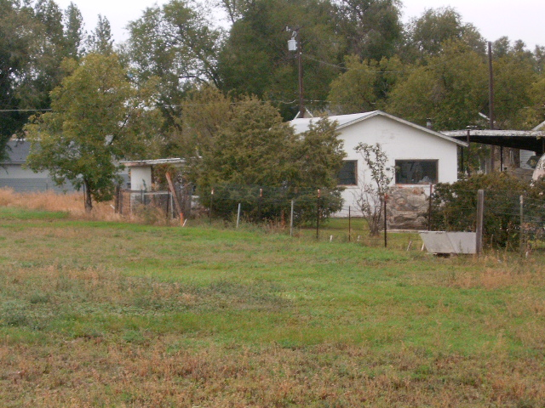

View of existing accessory buildings to be removed on Lot 14B

Site photos – SR #887- Multi-family dwellings

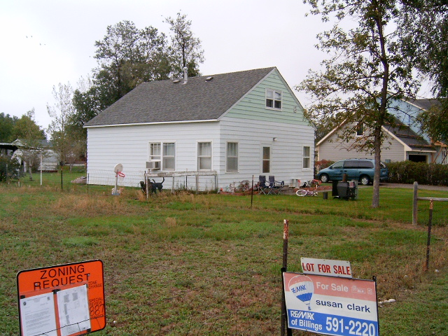

View of existing home on Lot 14C – 719 Mattson Lane

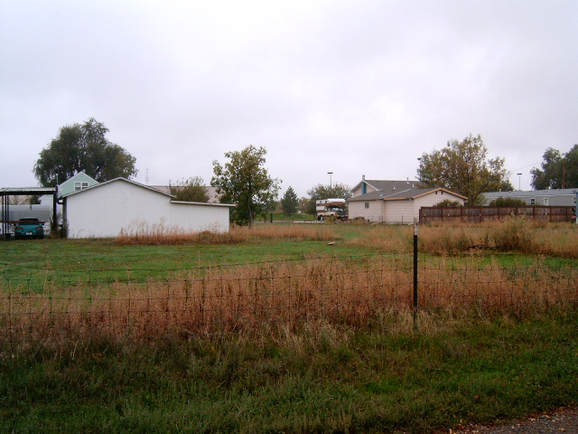

View from Lambrecht Lane – existing accessory buildings (left) on Lot 14B

