Zoning Map – SR #887 – Multi-family dwellings

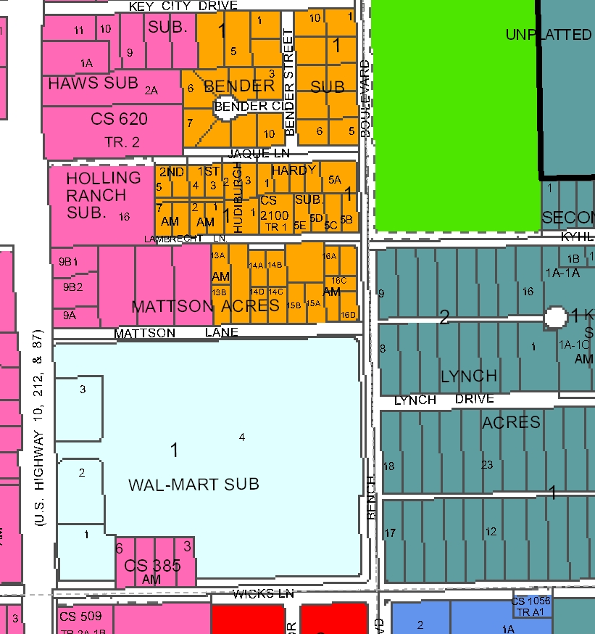
CC
NC
Subject Property
R-60
Public
R-70
PD- CC
HC

