Attachment A: Surrounding Zoning
Zone Change #869 – 412 Hallowell Lane
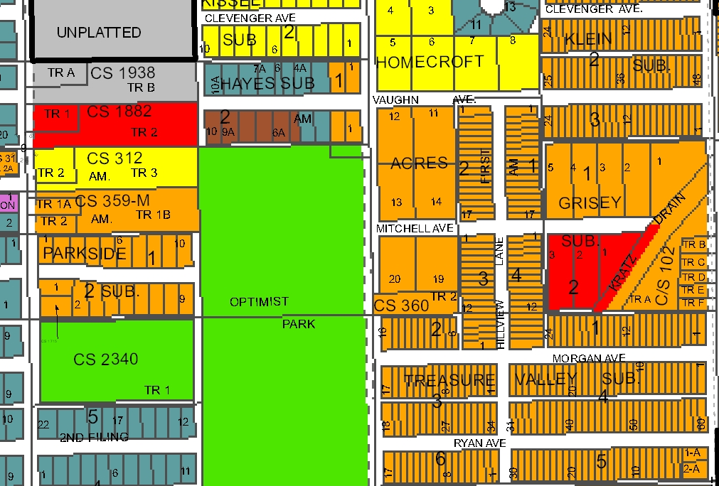
CI
R-60
R-96
R-50
CC
Public
R-70
Subject Property
NC

