Attachment B
Site Photographs, Zone Change #869– 412 Hallowell Lane
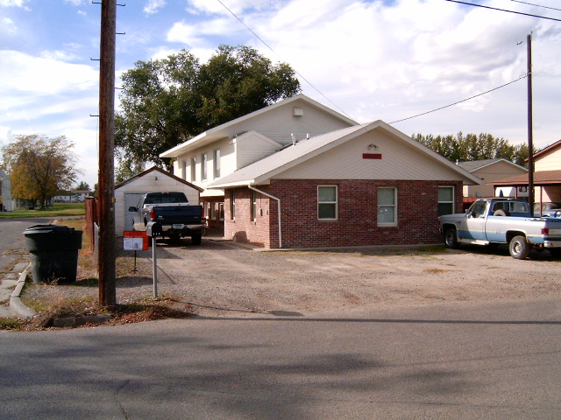
Subject Property view from Hallowell Lane
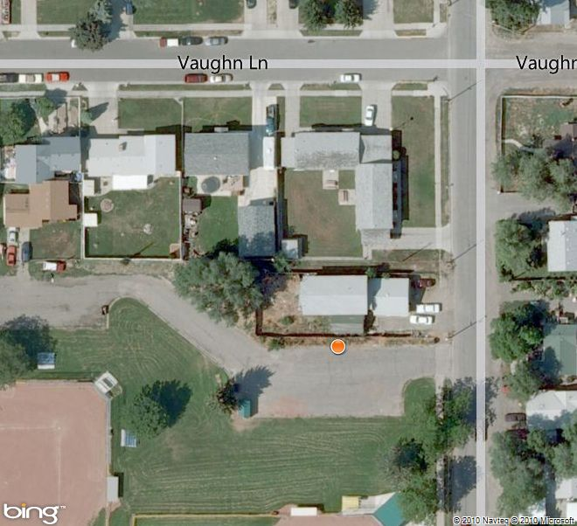
Aerial Map

Attachment B, continued
Site Photographs, Zone Change #869 – 412 Hallowell Lane
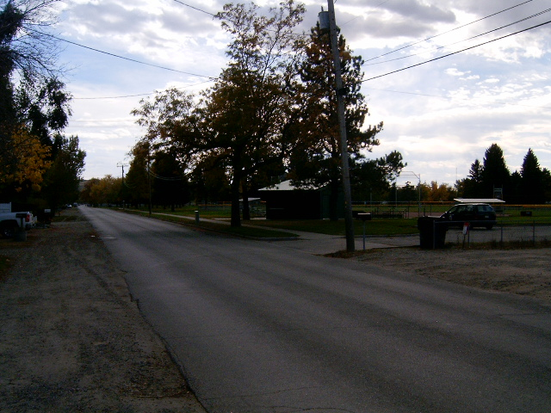
View south and west from east side of Hallowell Lane
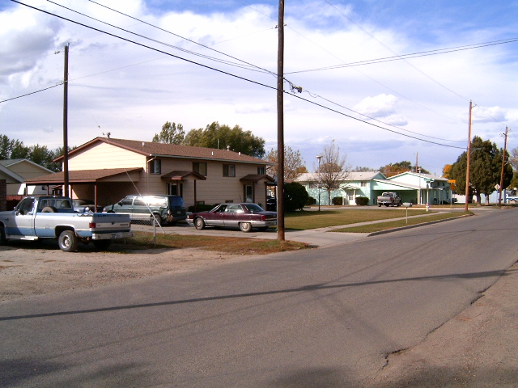
View north and west from east side of Hallowell Lane

