Grand Peaks Subdivision, 2nd Filing
Zoning Exhibit

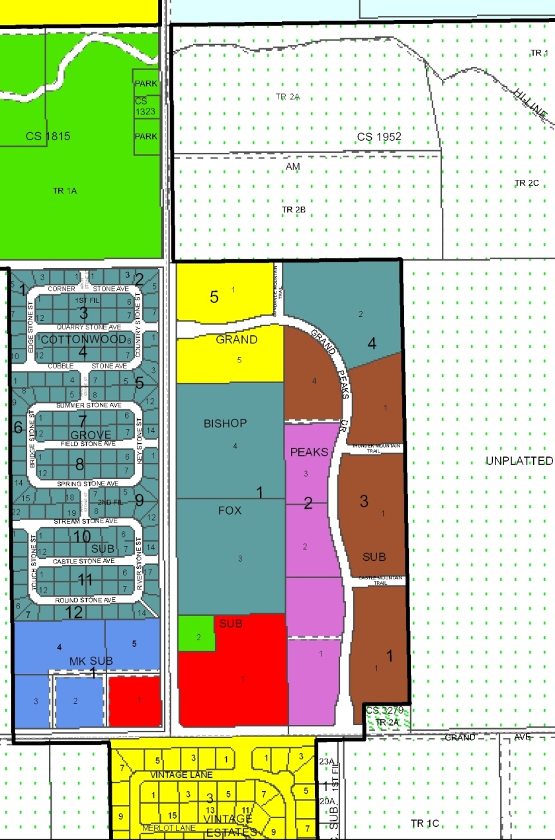
Subject Property Zoning
Magenta = RMF-R
Brown = R-5000
Aqua = R-7000

