Attachment A: Surrounding Zoning
Zone Change #870 – The Village Subdivision – St Vincent Healthcare Subdivision 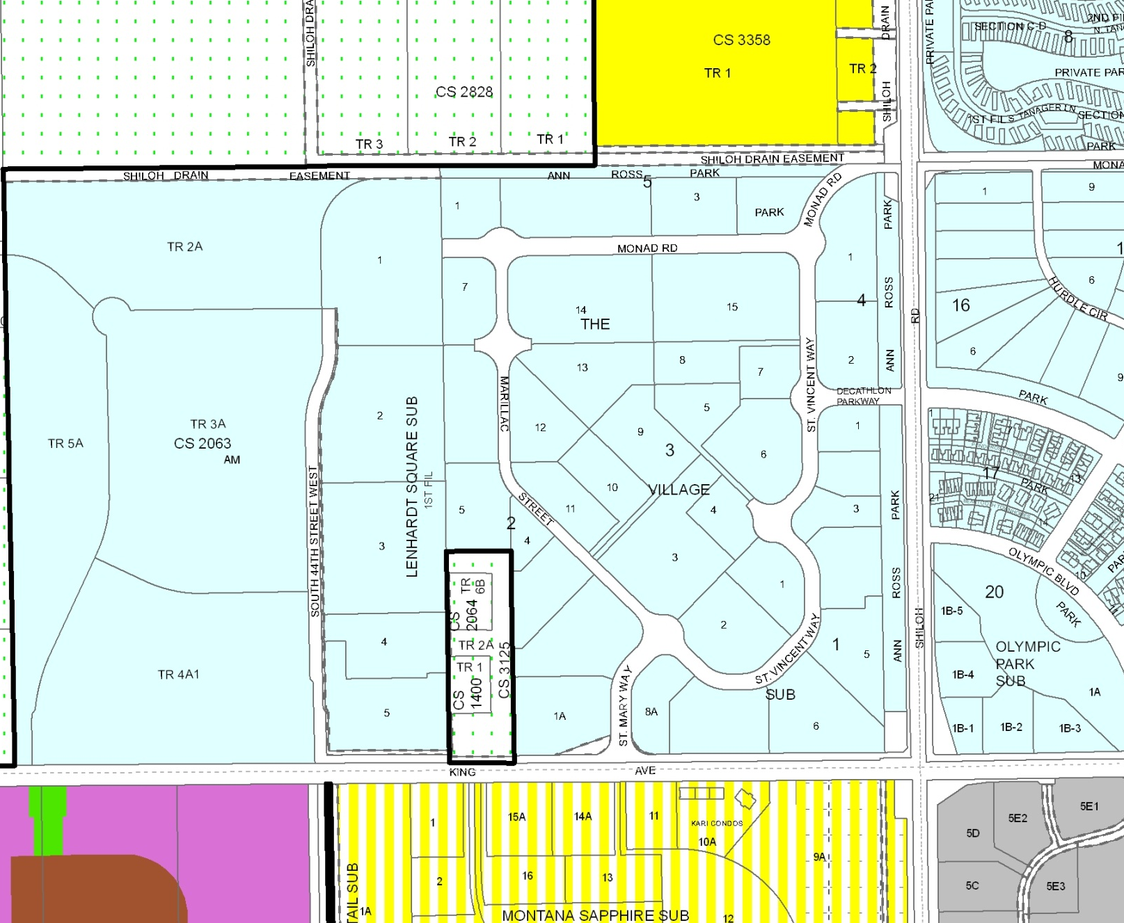
Subject Property
A-1
R-50
RMF-R
CI
ELI
PD- Lenhardt Square
PD
Olympic Park
PD
Shiloh Village
R-96
Public

Existing Planned Development Zoning Master Plan

Proposed Planned Development Zoning Master Plan
