Attachment B
Site Photographs
Zone Change #870 – The Village – St Vincent Healthcare Subdivision
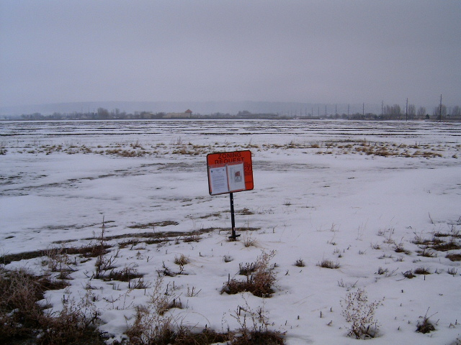
Subject Property view from King Avenue West
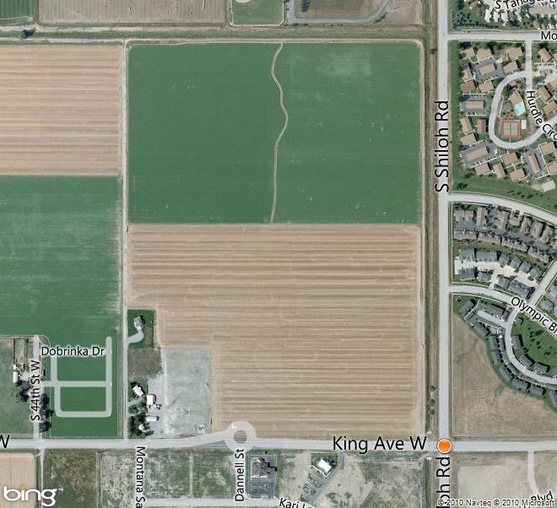
Aerial Map

Attachment B, continued
Site Photographs
Zone Change #870 – The Village – St Vincent Healthcare Subdivision
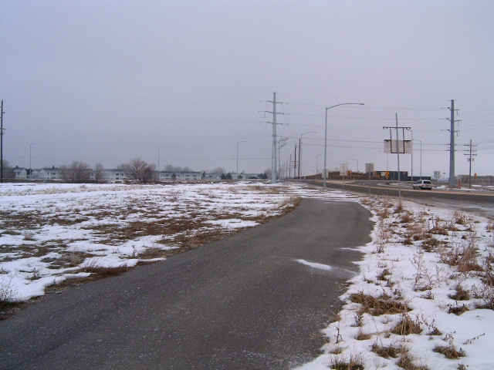
View east along multi-use trail on King Avenue West

View south across King Avenue West

Attachment B, continued
Site Photographs
Zone Change #870 – The Village – St Vincent Healthcare Subdivision
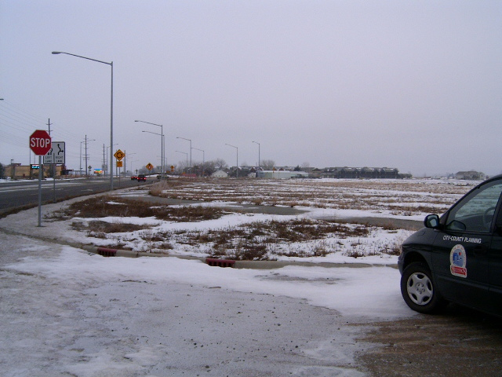
View west along King Avenue West

View north across subject property from King Avenue West

