Attachment A: Surrounding Zoning
Zone Change #871 – 766 Calhoun Lane
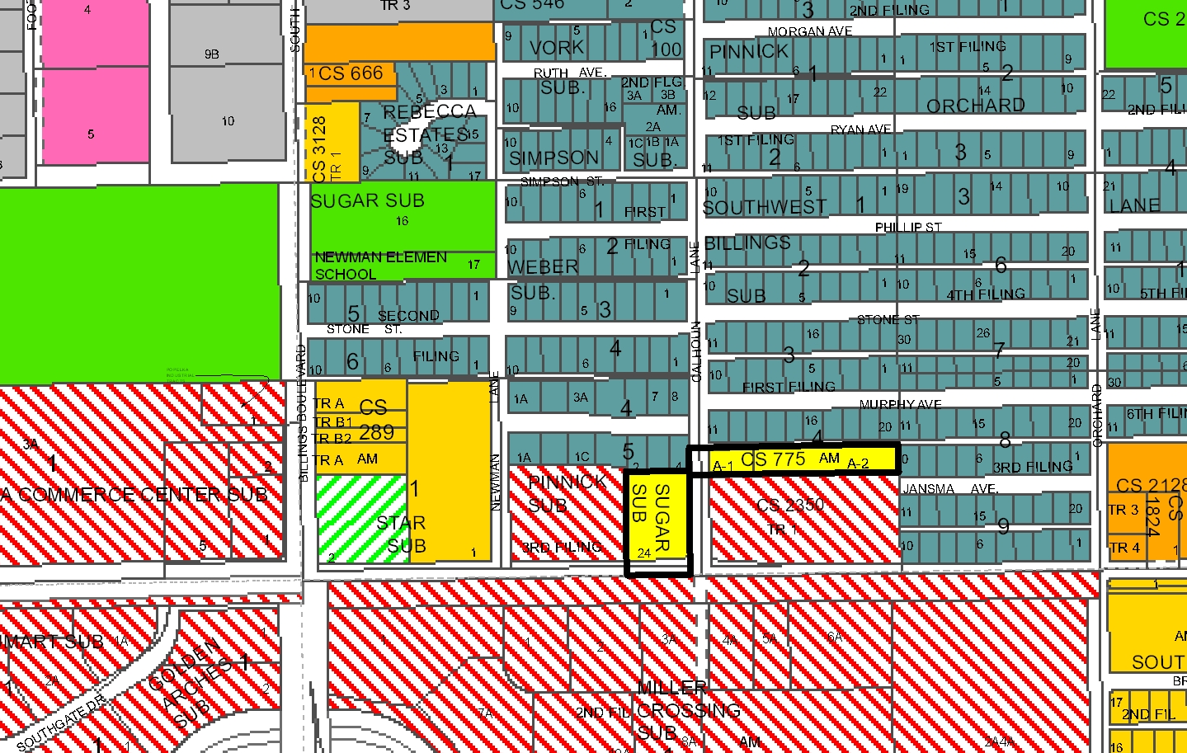
R-60
R-60
HC
RMH
ELC
Public
CI
RMH
R-70
EGC
R-96
Subject Property

