Attachment B
Site Photographs, Zone Change #871– 766 Calhoun Lane
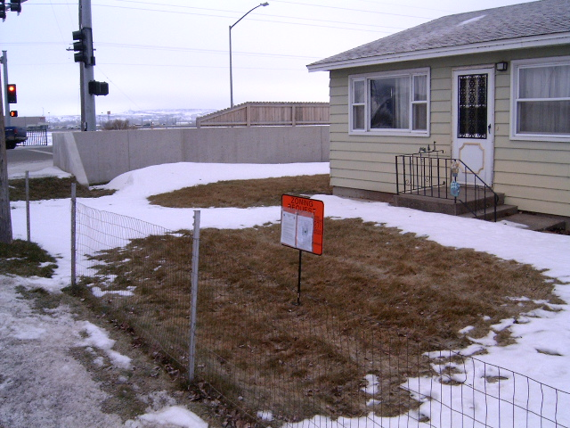
Subject Property view south west from Calhoun Lane
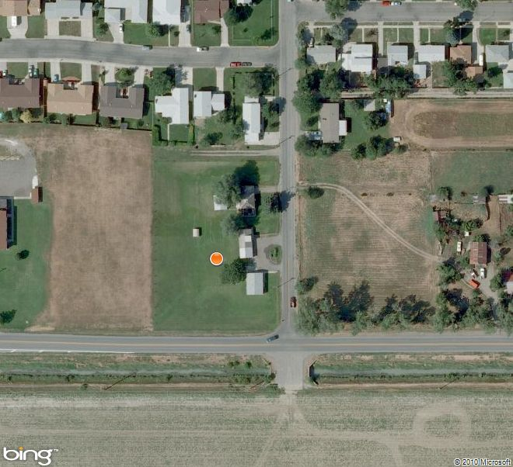
Aerial Map
Attachment B, continued
Site Photographs, Zone Change #871 – 766 Calhoun Lane
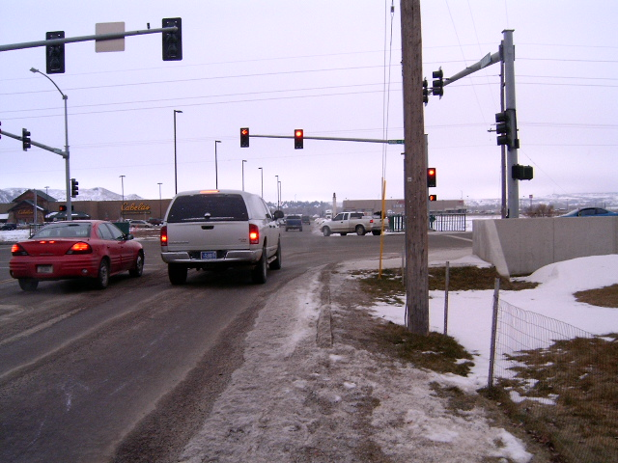
View south at traffic control at Calhoun Lane & King Avenue East
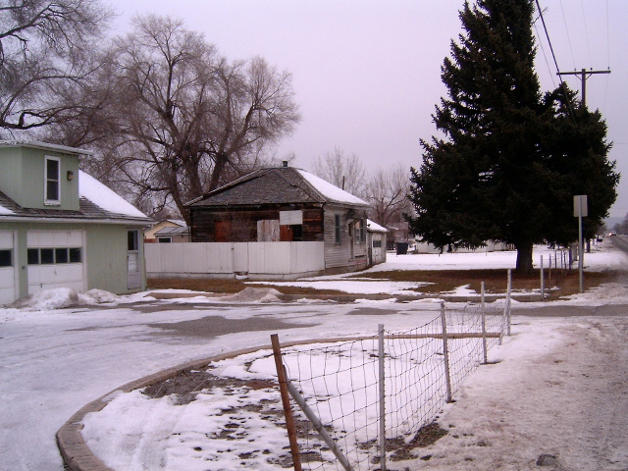
View north and west along Calhoun Lane

Attachment B, continued
Site Photographs, Zone Change #871 – 766 Calhoun Lane
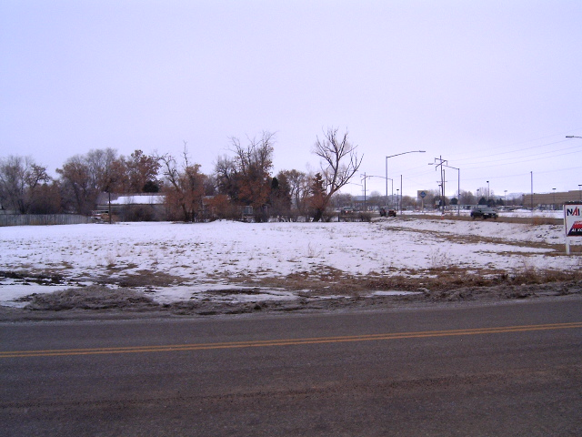
View south and east across Calhoun Lane
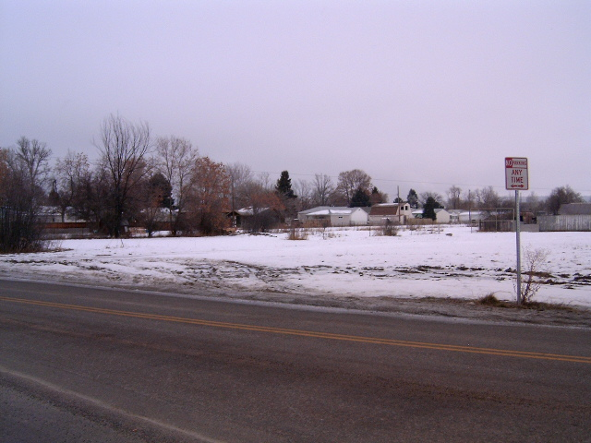
View north and east across Calhoun Lane

