Attachment A: Surrounding Zoning
Zone Change #872 – 1910 & 1918 Shiloh Road
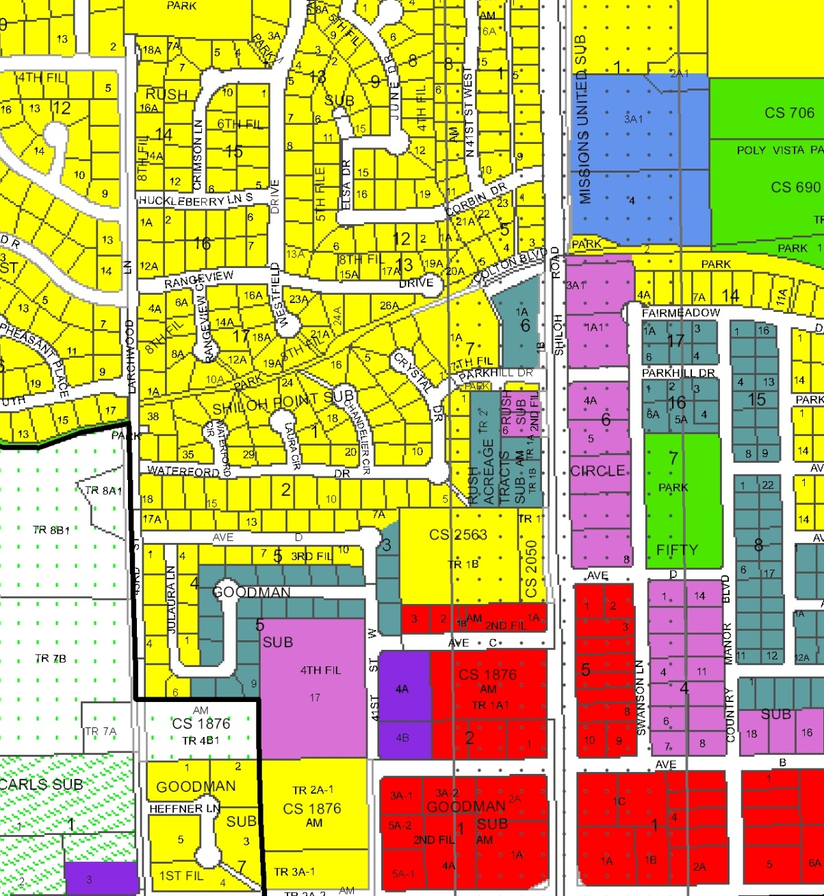
Shiloh Corridor Overlay
RMF-R
RP
Subject Property
NC
RP
AS
A-1
CC
R-70
RMF-R
Public
R-96

