Attachment B
Site Photographs, Zone Change #872 – 1910 and 1918 Shiloh Road
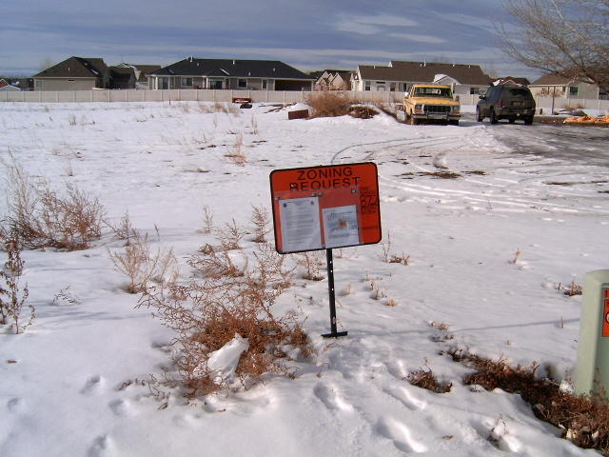
1910 Shiloh Road
1918 Shiloh Road
Subject Property view west from Shiloh Road
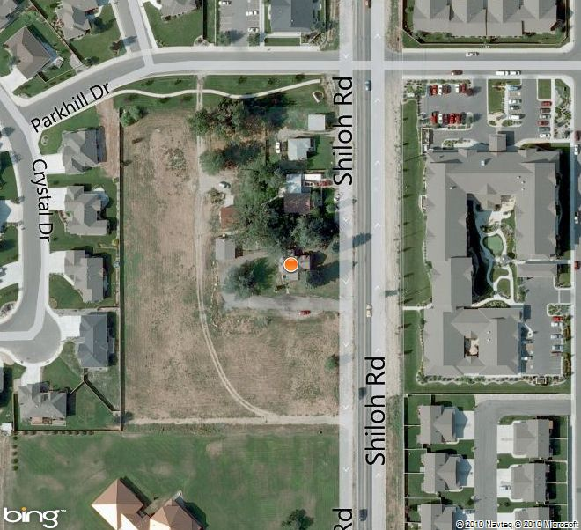
Aerial Map

Attachment B, continued
Site Photographs, Zone Change #872 – 1910 & 1918 Shiloh Road
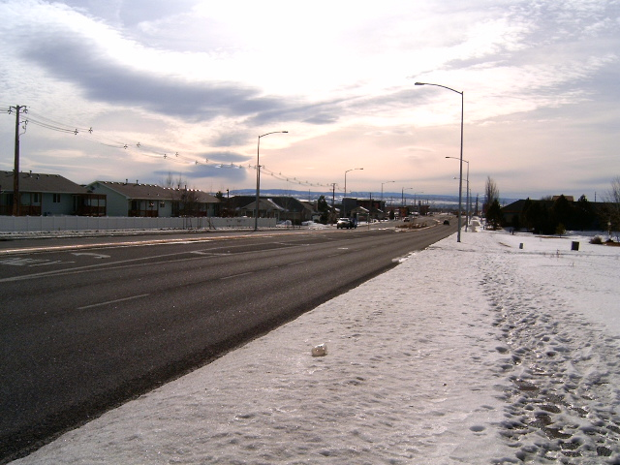
View south along Shiloh Road
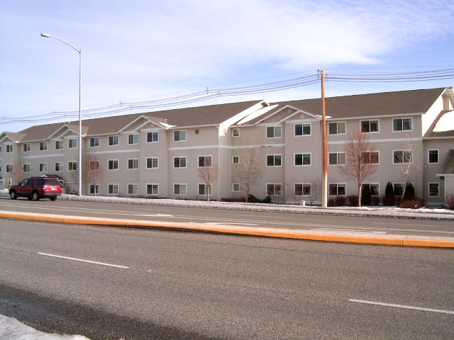
View north and east across Shiloh Road - Highgate Senior Living

Attachment B, continued
Site Photographs, Zone Change #872 – 1910 & 1918 Shiloh Road
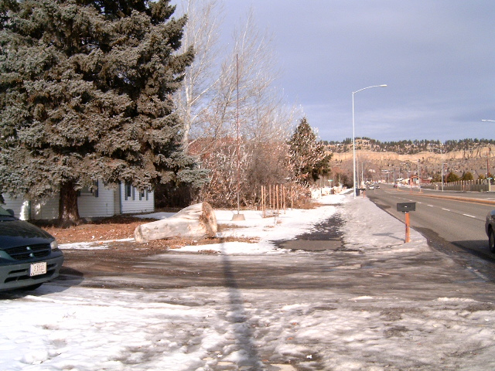
1918 Shiloh Road
View north along Shiloh Road
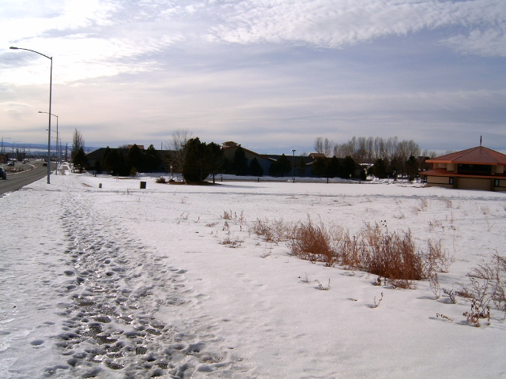
1910 Shiloh Road
View south along Shiloh Road

