Attachment A

Zoning Map – 1214 Main Street

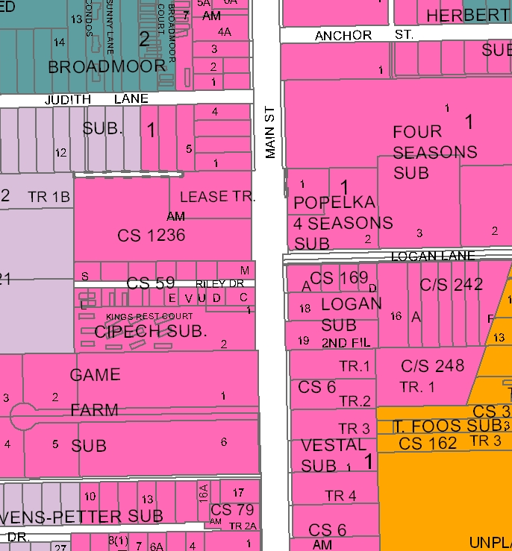
R-70
R-60
Main Street
RMF
Subject Property
HC

