Attachment B

Site photos – 1214 Main Street
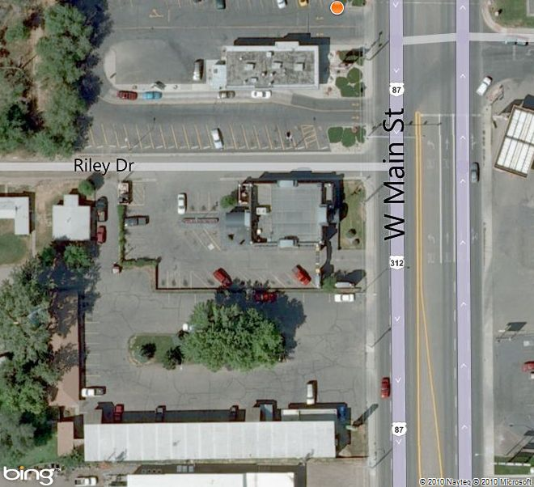

Subject property

Attachment C, continued

Site photos – 1214 Main Street

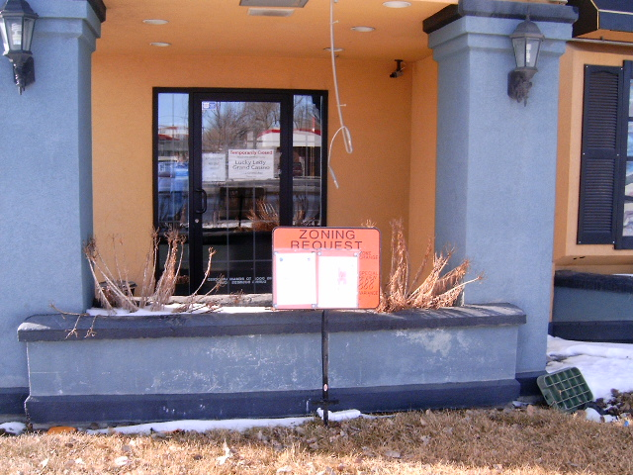

View from Main Street

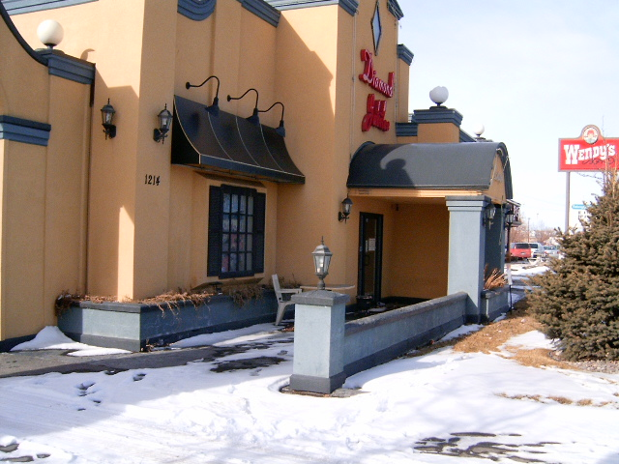

View north along front of building

Attachment C, continued

Site photos – 1214 Main Street

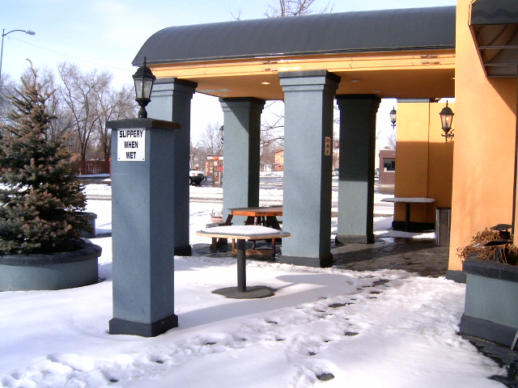

View of outdoor patio on west side of building – provides accessible entrance to building

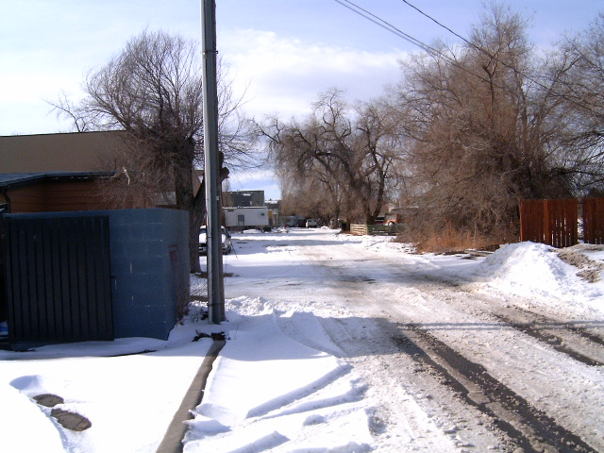

View west along Riley Drive to manufactured home park

