Attachment A: Surrounding Zoning
Zone Change #873 – 1648 Poly Drive
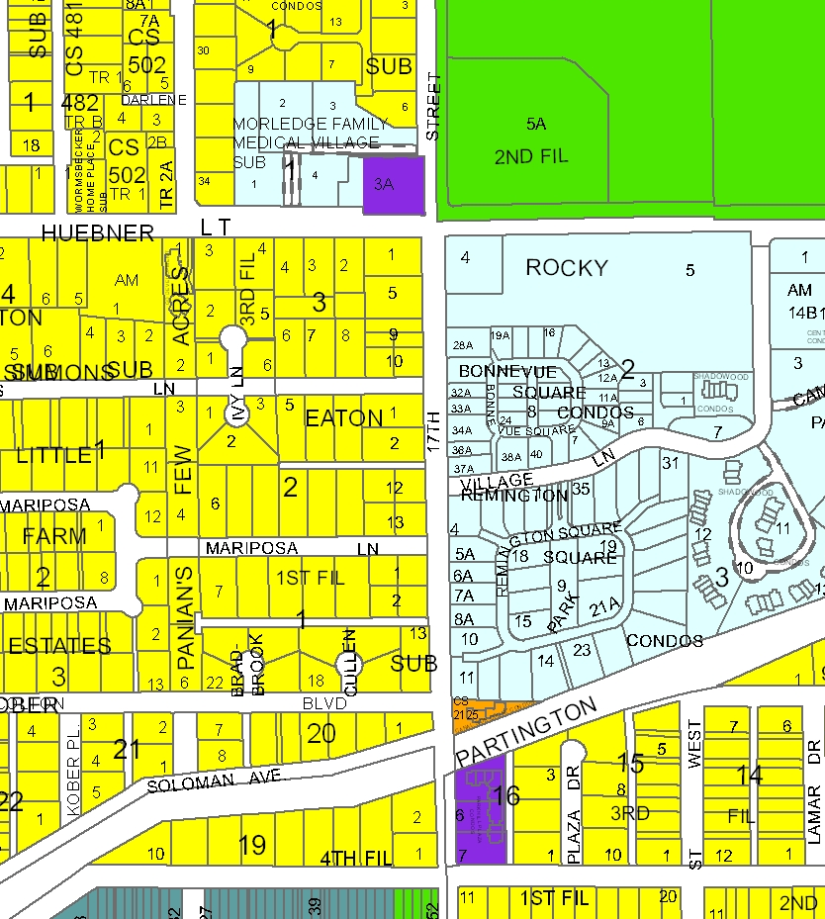
R-60
R-70
RP
Rocky Village - PD
Public
PD-RP
Subject Property
RP
R-96

