Attachment B
Site Photographs, Zone Change #873– 1648 Poly Drive
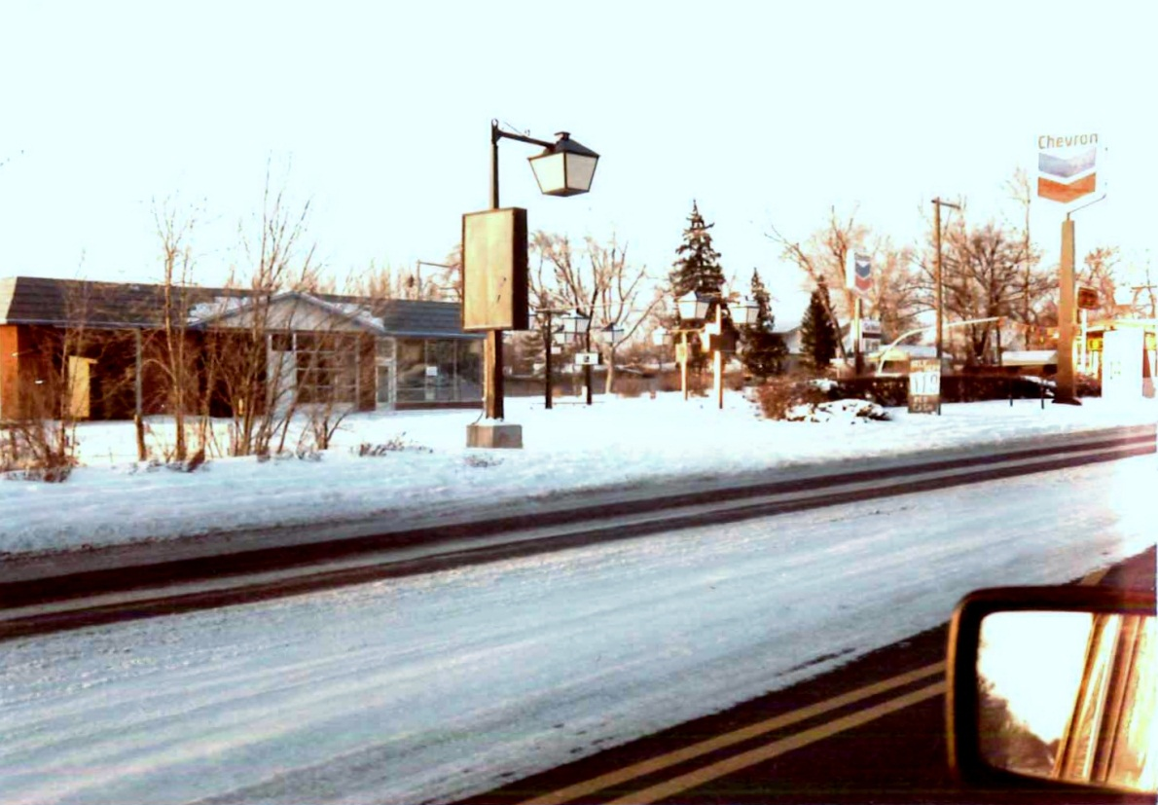
Subject Property view south west from Poly Drive – 1984

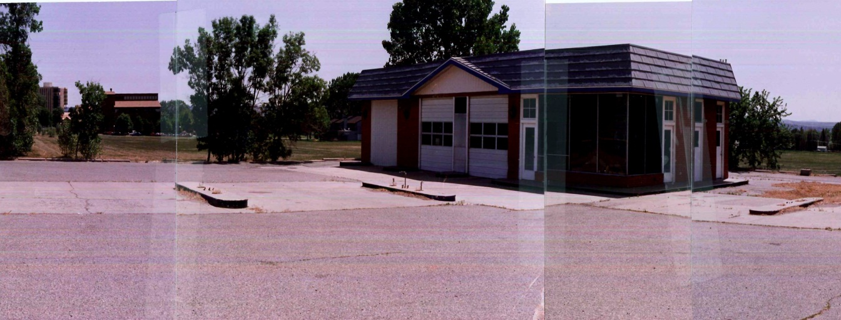
Subject property view south east from intersection – 1992

Attachment B, continued
Site Photographs, Zone Change #873 – 1648 Poly Drive
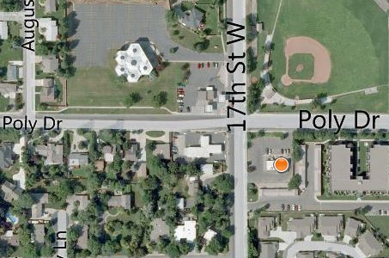
Aerial photo

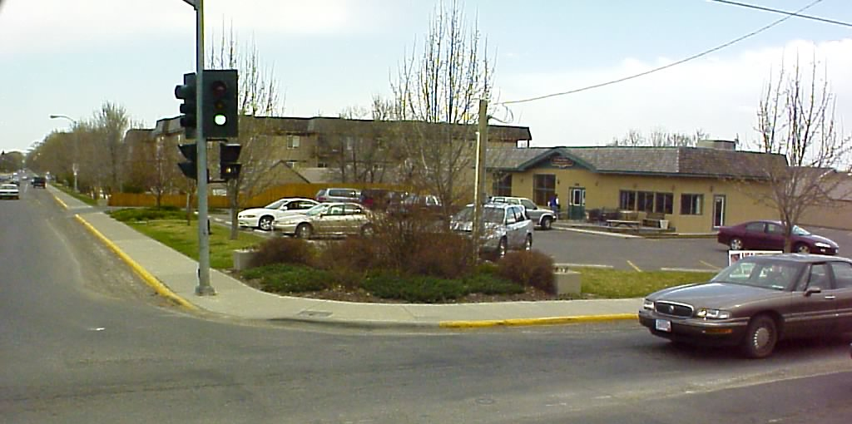
View south and east from intersection - 2003

Attachment B, continued
Site Photographs, Zone Change #873 – 1648 Poly Drive
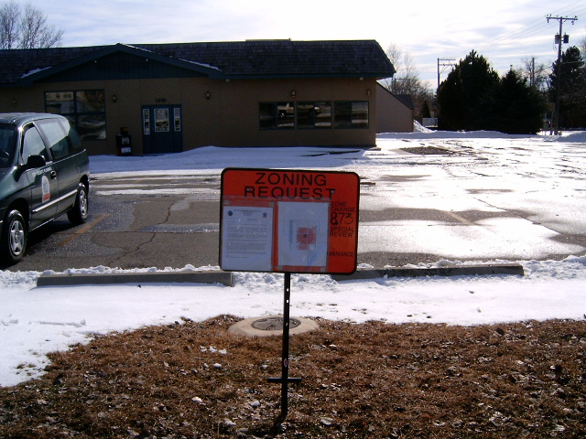
View south from Poly Drive – 2011
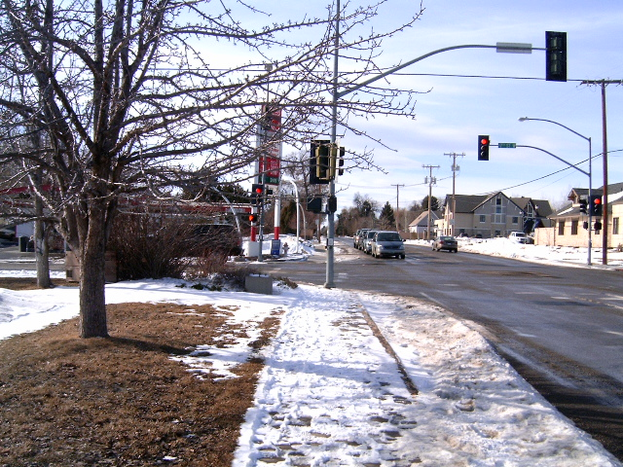
View west along Poly Drive - 2011
Attachment B, continued
Site Photographs, Zone Change #873 – 1648 Poly Drive
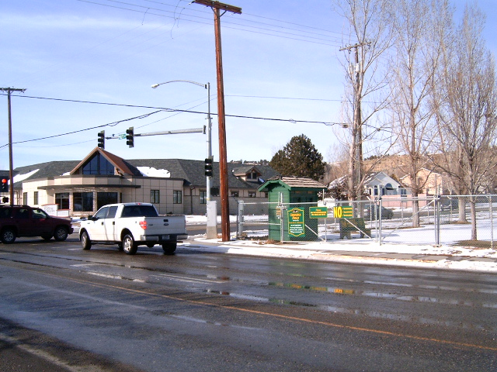
View north and west across Poly Drive – 2011
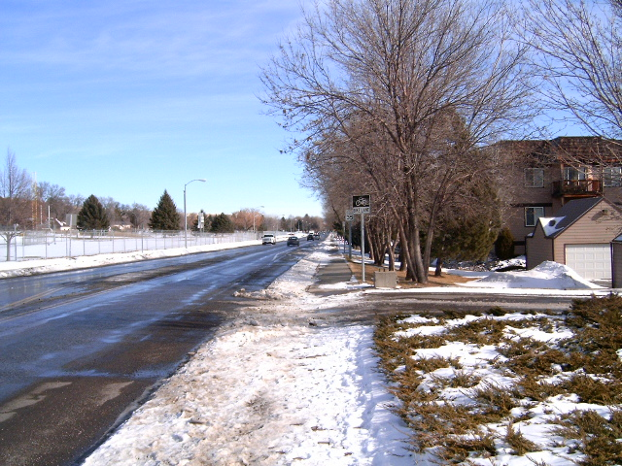
View east along Poly Drive - 2011

