Attachment A: Surrounding Zoning
Zone Change #874 – 327 Cook and 3919 Montana
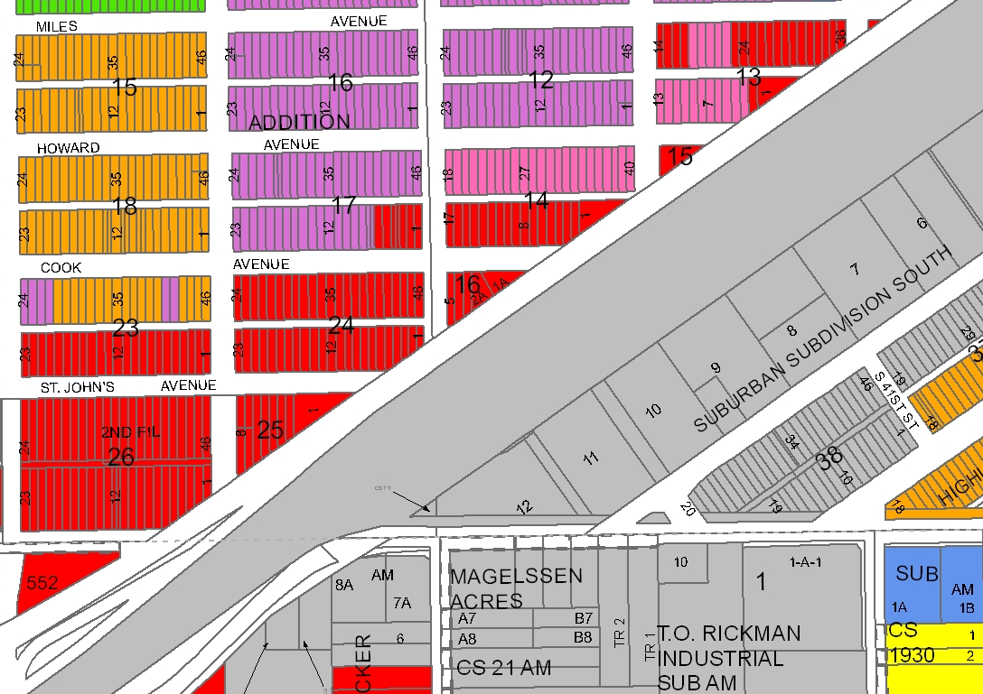
CI
Montana Avenue
HC
CC
R-96
Subject Property
NC
R-60
RMF-R
CC
HC
R-60

