Attachment B
Site Photographs, Zone Change #874 – 327 Cook and 3919 Montana
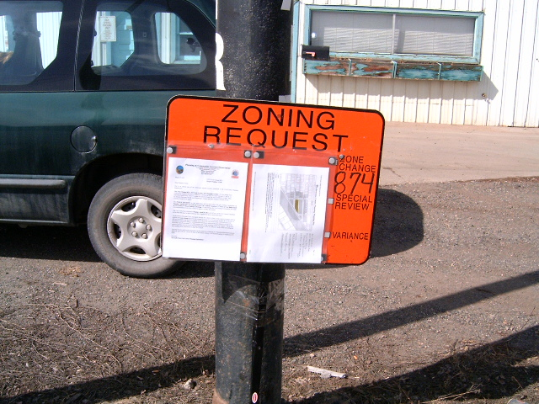
Subject Property view from Montana Avenue
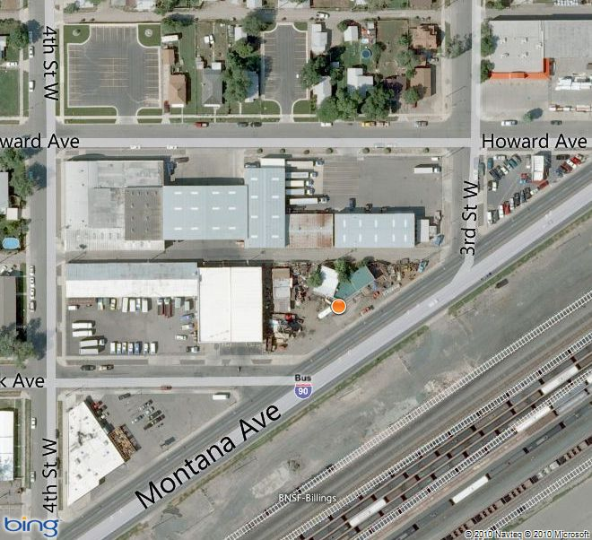
Aerial Map

Attachment B, continued
Site Photographs, Zone Change #874 – 327 Cook and 3919 Montana
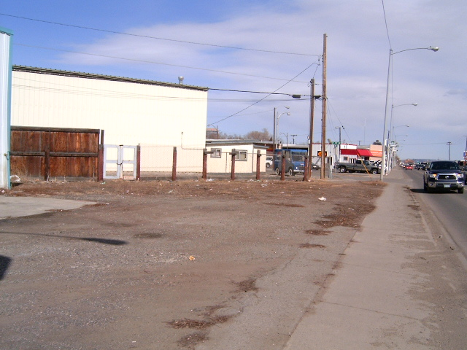
View east along Montana Avenue
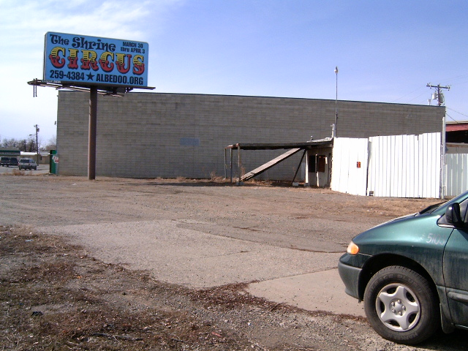
View west along Montana Avenue

Attachment B, continued
Site Photographs, Zone Change #874 – 327 Cook and 3919 Montana
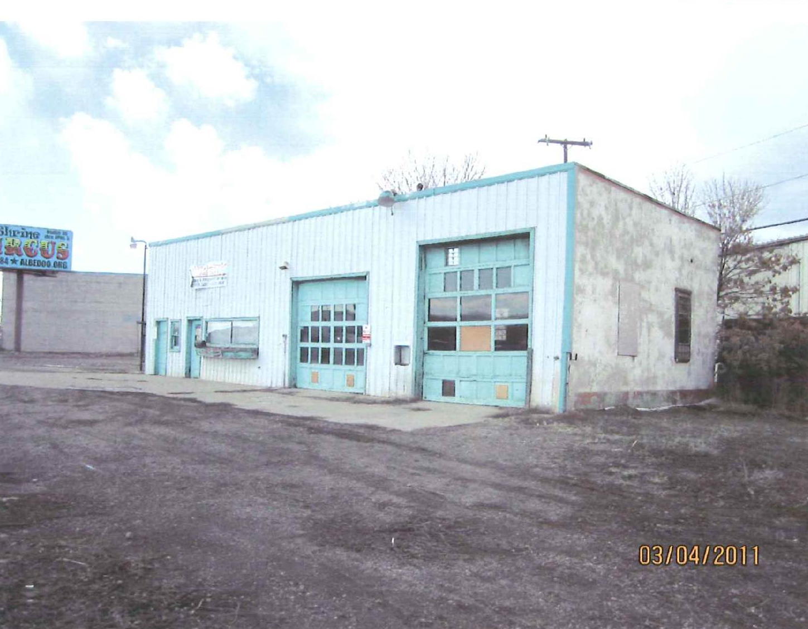
View northwest at 3919 Montana Avenue
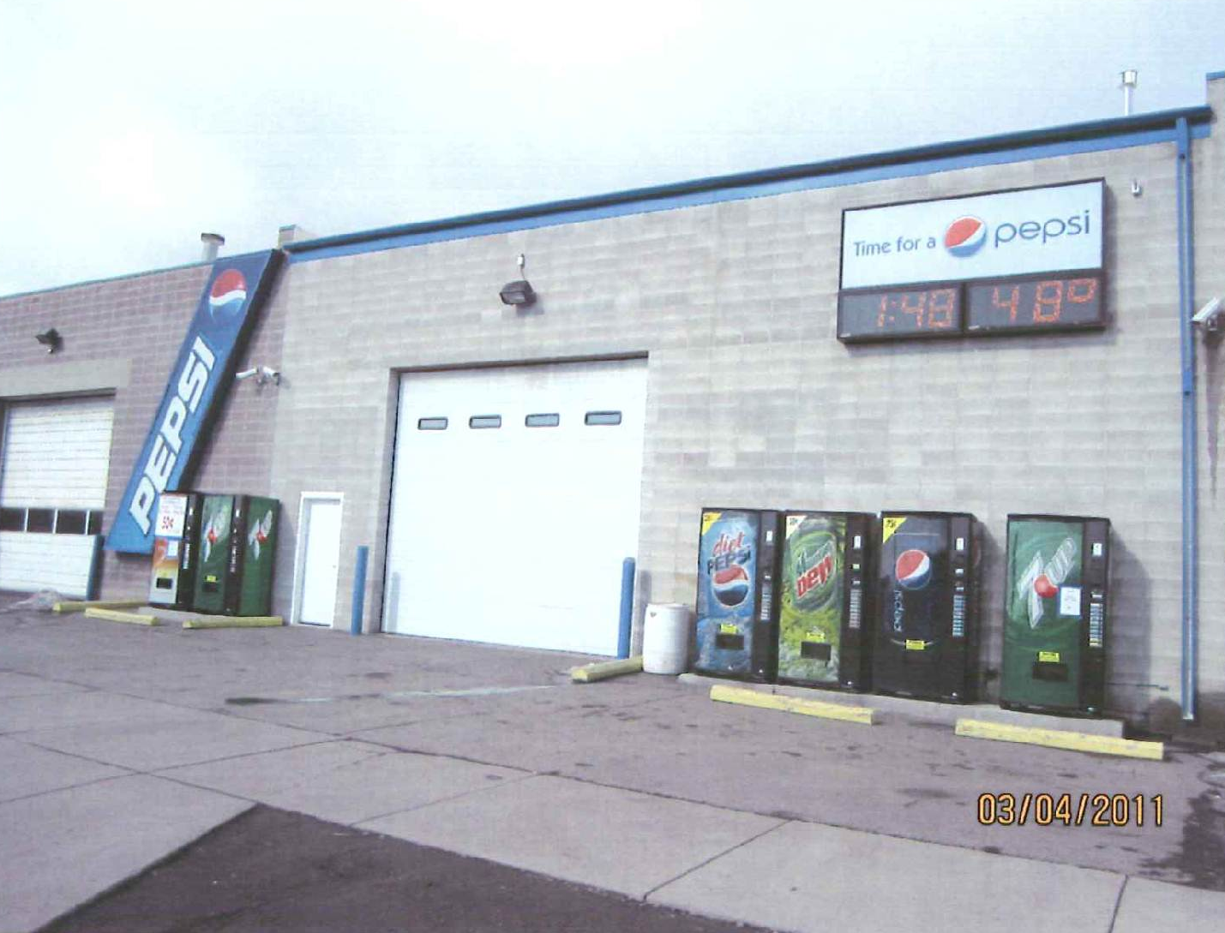
327 Cook Avenue

