Attachment A: Surrounding Zoning
Zone Change #875 – Lake Hills Subdivision
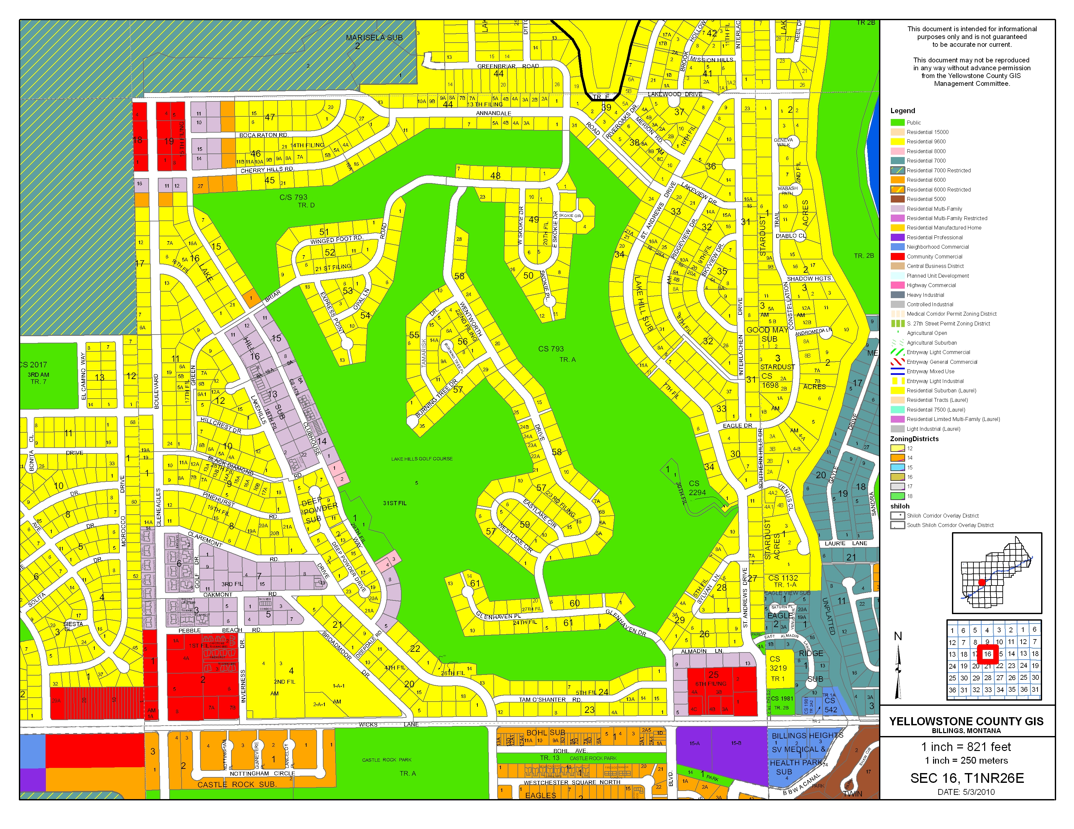
Lot G
Lots B & C
Public
R-96
R-70-R
RMF
Subject Property

