Attachment B
Site Photographs, Zone Change #875 – Lake Hills Subdivision
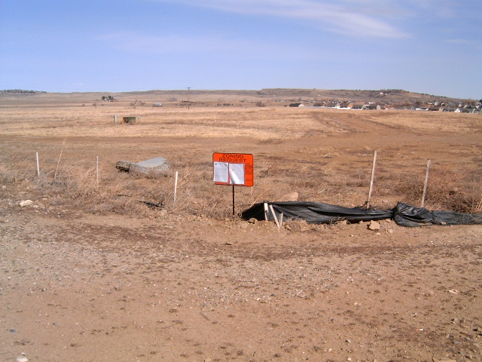
Subject Property view from Cherry Hills Road
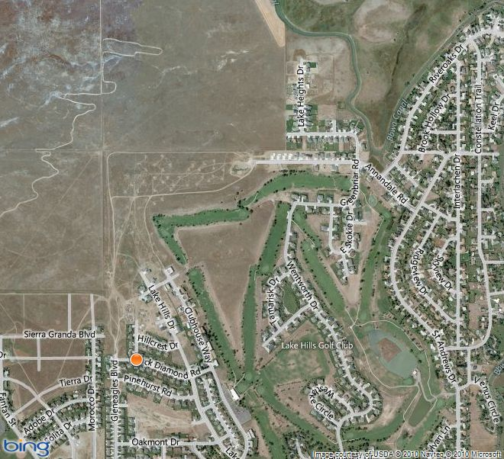
Aerial Map

Attachment B, continued
Site Photographs, Zone Change #875 – Lake Hills Subdivision
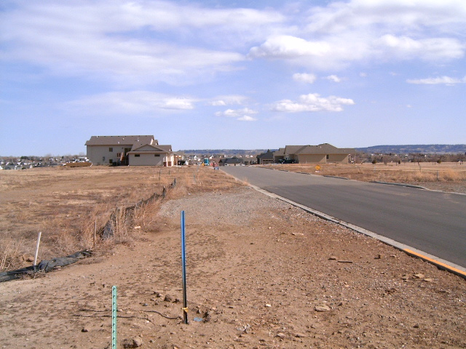
View east along Cherry Hills Road
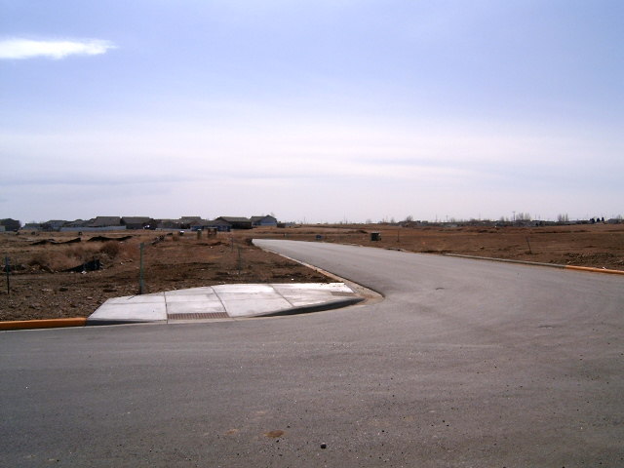
View south along intersection of Cherry Hills Rd and Clubhouse Way

Attachment B, continued
Site Photographs, Zone Change #875 – Lake Hills Subdivision
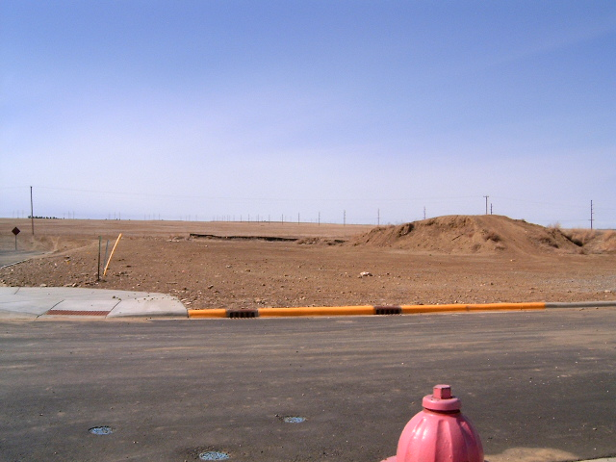
View northwest at intersection of Cherry Hills Road and Clubhouse Way
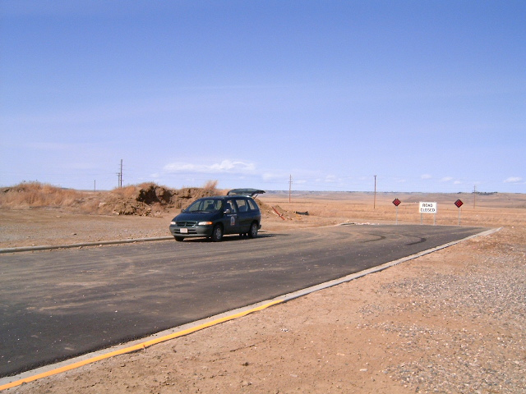
Current dead-end of Clubhouse Way

