Attachment A

Zoning Map – SR #889 – Tendernest Assisted Living

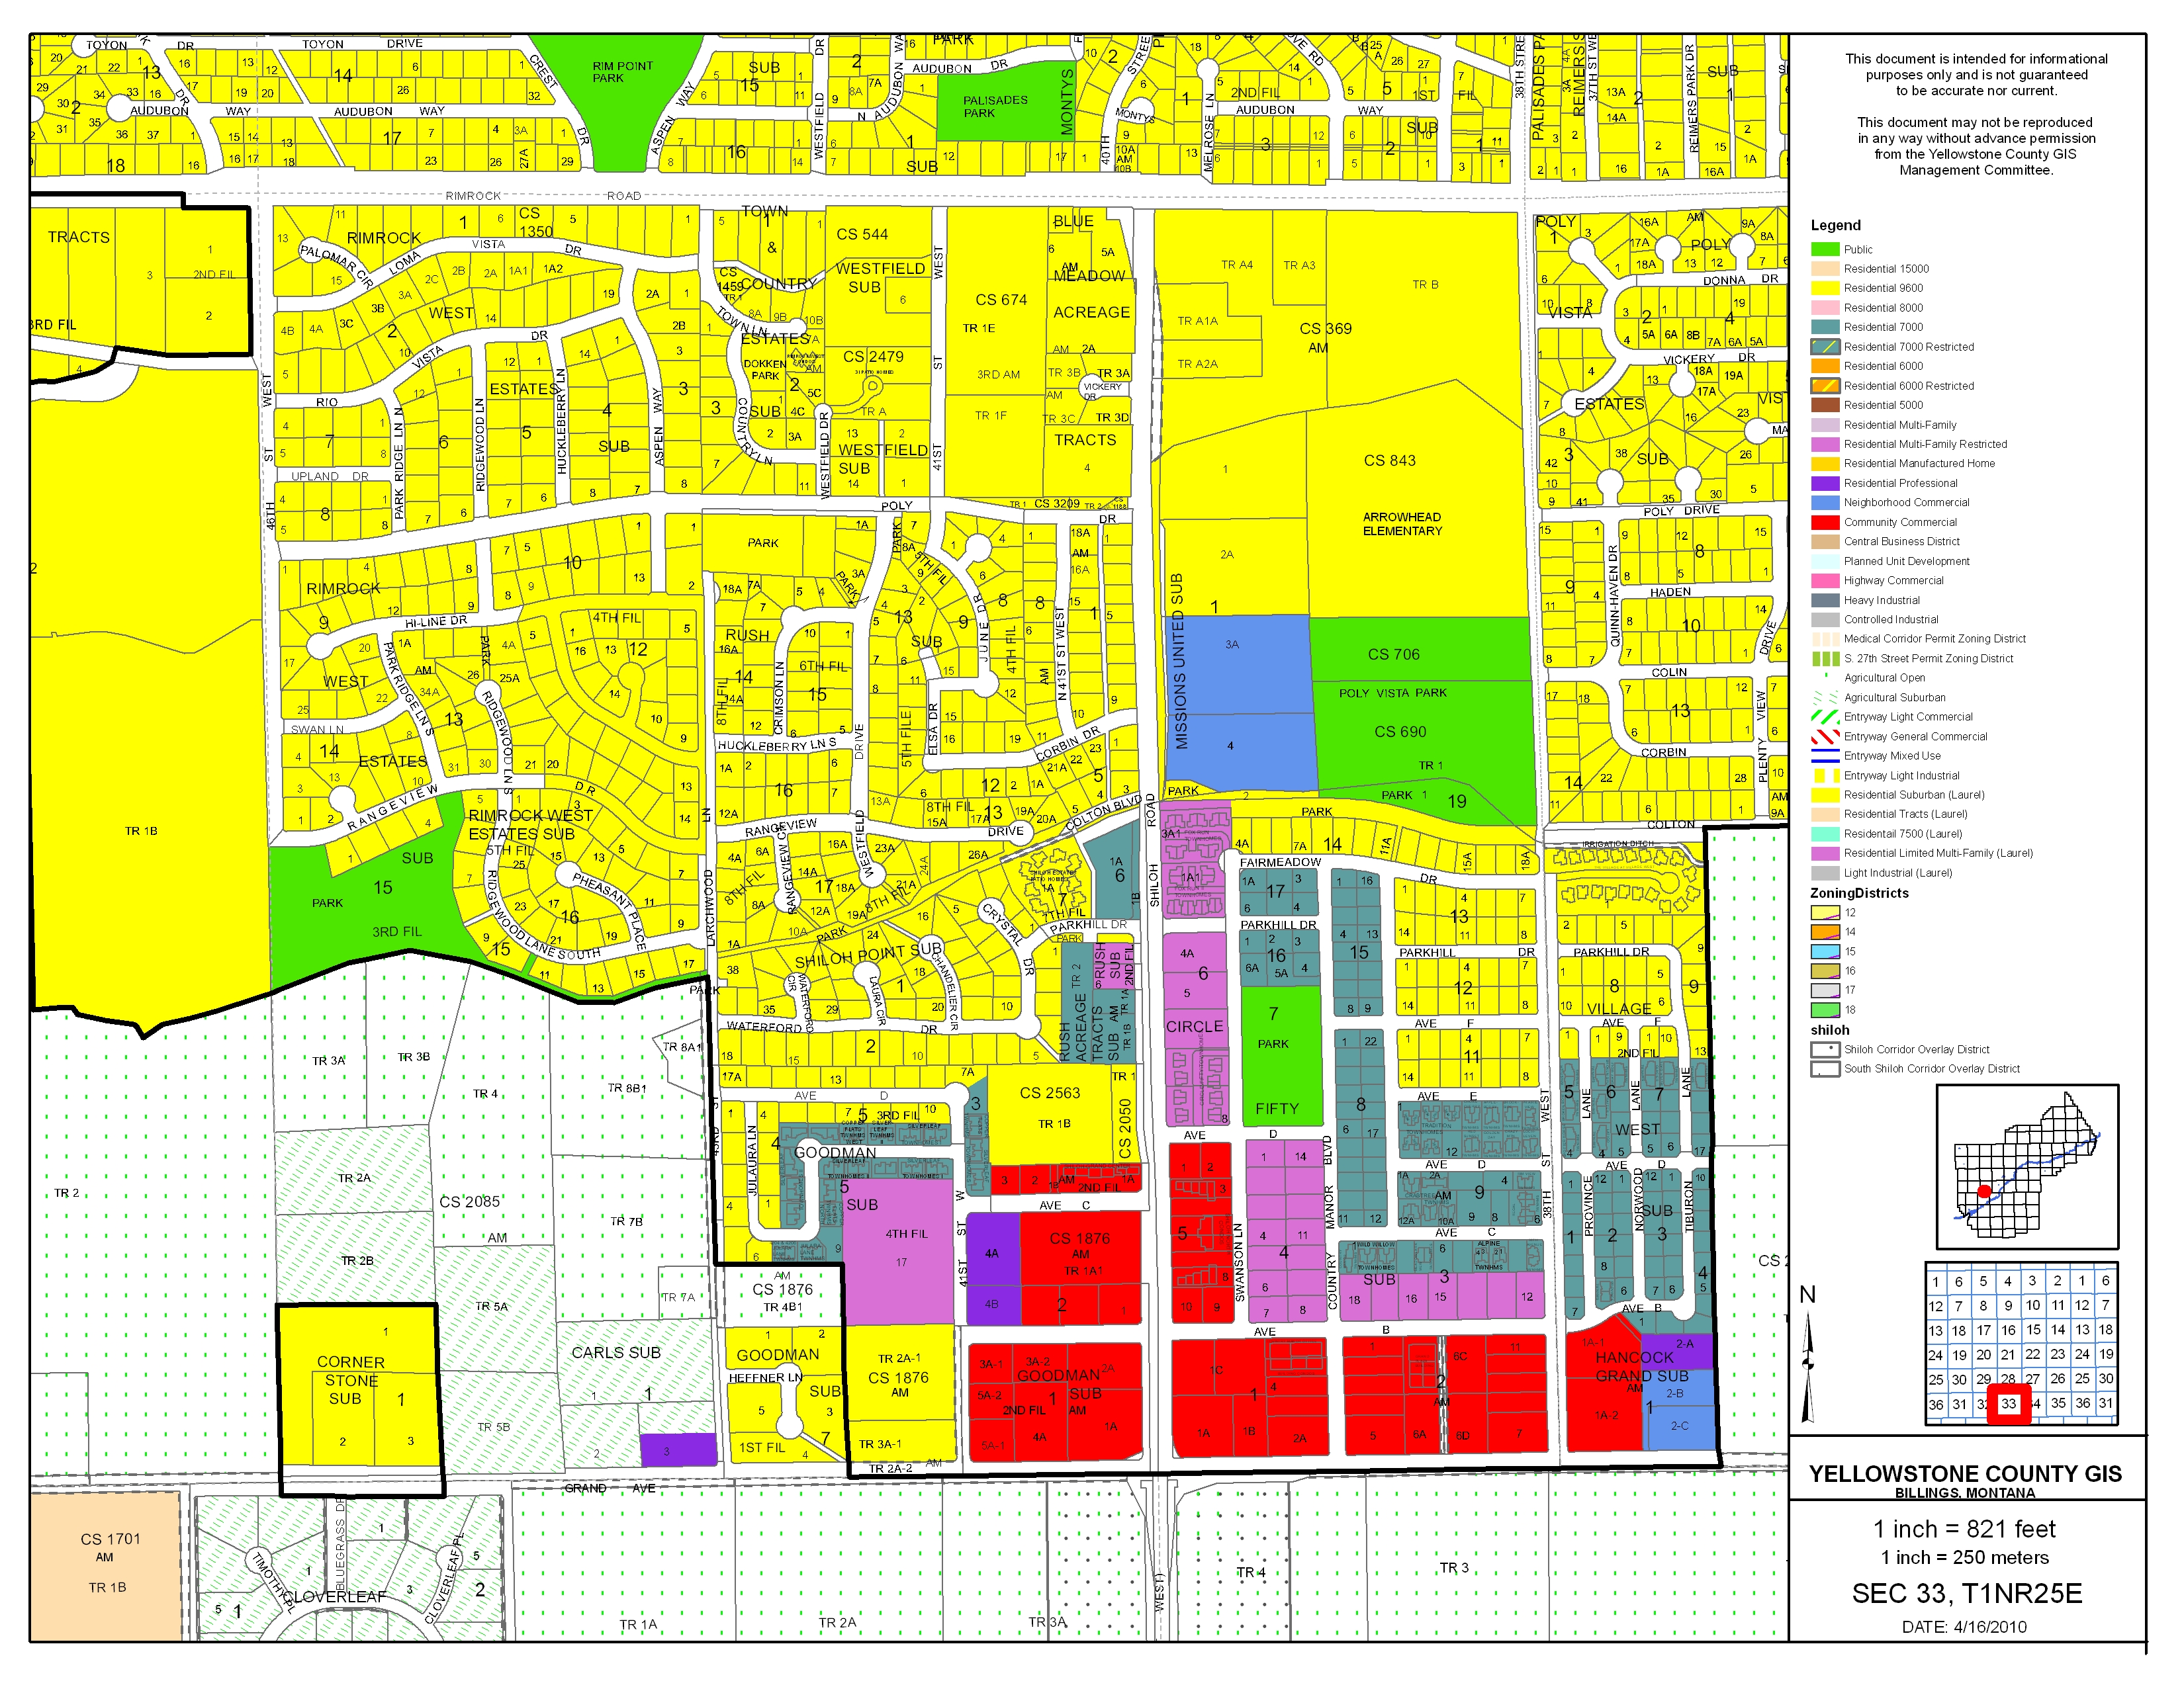
Subject Property
RMF-R
CC
Public
R-96
R-70
NC

