Attachment B

Site photos – SR #889- Tendernest Assisted Living

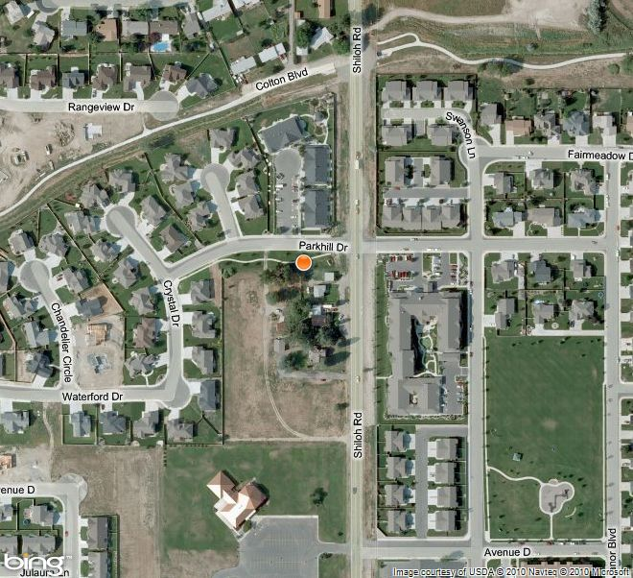Subject property

Attachment B, continued

Site photos – SR #889- Tendernest Assisted Living
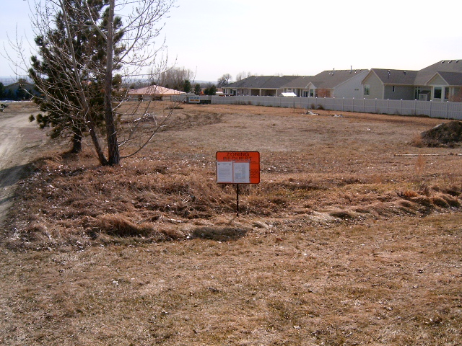

View south from Parkhill Drive – existing entry
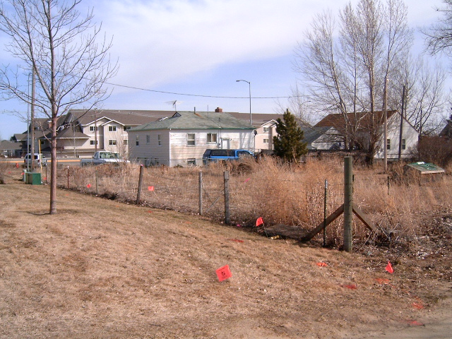

View east from existing entry to residence at 2010 Shiloh Road (Phase 1)

Attachment B, continued

Site photos – SR #889- Tendernest Assisted Living

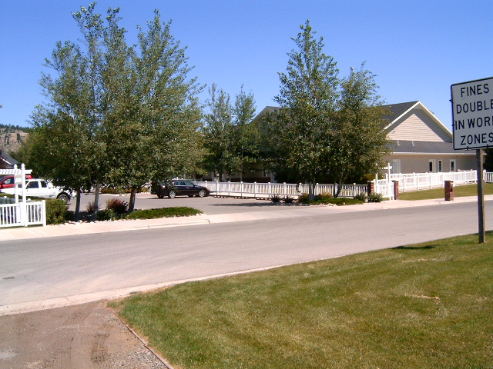

View north to Tendernest Assisted Living North Campus 4003 Parkhill Drive

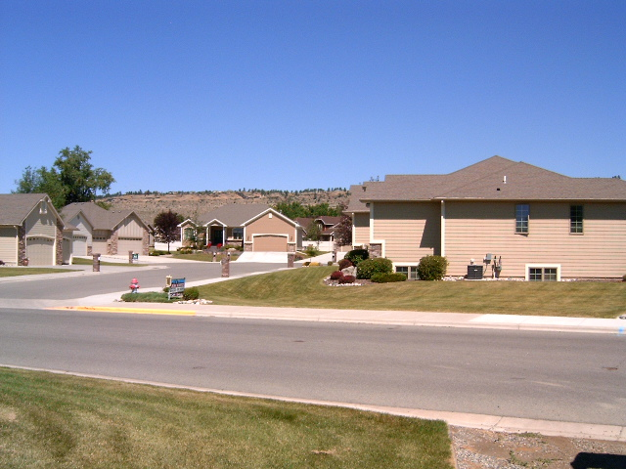

View north to Shiloh Point Condominiums

