Attachment C
Site Plan – SR #889 Tendernest Assisted Living

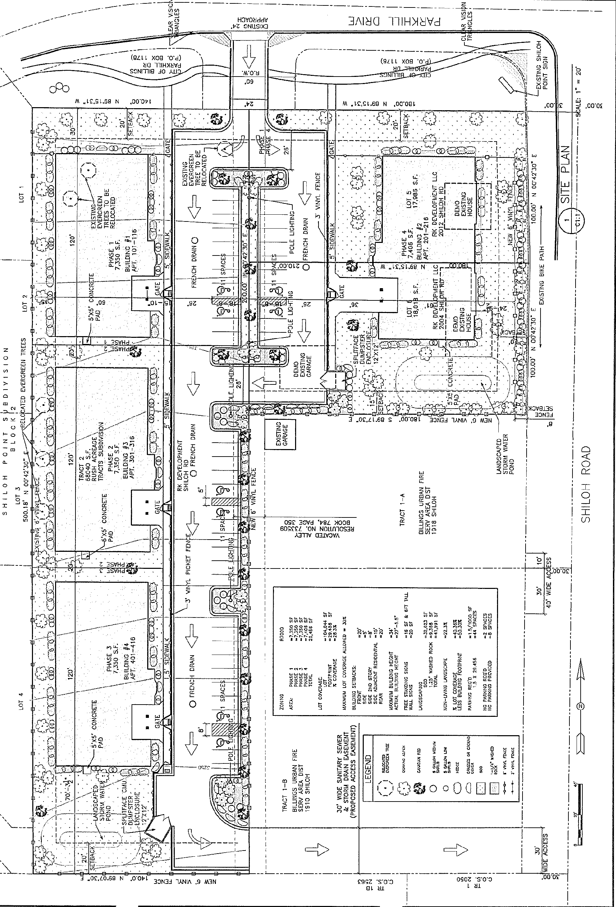

Previous Site Plan SR #885

Attachment C
Site Plan – SR #889 Tendernest Assisted Living

New Site Plan SR #889

Attachment C
Site Plan – SR #889 Tendernest Assisted Living

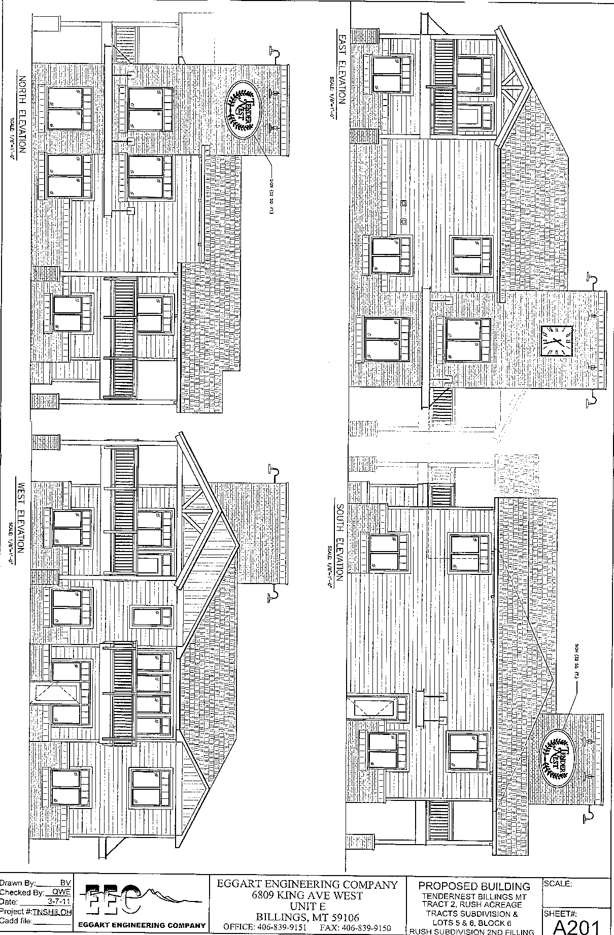

Attachment C
Site Plan – SR #889 Tendernest Assisted Living

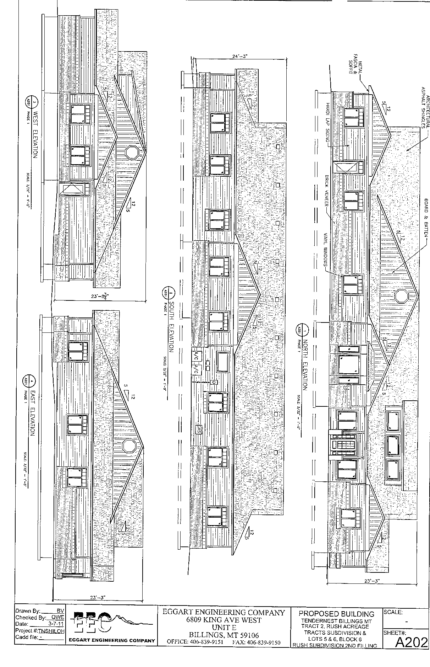

Attachment C
Site Plan – SR #889 Tendernest Assisted Living
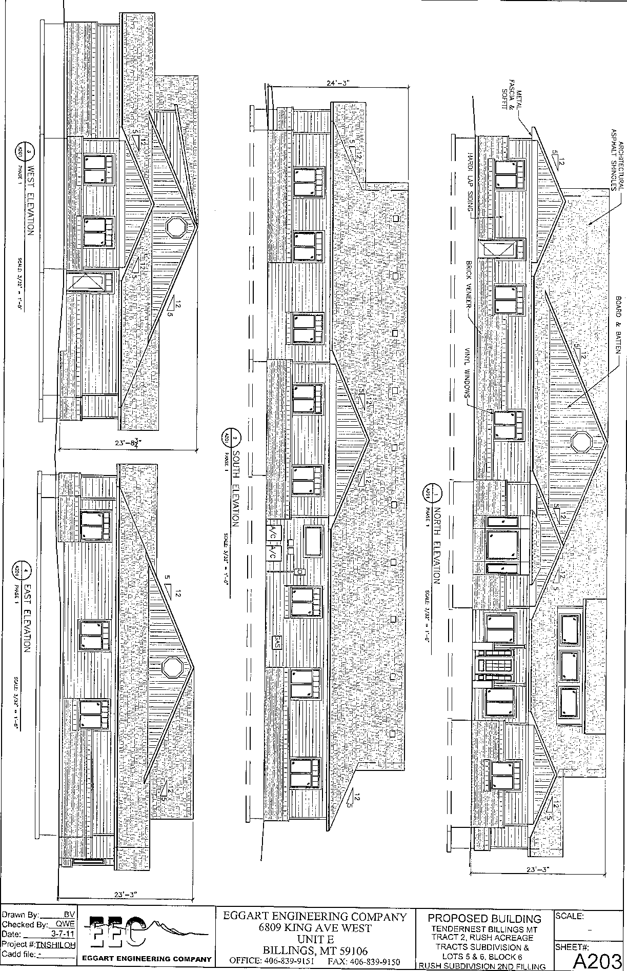

Attachment C
Site Plan – SR #889 Tendernest Assisted Living

