ATTACHMENT A
Zoning Map – ZC #876 – 519 Crow Lane
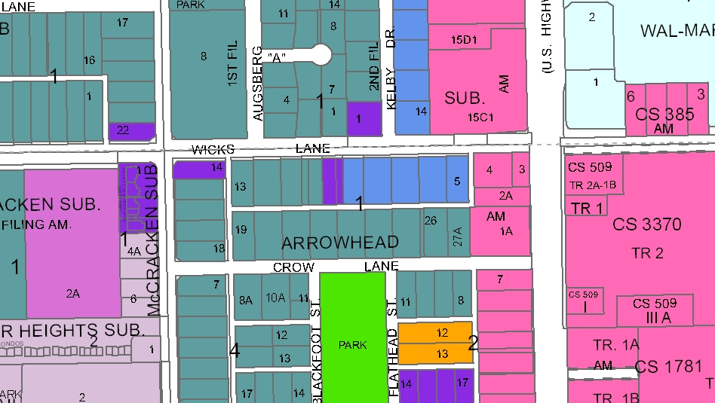
R-60
PD - CC
HC
NC
R-70
RP
RMF-R
RMF
Subject Property

