ATTACHMENT B
Site Photographs – ZC #876 – 519 Crow Lane
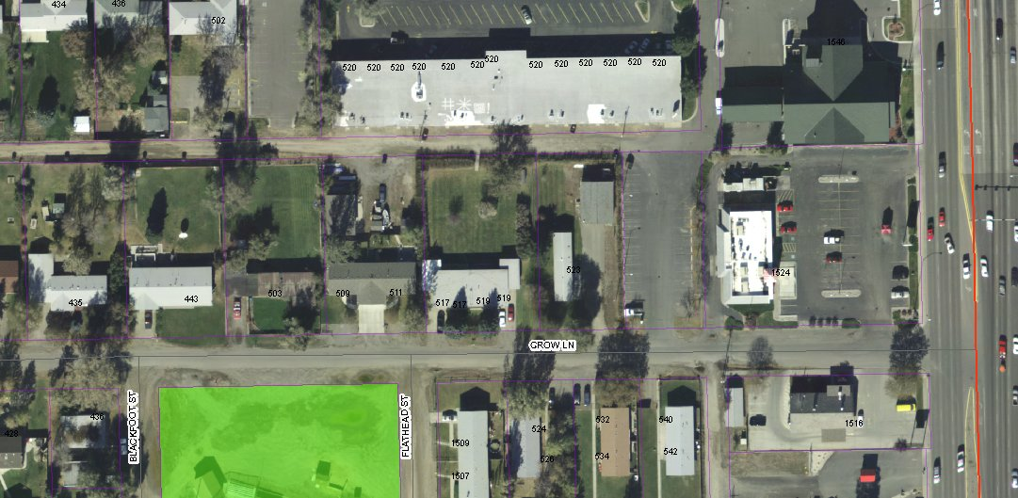

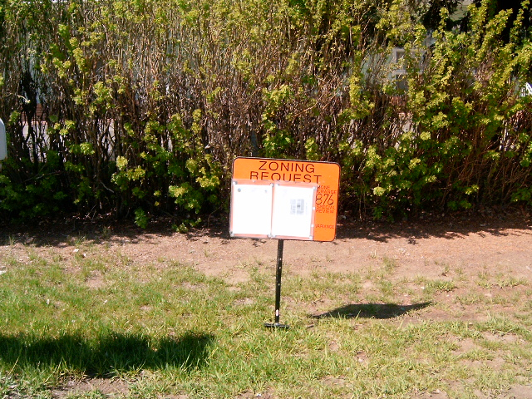
Subject Property

ATTACHMENT B, continued
Site Photographs – ZC #876 – 519 Crow Lane
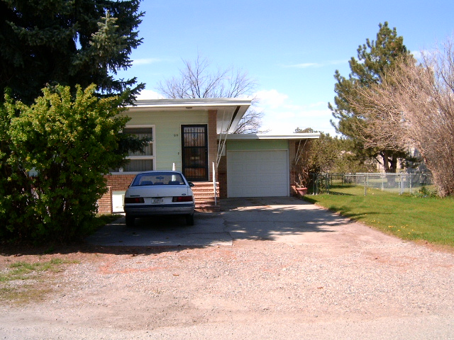
East side of Subject Property
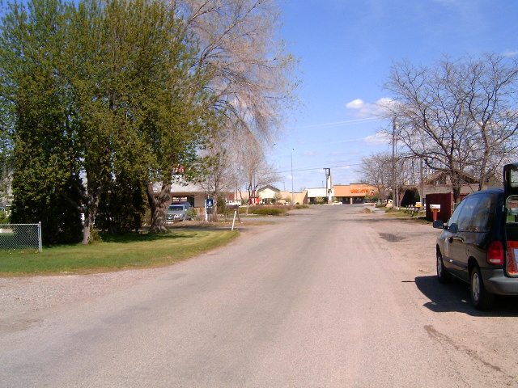
View east along Crow Lane

