
COMMUNITY DEVELOPMENT DEPARTMENT

Planning, Zoning and Building Safety

1415 Melody Lane, Bisbee, Arizona 85603 (520) 432-9240
Fax 432-9278
Carlos De La Torre, P.E., Director

MEMORANDUM

TO: Cochise County Board of Supervisors
FROM: Keith Dennis, Senior Planner
For: Carlos De La Torre, P.E., Community Development Director
SUBJECT: Docket Z-12-02 (Hodai)
DATE: March 16, 2012 for the March 27, 2012 Meeting

Application for a Rezoning (Downzoning)
Docket Z-12-01 (Hodai): The Applicant requests to downzone two parcels of land from TR-36 (Residential, 1 dwelling per 36,000 square feet) to RU-4 (Rural, 1 dwelling per 4 acres) in order to qualify for the Owner-Builder amendment to the County Building Code.

The property subject to the request (Parcel Nos. 401-37-262 and 263), which are undeveloped and unaddressed, are located generally ¼ mile East of Rancho Del Sol Road and ¾ mile South of Austin Henley Road, near Elfrida, AZ. The Applicant is Bo Hodai.

I. Planning and Zoning Commission
On Wednesday, March 14, 2012, the Planning and Zoning Commission voted unanimously (7 – 0) to recommend approval of this Docket, with the conditions recommended by staff.

II. Description of Subject Parcel and Surrounding Uses
Size: 5 Acres
Zoning: TR-36 (Residential, 1 Dwelling per 36,000 square feet)
Growth Area: Category D (Rural Growth Area)
Area Plan: None
Plan Designation: Rural
Existing Uses: Undeveloped Land
Proposed Uses: Single Family Residence and possible accessory structures
Surrounding Zoning
Relation to Subject Parcel | Zoning District | Use of Property
North | TR-36 | Undeveloped Land
South | TR-36 | Undeveloped Land
East | TR-36 | Undeveloped Land
West | TR-36 | Undeveloped Land

III. Parcel History

The property has no history of permits nor violations. The Applicant has erected a temporary structure on the property for shelter pending the outcome of the rezoning request.

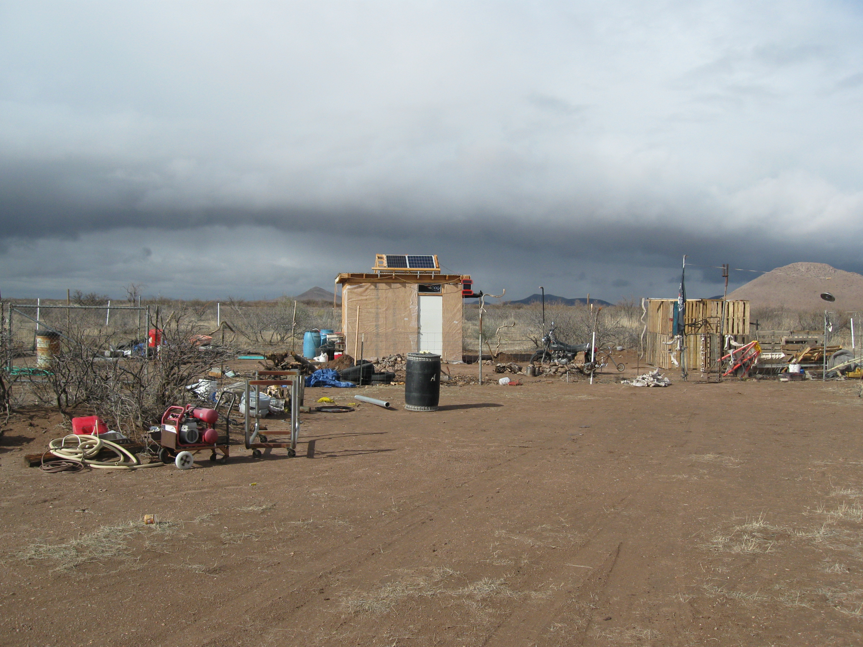
Northward view of the temporary shelter on the property.

IV. Nature of the Request

Bo Hodai, the Applicant, recently purchased two adjacent lots off Rucker Canyon Road, Northeast of Elfrida, AZ. His intention is to construct his own single-family residence on the site. He has applied to have the two parcels rezoned to RU-4, in order to qualify for the County Owner-Builder Amendments. These Amendments allow owner-builders of properties in Zoning Districts with a minimum density of one dwelling per four acres to opt out of building code inspections.

V. Analysis of Rezoning Request

Mandatory Compliance.
The subject property lies within a Category “D”—Rural Growth Area and is considered a “Rural” land use designation area. Section 402 of the County Zoning Regulations permits owners of property in such areas to request a rezoning to RU-4.

Compliance with Rezoning Criteria
Section 2208.03 of the Zoning Regulations provides fifteen (15) criteria used to evaluate rezoning requests. Ten (10) of the criteria are applicable and are listed below. The Applicant’s request complies with all ten (10) criteria.

1. Provides an Adequate Land Use/Concept Plan – Complies.
The attached Concept Plan is adequate for the proposed downzoning. A more robust site plan conforming to residential permitting requirements would be required before a residential permit could be issued. Note that Section 2208.03.B.1 does not relate specifically to what is proposed. That is, the rezoning would not facilitate a new residential subdivision development, but would facilitate residential development on one existing parcel. While the stipulation for residential rezonings is thus not applicable here, the requirements for non-residential rezonings are generally the same as what would be required for a residential building permit.

2. Compliance with the Applicable Site Development Standards - Complies.
The Applicant would be able to meet all applicable site development standards for the Rural District if the rezoning request is granted.

3. Adjacent Districts Remain Capable of Development – Complies.
The proposal would not affect the development prospects of any neighboring property.

4. Limitation on Creation of Nonconforming Uses – Complies .
The proposal would not create any potential for non-conforming uses. The Applicant proposes uses that are permitted within the current and proposed Districts, and can meet all development standards.

5. Compatibility with Existing Development – Complies.

The property is situated in an area that is almost totally undeveloped. The nearest residence is ¾ mile to the Southwest; the next nearest residence is approximately 1.5 miles to the East.

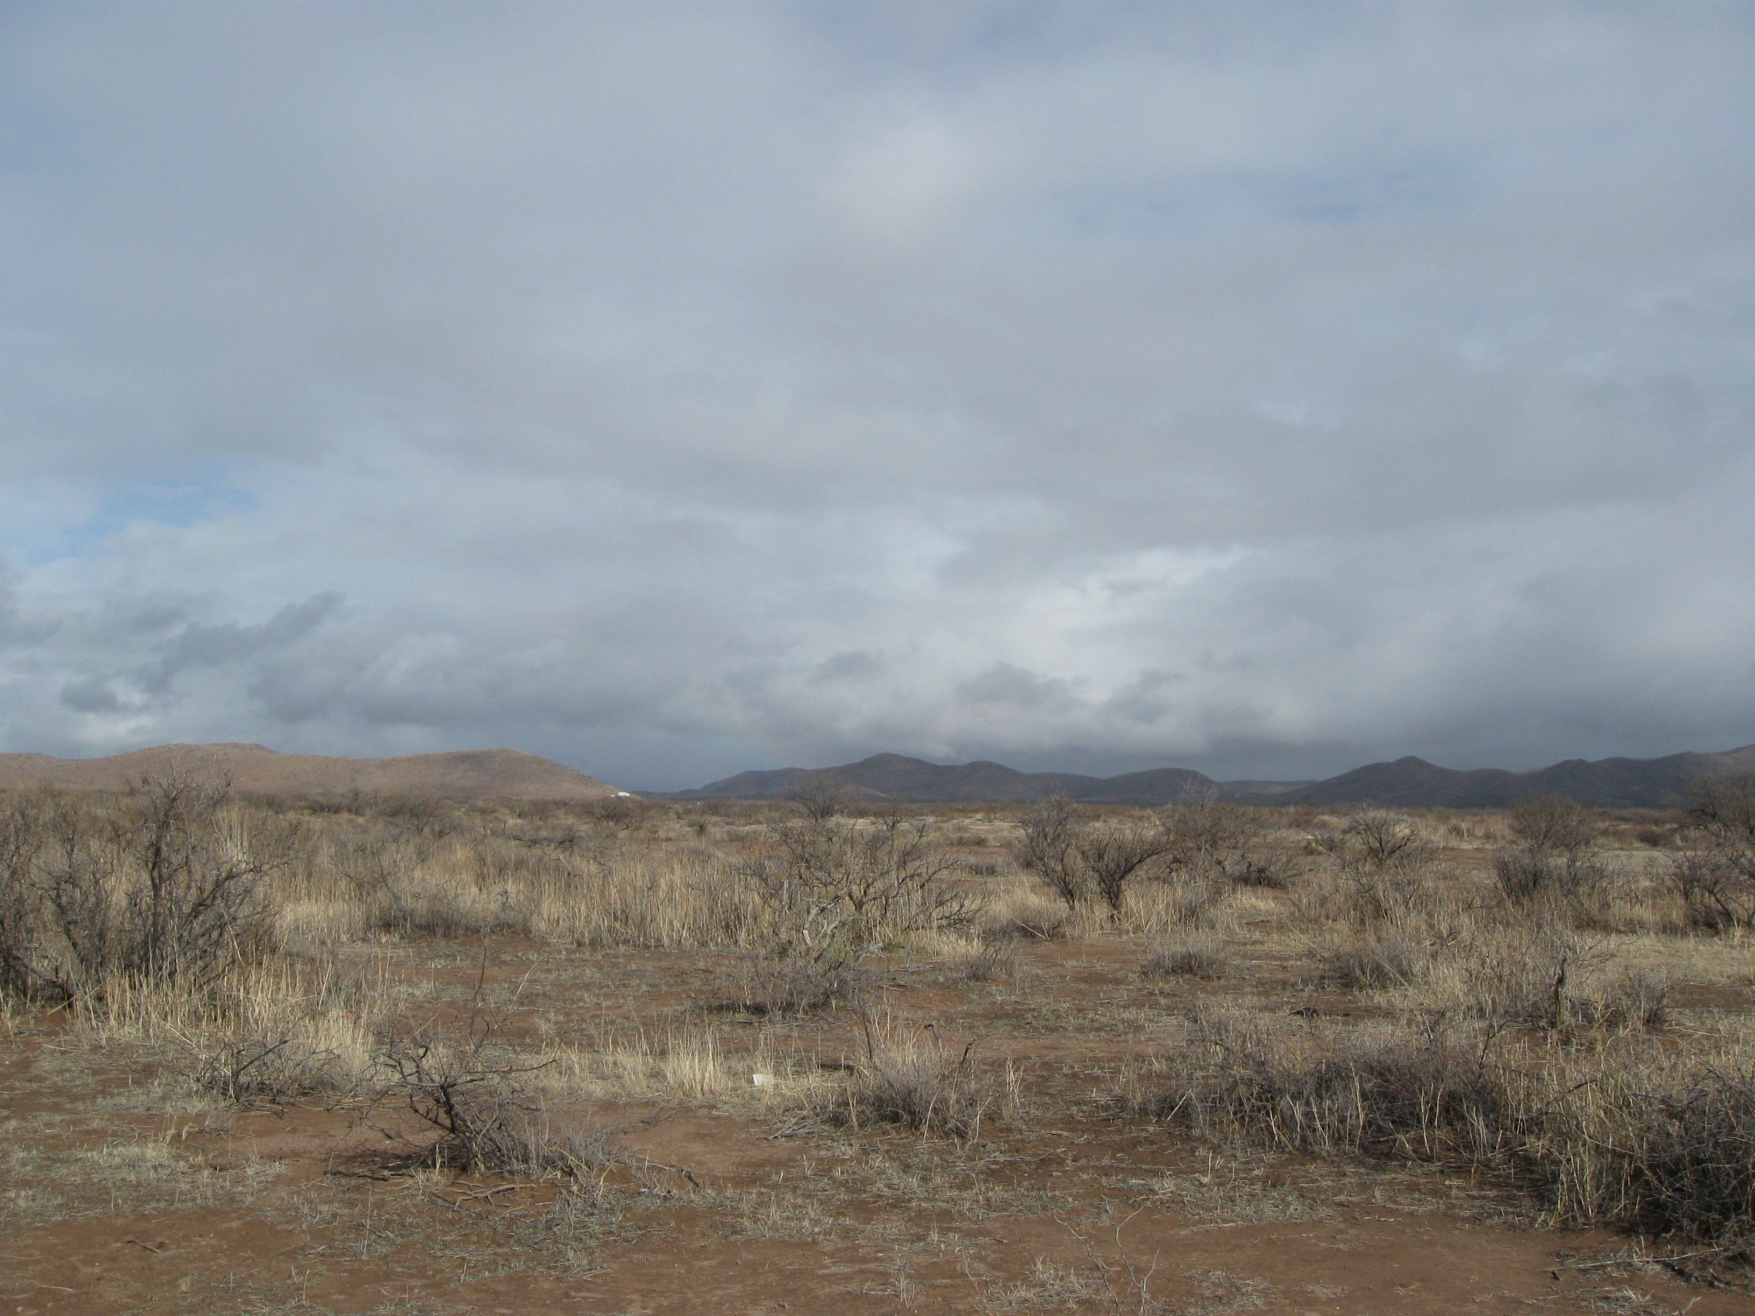
View to the East from the property. A residence can be seen in the distance, approximately 1.5 miles away.

6. Rezoning to More Intense Districts - Not Applicable.
As discussed, the proposal is for a less-intense Zoning District. Under the TR-36 standard, five homes could be built on the property; RU-4 would allow for one home on the same property.

7. Adequate Services and Infrastructure – Complies.
The home would be served by an on-site well and septic system. SSVEC would provide electric power and the property is within the Elfrida Fire District. The Applicant indicates that upon rezoning the property, the intent is to obtain a residential building permit, thereby qualifying him to obtain an address for the property. This would facilitate the provision of utilities and services to the site.

8. Traffic Circulation Criteria – Complies.
The proposal would result in development considered within the capacity of the transportation network to handle. The property is reached via primitive ranch roads beginning at Rucker Canyon Road.

9. Development Along Major Streets – Not Applicable.

The property is not within the vicinity of any major thoroughfare.

10. Infill - Not Applicable.

The Applicant does not propose a rezoning to GB, LI or HI.

11. Unique Topographic Features – Not Applicable.
This Factor only applies to rezonings to more intense districts, and not to downzonings.

12. Water Conservation - Not Applicable.
This criterion is applicable only to rezonings associated with Master Development Plans.

13. Public Input – Complies.
The Department sent the required notice to neighboring property owners within 1,500 feet, posted the property as required, and published a legal notice on February 16, 2012. To date, staff has received two letters of support from neighboring property owners (one of which was conditioned upon no concentrated animal feedlots being built on the property), and two letters opposing the request.

Note: because the request is for a downzoning, no Citizen Review process was required for this Docket.

14. Hazardous Materials – Not Applicable.
No hazardous materials are proposed for this site.

15. Compliance with Area Plan – Not Applicable
The property is not within the boundary of any area plan.

VI. Summary
Factors in Favor of Approval

- The rezoning, if granted, would allow for rural residential development in keeping with the rural, remote nature of the area.

- Two neighboring property owner have expressed support for the proposal;

- On March 14, 2012, the Planning and Zoning Commission unanimously recommended conditional approval of this Docket.

Factor Against Approval

- Two neighboring property owners have expressed opposition to the proposal.

VII. Recommendation
Based on the Factors in Favor of Approval, staff recommends that the Board of Supervisors conditionally approve Docket Z-12-01, subject to the following conditions:

- The Applicant shall provide the County with a signed Acceptance of Conditions and a Waiver of Claims form arising from ARS Section 12-1134 signed by the property owner of the subject property within thirty (30) days of Board of Supervisors approval of the rezoning; and

- It is the Applicant’s responsibility to obtain any additional permits, or meet any additional conditions, that may be applicable to the proposed use pursuant to other federal, state, or local laws or regulations.

VIII. Attachments
A. Rezoning Application
B. Concept Plan
C. Location Map
D. Public Comment

