
COMMUNITY DEVELOPMENT DEPARTMENT

Planning, Zoning and Building Safety

1415 Melody Lane, Bisbee, Arizona 85603 (520) 432-9240
Fax 432-9278
Carlos De La Torre, P.E., Director

MEMORANDUM

TO: BOARD OF SUPERVISORS
For: Michael Ortega, County Administrator

FROM: Beverly Wilson, Senior Planner
For: Carlos De La Torre, Community Development Director

SUBJECT: Bachmann Springs Plat Abandonment Docket S-05-13

DATE: March 28, 2012 for April 10, 2012 Board of Supervisors Meeting

NATURE OF THE REQUEST

This is a request, initiated by Staff, asking the Board of Supervisors to formally abandon the Bachmann Springs Subdivision Final Plat (FP) including the Assurance Agreement and the Final Plan. It is the finalizing step in a process begun on June 29, 2010, when the Board of Supervisors denied a request from the Developer for a time extension of a project that began in the late 1990’s. With the unanimous denial from the Board for a 3-year time extension for Dockets CP-22-04 and Z-99-12, Parcels 108-20-001, 007, 008A, 008C, 008D and 008F, 121-15-034A, 035 and 036 and 121-47-001, located at 2738 N. Middlemarch Road in Tombstone, AZ, were reverted from a Category "C" Comprehensive Plan Growth Area to a Category "D" Comprehensive Plan Growth Area, from a "Developing" Comprehensive Plan land use designation to a "Rural" Comprehensive Plan land use designation, and from a "Planned Development–PD" Zoning District designation to a "Rural–RU-4" Zoning District designation. The abandonment of the subdivision plat will correct the Assessor’s maps of Cochise County to reflect the original configuration of the parcels by deleting the lot lines.

HISTORY OF THE PROJECT

The Bachmann Springs Master Development Plan was approved on May 1, 2000 by the Board of Supervisors, and included a proposed Resort Community consisting of 1,709.43-acres. A Final Plan was also recorded in Book 14 of Maps, page 66A, which divided the parcels into ‘Tracts’, and Common Areas. The MDP included a 322-acre golf course, 1,125 custom home sites, 400 Hospitality rooms, and 74-acres of open space. The density of this development was 0.66 dwelling units per acre, with the golf course and the 120-lot subdivision planned as Phase 1. The original MDP was conditionally approved to include time frames for completion, along with definitive repercussions as stated in Condition #1:

- “If there is no substantial progress towards completion of Phase 1 as described in the MDP, within 48 months of final approval, then the rezoning will revert to RU-4 and all subsequent approvals, modification and conditions will be null and void.”

On December 16, 2003, a time extension request was approved by the Board, changing the original condition as follows:

- If there is no substantial progress towards completion of Phase 1 as described in the MDP, by May 1, 2008, then the rezoning will revert to RU-4 and all subsequent approvals, modifications and conditions will be null and void.”

In addition, three building permit applications were issued, including a permit for the golf course (expired 3/2/09), the comfort station and pump house (expired 4/23/09) and a manufactured home (expired 10/23/07). Our records also indicate that there are two voided permits for a septic system (voided 11/9/09) and a change of use for a laundry and break room (voided 11/9/09).

At some point, the golf course was installed, including irrigation from the on-site wells; however, the Bachmann Springs Subdivision, Phase 1 was not started, and no evidence of roadways, lot lines, or infrastructure exists (See photos below).

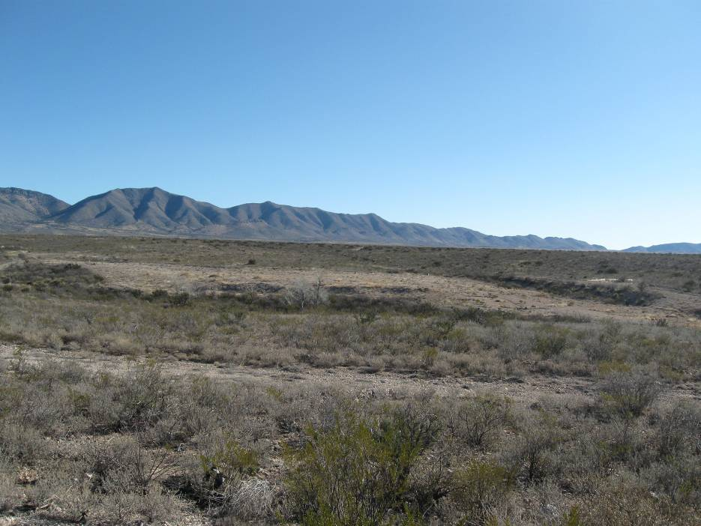
Remnants of the golf course.

In 2010, the successor to the developer requested an extension of the Assurance Agreement. Due to lack of progress on the development, the Board denied the request, reverted the zoning to RU-4 and reverted the Comprehensive Plan designation to Category “D” Developing Land Use. As a result, the parcels no longer can be developed in accordance with the Final Plat. Pursuant to the Assurance Agreement, the County is entitled to abandon the Plat by replatting the parcels to the state in which they existed before the Plat was recorded.

This 120-lot subdivision FP was recorded on July 24, 2007, along with the Assurance Agreement, which is the contractual document that guarantees that all improvements will be completed prior to the lots being released for sale. The Assurance Agreement was recorded by Fee No. 070724528. Currently, this FP exists only on the Assessor Maps and the lots are unbuildable because they are well under the 4-acre minimum required for building in the RU-4 Zoning District. Additionally, tax liens have been sold on these ‘paper’ parcels—a matter that will be corrected by the Treasurer’s Office when the ‘Abandonment Plat’, returning the subject parcels to their pre-development status, is recorded. As mentioned above, the improvements for the Subdivision have not been undertaken in accordance with the assurance agreement, thereby leading to this request to abandon the plat.

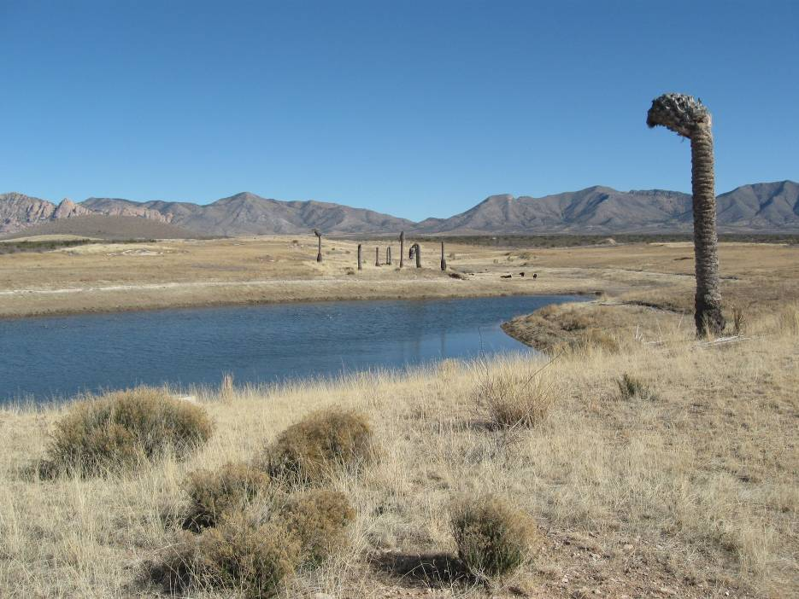
Existing pond and the remains of a golf course.

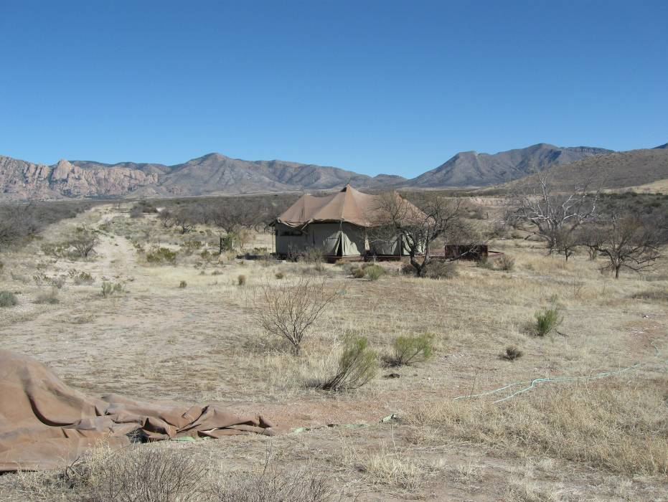
Remnants of the Comfort Station—photos were taken in February of 2012.

The Subdivision Plat was recorded after the Final Plan (mentioned above), but did not extinguish some of the ‘Block’ lines. The proposed Abandonment Plat consists of three sheets which will extinguish all Blocks, designated lot lines, proposed roadways and common areas. It will abandon the Final Plan as recorded in Book 14 of Maps at page 66A, and the subdivision as originally recorded in Book 15 of Maps at page 80 A – 80 J, Office of the Cochise County Recorder.

After the plat has been abandoned, the property owner is entitled per State law to again subdivide the property and sell no more than five parcels without a subdivision review by the County.

RECOMMENDATION

Staff recommends that the Board of Supervisors approve the plat abandonment of the Bachmann Springs, Phase 1 Subdivision Plat and authorize the Chairman to sign the Resolution and Abandonment Plat for recordation.

ATTACHMENTS: As You Are Aware Letters dated 5.2.00; 12.18.03; 7.2.10
Assurance Agreement

