
COMMUNITY DEVELOPMENT DEPARTMENT

1415 Melody Lane, Bisbee, Arizona 85603 (520) 432-9240
Fax 432-9278
Carlos De La Torre, P.E., Director

MEMORANDUM

TO: Cochise County Planning and Zoning Commission
FROM: Keith Dennis, Senior Planner
For: Carlos De La Torre, P.E., Planning Director
SUBJECT: Docket Z-12-04 (Doberstein)
DATE: April 12, 2012, for the April 24, 2012 Meeting

Application For A Rezoning
Docket Z-12-04 (Doberstein): The Applicant obtained a Special Use Permit in 2010 for manufacturing in an RU District (Docket SU-10-05). That Special Use carried a maximum of 5,000 square-feet of operating area. The Applicant now seeks to expand his operation beyond the maximum allowed for the approved Special Use in the RU District, and so requests to rezone the 5-acre property to HI (Heavy Industry). The subject parcel (305-73-020B) is located at 3911 E. Shelton Road in Kansas Settlement, AZ. The Applicant is Daniel Doberstein of DRD Fabricating.

Note: this Docket appears on the Board Consent Agenda because, per Section 2206.09 of the Zoning Regulations, a rezoning request may so appear if no public protest was registered prior to the initial public hearing before the Planning Commission.

I. Planning and Zoning Commission
On April 12, 2012, the Planning Commission voted unanimously (7 – 0) to forward this Docket to the Board of Supervisors with a recommendation of conditional approval. This recommendation includes the approval conditions recommended by staff, as well as the approval of a setback modification, as the principal structure on the property would be rendered non-conforming as a result of the increased HI setbacks.

II. Description of Subject Parcel and Surrounding Uses
Size: 30.04 Acres
Zoning: RU-4 (Rural – 1 dwelling per 4 acres)
Growth Category: D (Rural)
Plan Designation: Rural
Area Plan: None Applicable
Existing Uses: Metal Fabricating Business
Proposed Uses: Unchanged; the Applicant intends to expand existing business as described above.
Surrounding Zoning
Relation to Subject Parcel | Zoning District | Use of Property
North | RU-4 | Undeveloped Land
South | RU-4 | Undeveloped Land
East | RU-4 | Undeveloped Land, Rural Residential
West | RU-4 | Agricultural

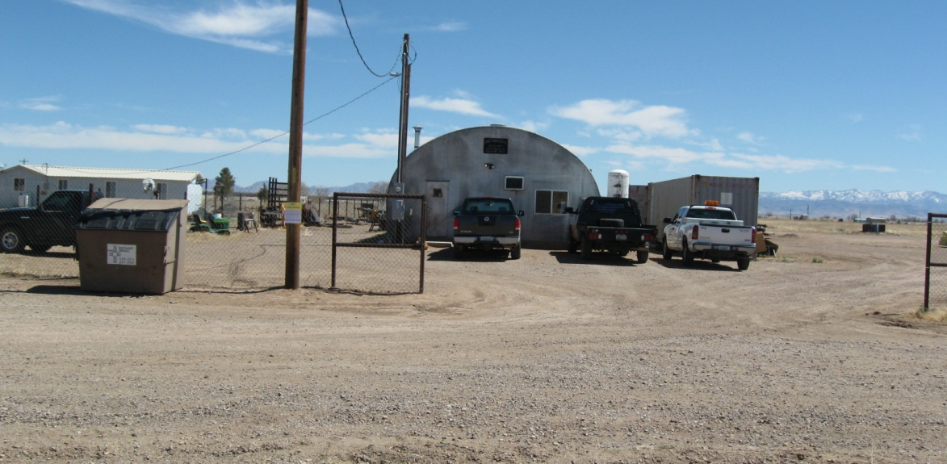

Eastward view of the DRD Fabricating shop.

III. Parcel History (See Condition #2)
There are no violations, code enforcement actions or permits currently associated with the property. Assessor's records show a 1,120 square foot house built in 1953, an 820 square foot "bunk house" built in 1954, and a 1,297 square foot Quonset building constructed in 1980.

In April 2010, the Applicant applied for and received Special Use approval from the Planning Commission authorizing manufacturing in an RU-4 District. At the time, the current Applicant, Daniel Doberstein, was renting the structures from Jonathan Schmidt, who was the owner of Parcel 305-73-020. The then 30-acre property also included a farmhouse. As part of the Special Use approval, the Applicant was required to obtain a commercial permit for the business, but this has yet to take place. Condition #2 would require the Applicant to file for a commercial permit within six months of Board of Supervisors approval.

In October of that year, the Applicant purchased a five-acre portion of Parcel 305-73-020, which included the structures and yard for DRD Fabricating. This parcel, 305-73-020B, is subject to the current rezoning request.

IV. Project Description
The Applicant, Daniel Doberstein of DRD Fabricating, operates a small-scale metal fabrication and welding business on the subject property. The business' clientele includes local farmers and ranchers who require fabricated metal replacement blades and other parts for farm equipment. The business also performs some work for the Border Patrol, welding fuel and water tanks onto one-axle trailers. In addition, Mr. Doberstein has seen an increase in business from local mining interests, as mining activity in the area has increased significantly in recent years. The increase in activity has prompted him to seek to expand the business. Manufacturing is allowed as a Special Use in the RU District, provided that the total activity area does not to exceed 5,000 square feet. The Applicant has decided that 5,000 square feet of operating area (which includes outdoor storage) is not sufficient, hence this request.

V. Analysis of Impacts
Section 2208.03.A of the Cochise County Zoning Regulations lists fifteen (15) factors used to evaluate the appropriateness of a rezoning application. Staff utilizes these factors in formulating a recommendation, including conditions under which a recommendation of approval is appropriate. The Planning and Zoning Commission and the Board of Supervisors will also consider these in deciding whether to approve or deny a rezoning. For most rezoning Dockets, there will be factors in favor and against the request, and some individual factors may weigh more heavily than others. As stated in Section 2208.03B of the Zoning Regulations, "No set of factors, however, can totally determine the acceptability of all land use proposals. For example, a property owner who adequately demonstrates compliance with the intent of Comprehensive Plan goals and policies may be able to receive approval in spite of non-compliance with any individual factor. Conversely, a determination that unusual circumstances exist or there is great public protest pertaining to a rezoning request may result in a denial even though the rezoning appears to comply with other factors." Thirteen of the 15 factors are applicable to the rezoning request, and with the recommended conditions and one waiver, the request would comply with 12 of these factors.

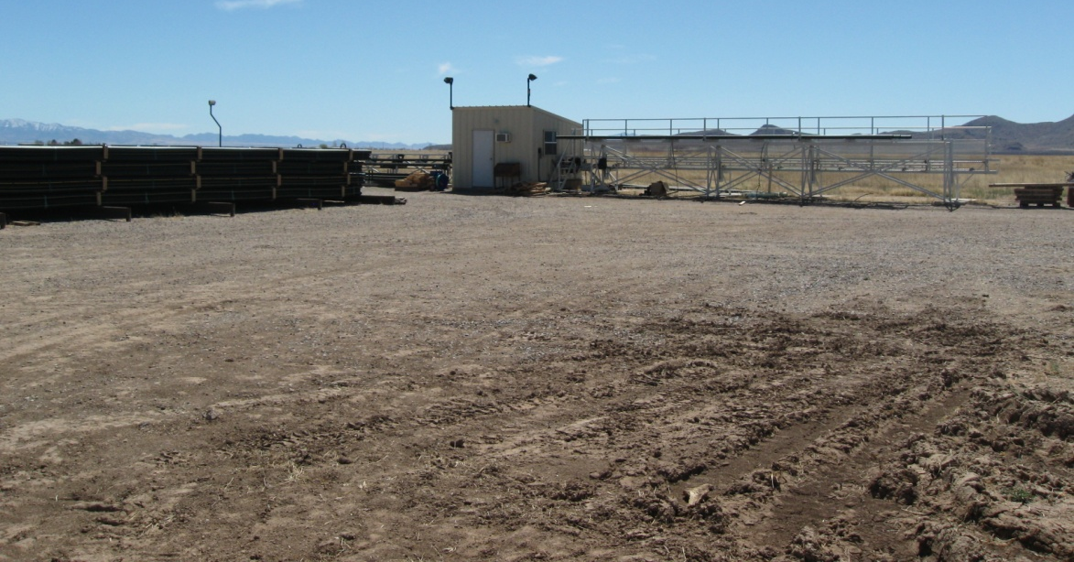
Southeast view of native-surfaced yard with outdoor storage.

Mandatory Compliance
The subject property lies within a Category D—Rural land use designation area. Section 402 of the County Zoning Regulations permits owners of property lying within “Rural” land use areas to request a rezoning to HI. Initially a rezoning to Light Industry was discussed, as this would allow for the proposed use as a permitted principal use. However, Section 402 of the Zoning Regulations does not allow rezonings to LI in a Rural Comprehensive Plan Designation area, and the Applicant has instead asked for a rezoning to Heavy Industry (HI).

1. Provides an Adequate Land Use/Concept Plan. — Complies
The Applicant has provided what staff considers a strong concept plan for the request. In any subsequent commercial permitting phase, a site plan meeting commercial permit standards would be required.
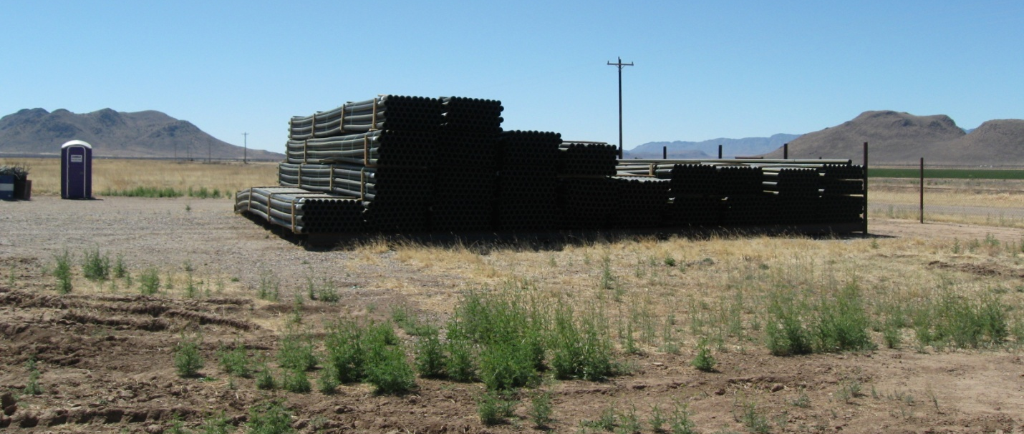
Looking South at outdoor storage area.

2. Compliance with Applicable Site Development Standards. — Complies with Waiver
This parcel is capable of complying with most site development standards for commercial use as required for setbacks, site coverage, distance between structures, glare, noise, odors, landscaping, parking, and nuisance. There is one unavoidable deficiency, however, which is the location of the existing structures relative to the North property line. If the property is rezoned, the new setback would be 100 feet from property lines and 20 feet from road travelways. The existing shop would be within the 100 foot setback. The Applicant has asked that the shop be legitimized in its current location.

3. Adjacent Districts Remain Capable of Development.— Complies

The proposal is intended to facilitate the expansion of an existing, light industrial business. It is essentially surrounded by agricultural land, and is in close proximity to the Faria Dairy operation to the immediate Northwest, another business which operates under HI zoning. The zoning change would not affect the development potential of neighboring properties.
4. Limitation on Creation of Nonconforming Uses. — Complies
This rezoning will not result in non-conforming uses. It will, rather, take what is now allowed by Special Use under certain size restrictions, and make the use a permitted principal use with no restrictions on size.
5. Compatibility with Existing Development. — Complies
The business has existed at this location for approximately six years and is considered compatible with the character of development in the area.

6. Rezonings to More Intense Districts. — Complies
The property is already home to an industrial land use; a large HI District (the Faria Dairy) lies 300 feet away from the property. Staff considers the project site as a reasonable extension of this existing industrial district.

7. Adequate Services and Infrastructure. — Complies

As proposed, rezoning this parcel to accommodate the business expansion will not create a significantly higher traffic volume as analyzed by the County Transportation Planner. As an agricultural resource production area, the road network is already accustomed to traffic from larger vehicles.

There is adequate existing infrastructure to support the commercial use of this parcel. The property is served by a well-share from the adjacent parent parcel, and has a private sanitary sewer system. SSVEC provides electricity, and the property is within the Willcox Rural Fire District.

8. Traffic Circulation Criteria. — Complies

The change to an HI Zoning District would not burden the existing transportation infrastructure, nor will it result in any traffic through residential areas.

9. Development along Major Street. — Complies

This proposal does not include new access points to any major street. The concept plan does, however, propose two additional curb cuts along Alamo Lane.

10. Infill.— Does Not Comply
Compliance with this factor is described in Section 2208.B.7 as follows: “If rezoning to GB, LI, or HI, the site is in an existing Enterprise or Enterprise Redevelopment plan designation area.” The property is instead within a Rural plan designation area.
11. Unique Topographic Features.— Not Applicable

12. Water Conservation. — Complies

Compliance with this factor is determined by compliance with Section 102E of the Comprehensive Plan (Water Conservation Goal and Policies). The property is served by a metered well-share originating from the parent parcel, of which the project site was formerly a part. The land use already uses minimal water, particularly relative to the agricultural and feedlot uses in the immediate vicinity. Having been historically used for agricultural-related activities, the property was cleared of large vegetation decades ago. The use of gravel surfacing rather than paved surfacing on what is currently a native surfaced property will mean that runoff issues would be improved though the commercial permitting process.

13. Public Input — Complies

The Applicant conducted a Citizen Review, and received no correspondence. At the time of this memorandum, the Department has received no communication regarding this proposal.

14. Hazardous Materials. — Not applicable (See Condition #3)

Although the proposal is a rezoning to a Heavy Industry District, the purpose is to expand an existing metal fabrication/machine shop. No hazardous materials are utilized as part of the business. Should this change, the Applicant would be responsible for compliance with any applicable permit requirements or hazardous material-related conditions as may be applicable pursuant to local, state, or federal regulations (see Condition #3).

15. Compliance with Applicable Area Plan, Master Development Plan or Comprehensive Plan Policies. — Complies. Both the Category D Growth Area description and the Rural Plan Comprehensive Plan Designation specify these areas as appropriate for industrial development.
VI. Public Comment

The Department mailed notices to neighboring property owners within one mile. Staff posted the property on March 21, 2012, and published a legal notice in the Bisbee Observer on March 22, 2012. To date, staff has received no input from neighbors regarding the proposal.

VII. Summary and Conclusion

Factors in Favor of Allowing the Rezoning

- The proposal comes as a result of the success of a business providing valuable machine tool services to area agricultural, law enforcement, and mining sectors of the local economy;

- The project site is within close proximity to an existing HI District;

The proposal would comply with the applicable Comprehensive Plan Growth Category and Plan Designation policy guidelines;

- Rezoning to Hi to facilitate business expansion would not generate a significant increase in traffic;

- With the conditions of approval recommended by staff, the project would comply with 12 of the 13 applicable rezoning evaluation factors; and

- One neighboring property owner supports the request.

Factors Against Approval

None Apparent.

VIII. Recommendations
Based on the factors in favor of approval, staff recommends conditional approval of the rezoning request.

Sample Motion: Mr. Chair, I move to approve Docket Z-12-04, based on the Factors in Favor of approval as the Findings of Fact, with the conditions of approval recommended in the staff memorandum, and the setback modification as requested by the Applicant.

Recommended Conditions of Approval:

- The Applicant shall provide the County with a signed Acceptance of Conditions and a Waiver of Claims form arising from ARS Section 12-1134 signed by the property owner within thirty (30) days of Board of Supervisors approval of the rezoning or the approval of the rezoning may be deemed void;

- Within six months of Board of Supervisors approval of the rezoning, the Applicant shall apply for a commercial permit for the existing and/or expanded operation; and

- It is the Applicant’s responsibility to provide a revised site plan in conformance with all site development standards except as waived, to obtain any additional permits, or meet any additional conditions that may be applicable to the proposed use pursuant to other federal, state, or local laws or regulations.

IX. Waiver Request
The Applicant requests that the existing structures on the property be allowed to remain in their current location, modifying the 100-foot setback required for principal uses in the HI District.

X. Attachments
- Rezoning Application
- Location Map
- Concept Plan
- Citizen Review and Public Comment

