
COMMUNITY DEVELOPMENT DEPARTMENT

Planning, Zoning and Building Safety

1415 Melody Lane, Bisbee, Arizona 85603 (520) 432-9240
Fax 432-9278
Carlos De La Torre, P.E., Director

MEMORANDUM

TO: Cochise County Board of Supervisors
FROM: Beverly Wilson, Senior Planner
For: Carlos De La Torre, P.E., Director of Community Development
SUBJECT: Dockets Z-12-03 (Miles)
DATE: April 12, 2012 for the April 24, 2012 Meeting

application for a rezoning
This is a request from Marshall Miles, the owner of GM Propane, to rezone a parcel of land from R-36 (Residential, one dwelling per 36,000 square feet) to RU-2 (Rural, one dwelling per 2-acres). The subject parcel (#202-26-006A) is located at 1551 West Archery Lane, northwest of the City of Willcox.

i. planning and zoning commission actions
On April 11, 2012, the Planning and Zoning Commission voted (8-0) to forward this Docket to the Board, with a recommendation of conditional approval. The Commission recommendation included waiver requests for screening and landscape requirements and a modification of driveway and parking lot surface requirements to allow 2” gravel instead of a double bituminous surface treatment. In addition, the Commission recommended the following conditions of approval, as recommended by Staff:

- The Applicant shall provide the County with a signed Acceptance of Conditions and a Waiver of Claims form arising from ARS Section 12-1134 signed by the property owner of the subject property within thirty (30) days of Board of Supervisors approval of the rezoning or the approval of the rezoning may be deemed void;

- It is the Applicant’s responsibility to submit a revised site plan showing the correct parking stalls with a Building/Use permit application within 30 days of approval. The application will include a completed joint permit application, a Right-of-Way permit application, and a Land Clearing Permit. The Applicant will work with the Health Department and the Highway/Floodplain Department to meet all requirements and dedicate to the County 33-ft. of Joe Hines Road. A permit must be issued within 12 months of the rezoning/special use approval, otherwise these approvals may be deemed void upon a 30-day notice to the applicant; and

- The Applicant must obtain any additional permits, or meet any additional conditions, that may be applicable to the proposed use pursuant to other federal, state, or local laws or regulations.

ii. description of subject parcel and surrounding uses
Size: 4.52-acres (196,701.63 square feet)
Existing Zoning: TR-36
Proposed Zoning: RU-2
Growth Area: Category B – Community Growth Area
Plan Designation: Developing
Existing Use: Propane distribution company (GM Propane)
Proposed Use: Adding propane storage facility to the propane distribution company
Surrounding Zoning
Relation to Subject Parcel | Zoning District | Use of Property
North | TR-36 | Undeveloped
South | TR-36 | Residential
East | TR-36 | Residential
West | TR-36 | Residential

iii. parcel history
February 13, 1990–Permit issued for an 18’ by 80’ mobile home, 9’–10’ tall.

There are no permits issued for the 30’x70’ metal building on site, or for the commercial business - GM Propane.

iv. nature of the rezoning request
The Applicant states that he is seeking to legitimize an existing business (GM Propane) and to add a large propane storage tank to the site. ‘Wholesaling, warehousing, distribution or storage of propane’ is allowed with Special Use Authorization in the Rural Zoning District; however, it is not allowed in the current Zoning District of R-36. Therefore, to legitimize the existing business, the parcel must be rezoned and a Special Use authorization obtained.
v. analysis of rezoning impacts
§ 2208.03.A of the Cochise County Zoning Regulations lists fifteen (15) factors used to evaluate the appropriateness of a rezoning application. The Planning and Zoning Commission and the Board of Supervisors shall consider these in deciding whether to approve or deny a rezoning. Twelve of the fifteen factors are applicable to this rezoning request, and the request complies with all of the applicable factors (one with conditions and waivers).
Mandatory Compliance
The subject property is located in a Growth Category B - Developing area, which is described in §404.03 of the Cochise County Zoning Regulations as follows:

"Lands that are developed with scattered, mixed residential, business or industrial and agriculture-related uses and that ultimately will accommodate future growth, as the more populated areas reach build-out."

Rezoning to RU-2 is permitted in a Developing Plan Designation under §402 of the Cochise County Zoning Regulations. Although the current zoning is Residential, at this time, the character of the surrounding neighborhood is more rural in character; as such, this is a reasonable request with regard to the Comprehensive Plan and Zoning Regulations.

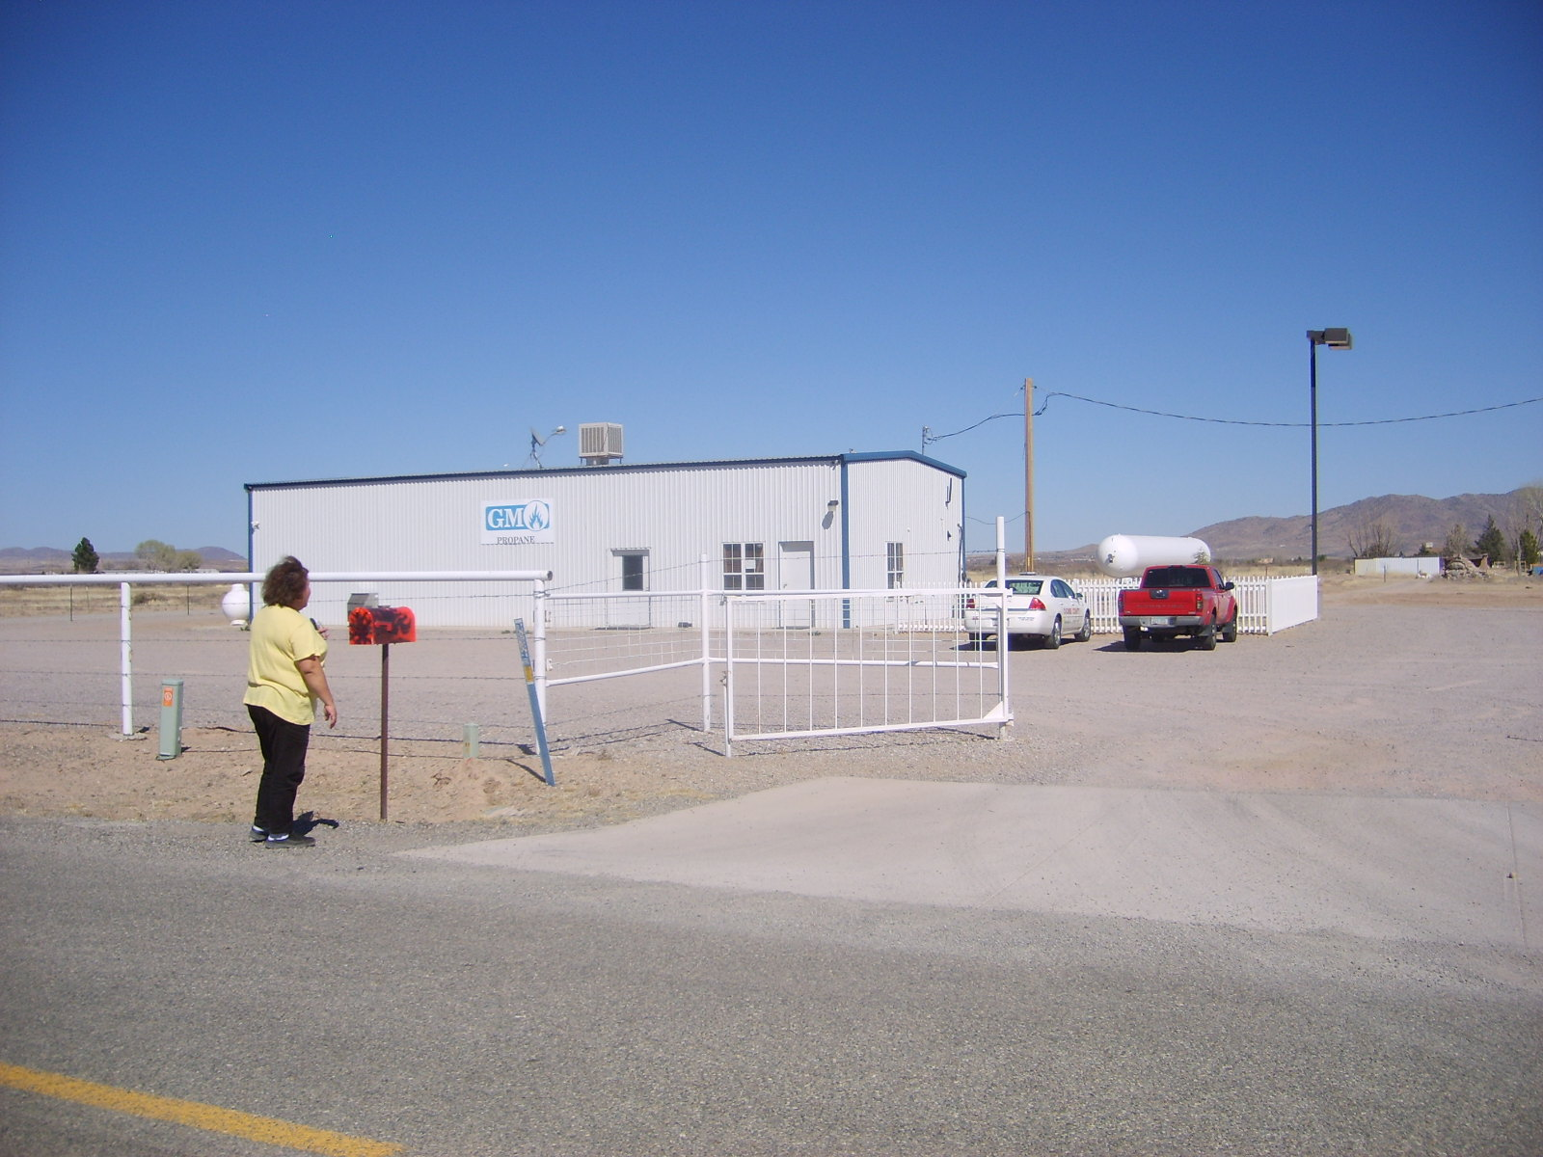
GM Propane is located in this large metal building on the east side of Joe Hines Road.

1. Provides an Adequate Land Use/Concept Plan: Complies
For a non-residential application, §2208.03B1 of the Zoning Regulations requires a land use/concept plan for a non-residential use which shows:

“The general location, size and height of all structures, location, surface and width of driveways, general location and number of parking spaces, setbacks, proposed screening and landscaping and any significant topographical features such as washes, wetlands, cultural, archaeological or historical sites, hills, and rock outcroppings.”

This application includes a concept plan (See Attachment B) which depicts the required elements as stated above. The concept plan is in conformance with all but three site development standards (discussed below) for the RU-2 district and is sufficient to review the Special Use as proposed. The Applicant has requested a waiver from the screening, landscape, and parking surface requirements as described below (See Attachment C). The Applicant also included two additional detailed plans showing the traffic circulation plan for a new 56-foot long propane storage tank, as well as critical details of the tank installation, including emergency shut-off switches.

2. Compliance with Applicable Site Development Standards: Complies with Conditions and Waivers

This 4.52-acre parcel is of a size and configuration that will allow compliance with most of the applicable site development standards for the proposed RU-2 district when used as a commercial site. Standards not currently in minimum compliance will become so with the requested conditions and waivers, as shown below. Articles 6 and 18 of the Zoning Regulations require the following development standards:

Setbacks: Special Uses require at least double the minimum setback of the district in which the Use is located. The RU-2 district’s minimum setback is 20-feet; therefore, the required minimum setback would be 40-feet; the concept plan indicates that the Applicant complies with this requirement.

Maximum height: The building, at 14-feet, 9-inches tall, is well under the 30-foot maximum allowed.

Maximum site coverage: The maximum site coverage allowed in the RU Zoning District is 25%. The site consists of 196,701.63 square feet. The building is 2,100 square feet, well within the limits of coverage.

Screening: §604.06 of the Zoning Regulations states: “In Category B Growth Areas, whenever a non-residential use abuts a residential zoning district, the developed area of the non-residential site shall be screened with a 6-foot high solid screen.” The Applicant has asked for a waiver of this standard as he has operated the business since 1999 without screening. A 6-foot high screen around the perimeter of the site would not sufficiently screen the business due to the large size of the lot (See Attachment C).

Off-street parking: §1804 of the Zoning Regulations addresses off-street parking requirements. The current commercial use requires one parking stall for every 250-square feet of gross floor space in the building, for a total of eight required parking stalls. The site plan depicts seven stalls, but will be corrected on a new site plan, submitted with the commercial permit. In addition, one handicapped stall must also be provided. If approved, a revised site plan will be required prior to permit issuance.

§1804.07 of the regulations address parking area improvements. In the Category B Areas, all parking areas, loading areas and driveways must be improved with a double bituminous surface treatment, or with an equivalent or better treatment approved by the County Zoning Inspector. Furthermore, the site must be graded to drain sufficiently. The site plan indicates that the entire area will be graveled; however, the Applicant states in his waiver request that the gravel has been in place for many years (See Attachment C). However, the Applicant would be required to install a new concrete apron that meets or exceeds the County Road Construction Standards.

Landscaping: Commercial sites in a Category B Areas are required to install a minimum of 5 percent of the site as landscaping. The Applicant has requested a waiver from this requirement due to the nature of the propane business, the fact that it has been in operation for 13 years and the increased potential for fire (See Attachment C). And, as stated previously, the character of the immediate area is more Rural than Residential. Staff supports this request for the reasons stated.

Legal access: The Applicant shows a 60-foot wide concreted driveway accessing this parcel from Joe Hines Road. If approved, the Applicant would be required to obtain a Right-of-Way permit, as the County Highway Department does not have record of one for the site. In addition, the County is requesting that the Owner of this parcel dedicate a 33-foot wide portion of Joe Hines Road traversing the subject property. Staff will prepare the documentation that will be needed to coordinate this easement (See Attachment E). These requirements would be included as a condition for approval (See Condition #2).

Sewage Disposal and Water Requirements: An existing septic system is in place. During the Commercial Permitting process, the Department of Environmental Health requirements must be met (See Condition #2). Water is provided by a private well on-site.

Floodplain and Drainage Requirements: The County Floodplain Engineer has reviewed this site and does not see any flood zone restrictions.

Outdoor Lighting Standards: This proposed use does not include nighttime lighting, as it will not conduct business during nighttime hours. Any future outdoor lighting must comply with the county’s Light Pollution Code.

Outdoor Storage: Per Section 1804.08 of the Zoning Regulations, areas of the site used for the storage of vehicles, materials, or equipment requires a dust-free, gravel surface, or with an equivalent or better surface approved by the County Zoning Inspector. The concept plan shows gravel over the entire site, which would meet the requirements for this standard.

Land Clearing: Any clearing of more than one-acre of land will require compliance with the requirements of the Cochise County Land Clearing Ordinance. This requirement can be met at the commercial use permit phase if these requests for rezoning and special use authorization are approved.

3. Adjacent Districts Remain Capable of Development: Complies.
The adjoining parcels will be able to continue to meet site development standards, such as setbacks, so if approved, adjacent parcels would be able to develop.

4. Limitation on Creation of Nonconforming Uses: Complies.
If this application is approved, the rezoning would not create any nonconforming uses. There is no alternative zoning district that would allow the establishment of a facility for wholesaling, warehousing, distribution or storage of propane, therefore this request is reasonable.

5. Compatibility with Existing Development: Complies.
Although the property and surroundings are currently zoned TR-36, the existing development of the area is more in keeping with the Rural (RU) zoning district, and characterized by large lots and low-density development. As a result, this request is considered both compatible and reasonable with existing development.

Page one of the Concept Site Plan as submitted.

6. Rezoning to More Intense Districts: Not Applicable
This is a request to rezone a less intense zoning district (a “downzoning”); therefore, this factor is not applicable.

7. Adequate Services and Infrastructure: Complies
The rezoning and Special Use requested would not have a significant impact on roads or infrastructure. Per the County’s Transportation Planner, the uses would generate minimal traffic, which appears to be equivalent to the number of trips that would otherwise be generated if used for residential uses under the current zoning.

The subject parcel has electric service and telephone in place, and is served by an individual well with an existing septic system.

Fire Protection: The Applicant has stated that the property is protected by the Willcox Rural Fire Department, a subscription fire department serving this area.

8. Traffic Circulation Criteria: Complies
This Rezoning/Special Use request would not create any new access points along Joe Hines Road nor would it affect or alter existing traffic circulation patterns or add to local traffic congestion. As previously stated, the Applicant will be required to obtain a Right-of-Way permit for the existing access to Joe Hines Road.

9. Development Along Major Streets: Not Applicable.
The property does not access any major roadway.
10. Infill: Not applicable as it applies to non-residential zoning.
11. Unique Topographic Features: Complies.

This request is not for an intensification of development and no topographic features exist that would limit the existing development.

12. Water Conservation: Complies

This is not a request for new construction as the existing building was constructed in 1999. The building is not used for retail sales, but to house an office for customers to remit payments for propane delivered to their homes. There is no public restroom in which a waterless urinal could be installed. In addition, the Applicant has requested a waiver from landscape requirements to avoid potential fire danger on the site. This will also reduce his water use.

13. Public Input: Complies.
The Applicant submitted a letter of support for this project with his application. He also submitted a Consent Signature Form with seven signatures; all signatories support his request.

The Planning Department mailed a legal notice to property owners within 300 feet of the Site, posted notices at the site on March 15, 2012, and published a legal notice in the Bisbee Observer on March 15, 2012. Staff has received several calls reporting the appearance of the large storage tank on the site, asking if the Applicant had taken the steps to legitimize it. After being informed that this rezoning/special use application was submitted by the Applicant on February 17, 2012, no one expressed opposition or submitted a protest letter. One violation was reported, but an Inspector visited the site and said that the tank was being repainted, but remained empty.

14. Hazardous Materials: Complies
The Applicant has submitted the Material Safety Data Sheets (MSDS) for the propane, indicating that the size of the gas cylinder, which will be used for propane storage, is 8-ft. wide by 56-ft. long. The Applicant will be required to install the tank, per an approved site plan at the commercial permitting phase if the Rezoning and Special Use Authorization are approved. The standard used by Cochise County will be the 2003 International Fire Code, Chapter 38. The location of the tank will be required to meet Table 3804.3 “Location of LP-Gas Containers”. In addition, any electrical installation will be installed per the requirements of the 2005 National Electric Code, Article 500 “Hazardous (classified) Locations”. The Applicant notes that propane will evaporate, however, no propane should escape, as there are four safety features on this storage tank: fill line, burn links, and shut off valves.
15. Compliance with Applicable Area Plan, Master Development Plan or Comprehensive Plan Policies: Complies
This proposal complies with the policies of the Comprehensive Plan regarding Developing Areas. The characteristics of scattered mixed residential, business, or industrial and agriculture-related uses that will accommodate future growth as the more populated areas reach build-out describes the areas surrounding Willcox.

vi. SUMMARY

Factors in Favor of Approval of Rezoning

- The rezoning request complies with eleven of the fifteen factors as listed in §2208.03.A of the Cochise County Zoning Regulations and used to evaluate the appropriateness of a rezoning application. One factor complies with conditions and waivers, while three factors are not applicable to this request;

- The rezoning request is permitted within the Growth Category B Areas, Developing Plan Designation, and therefore meets the mandatory compliance for rezoning;

- The subject parcel is of a size and configuration that would allow compliance with all applicable site development standards with the conditions and waivers requested; and

- The Applicant received one written letter of support and seven signatures supporting his request, with no indication of protest. The Cochise County Planning Department has received one letter of support for the proposal.
- At their regular meeting on April 11, 2012, the Planning Commission voted unanimously to forward a recommendation of conditional approval.

Factors in Favor of Denial

- The Applicant has established his business, including building the structure and taking Right- of- Way to Joe Hines Road, with no permits; and

2. There are no RU-2 zoning districts directly abutting the boundaries of the subject parcel, therefore this is not an expansion of an existing zoning district.

vii. staff recommendation
Based on the Factors in Favor of Approval, staff recommends that the Board of Supervisors conditionally approve this request, subject to the following conditions:

- The Applicant shall provide the County with a signed Acceptance of Conditions and a Waiver of Claims form arising from ARS Section 12-1134 signed by the property owner of the subject property within thirty (30) days of Board of Supervisors approval of the rezoning or the approval of the rezoning may be deemed void;

- It is the Applicant’s responsibility to submit a revised site plan showing the correct parking stalls with a Building/Use permit application within 30 days of approval. The application will include a completed joint permit application, a Right-of-Way permit application, and a Land Clearing Permit. The Applicant will work with the Health Department and the Highway/Floodplain Department to meet all requirements and dedicate to the County 33-ft. of Joe Hines Road. A permit must be issued within 12 months of the rezoning/special use approval, otherwise these approvals may be deemed void upon a 30-day notice to the applicant; and

- The Applicant must obtain any additional permits, or meet any additional conditions, that may be applicable to the proposed use pursuant to other federal, state, or local laws or regulations.

Sample Motion: Mr. Chairman, I move to approve Docket Z-12-03, rezoning Parcel # 202-26-006A from R-36 to RU-2, with the requested waivers for screening and landscape requirements, the modification of parking area improvements to allow 2” of gravel and the conditions of approval recommended by staff.

viii. attachments
A. Rezoning Application
B. Concept Plan
C. Waiver Request
D. Location Map
E. Memo dated 3.8.12 from T. Couchenour
F. Transportation Planner’s Memo
G. Citizen Review Notification

