
COMMUNITY DEVELOPMENT DEPARTMENT

Planning, Zoning and Building Safety

1415 Melody Lane, Bisbee, Arizona 85603 (520) 432-9240
Fax 432-9278

MEMORANDUM

TO: Board of Supervisors
Through: Michael Ortega, County Administrator

FROM: Michael Turisk, Planning Manager
For: Karen Riggs, Interim Community Development Director

SUBJECT: Docket CP-12-01/Z-12-05 (Martin)

DATE: August 15, 2012 for the August 28, 2012 Meeting

APPLICATION FOR A COMPREHENSIVE PLAN AMENDMENT AND REZONING

The applicant has requested a Comprehensive Plan amendment from the existing designation of NC (Neighborhood Conservation) to DEV (Developing) to facilitate rezoning the 6.3 acre subject parcel from TR-36 (Transitional-Residential; minimum lot size 36,000 sq.-ft. to GB (General Business). The property is located approximately .7-mile north of Mustang Corners in Whetstone, on the corner of SR90 and E. Hamel Rd. The Applicant is Bill Martin of Madera Realty in Tucson.

I. Description of Subject Parcel and Surrounding Uses
Current Zoning: TR-36
Proposed Zoning: GB
Parcel Size: 6.3 acres
Existing Growth Area: Category B (Community Growth Area)
Existing Plan Designation: NC (Neighborhood Conservation)
Existing Development: None
Proposed Uses: Unspecified Commercial Use(s)

Surrounding Zoning
Relationship to Subject Parcel | Zoning District | Use of Property
North | GB | commercial and residential
West | RU-4; MH-72 | SR90; residential; some undeveloped land
South | TR-36 | residential; some undeveloped land
East | TR-36 | residential

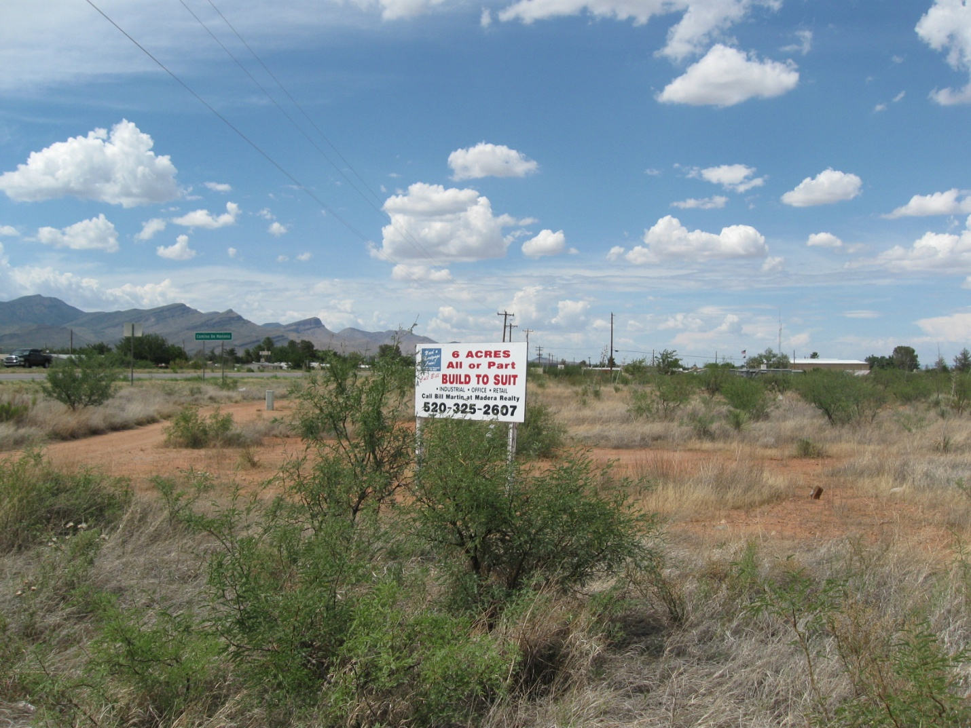View northward to subject property. SR90 is to the left.
II. Parcel History
There are no records of history for the subject parcel.

III. NATURE OF REQUEST AND ANALYSIS OF IMPACTS

Comprehensive Plan Amendment

The Applicant has requested rezoning the 6.3-acre subject parcel from TR-36 to GB. However, in order to obtain GB rezoning, an amendment to the Cochise County Comprehensive Plan (Plan) must first be approved to change the Neighborhood Conservation (NC) designation to Developing (DEV), as GB zoning isn’t permitted in the NC Plan areas. The subject parcel is located approximately .7-mile north of Mustang Corners (SR90 and 82) in the Whetstone area, an area not covered by an adopted area plan. The Applicant has submitted this request to enable a future purchaser to pursue commercial activities that have yet to be determined. This request constitutes a minor Comprehensive Plan Amendment.

Plan Designations represent the broad parameters for delineated land use in the Comprehensive Plan. The Plan indicates that the creation of new zoning districts must be consistent with the character and intent of the Plan Designation or Growth Area in which the site is located.
The Comprehensive Plan Growth Area Categories and Designations are designed to provide a measure of protection to the existing character of an area. Section 302 of the Plan indicates that it may be occasionally amended; however, an amendment must be justified by citing specific examples of existing or future growth patterns that do not support continuing the pattern implied by the existing Area Category or Designation.
The subject parcel is designated Neighborhood Conservation (NC); this designation is a reflection of the overall residential character of the surrounding area, and is intended to provide a measure of protection from proliferating non-residential (commercial) uses. However, large areas to the west (across SR90) and south are designated Developing (DEV), and there is precedent for commercial zoning and activity in the general area. Established residential and rural-residential uses are also in the area, especially to the north and east. SR90 is to the west, with residential properties and undeveloped land beyond.
A large portion of the subject area lies within a Category B Growth Area, areas described by the Plan as having a moderate level of residential and/or non-residential growth. Furthermore, Category B Growth Areas serve as a logical transition between urban growth and rural areas and/or has a distinctive community identity. These areas also have adequate water, access, drainage and sewage disposal, improved streets designated as arterial or collectors that may support limited non-residential development, and have substantial potential for further development. A small acreage Plan amendment such as this implies that this is an appropriate location for commercial development, including associated infrastructure and services, as opposed to strictly or overwhelmingly continuing residential land uses in the area.
Although a Plan amendment to Developing would not entirely be in keeping with the established, largely residential and rural-residential character of the area, because of the property’s proximity to another GB district and SR 90, and large areas designated Developing to the south and west across SR90, a change to Developing would not be inappropriate.
The Comprehensive Plan suggests that a small acreage plan amendment such as this may not be supported, because once established, a precedent is set to request additional plan changes in proximity to the original request thus potentially significantly changing patterns of growth. Based on this it may be necessary to expand the size of the amendment area to encompass a logical plan amendment area rather than approve a spot amendment designed to accommodate a single parcel rezoning. The Commission, in the future, may wish to consider a Comprehensive Plan change that would better reflect the anticipated potential for commercial development along the east side of the SR 90 corridor under the County’s jurisdiction.

Summary of Compliance with Rezoning Factors

Section 2208.03 of the Zoning Regulations provides 14 rezoning evaluation factors. Most of the factors are not applicable at this time due in part to the speculative nature of the request.
Mandatory Compliance: Permitted Districts by Plan Designation or Other Adopted Plans
Section 2208.03 reads:
Within each Plan Designation or Area, as depicted in Article 4, Section 402, only those zoning districts which are compatible with the characteristics of that Designation or Area may be formed. Further, if a master development plan, transportation plan or other land use plan has been adopted for the area encompassing the rezoning, the rezoning shall be consistent with the adopted plan. In order to protect the integrity and purpose of the County Comprehensive Plan, compliance with this factor is mandatory.
If the desired zoning district is not permitted in the existing Plan Designation or Area, then it cannot be formed unless a plan change is first obtained according to the provisions of Article 4.
The subject parcel is not within an adopted area plan, MDP or other land use plan. Furthermore, the Applicant has requested changing the existing Plan Designation from Neighborhood Conservation (NC) to Developing (DEV) to facilitate rezoning the site to GB.

Land Use/Concept Plan – Does not comply

The Zoning Regulations indicate that a concept plan be submitted as part of a rezoning application:
1. The applicant’s application is accompanied by a Land Use/Concept Plan, which at a minimum includes:
Non-residential
The type(s) of use(s) planned for the site is specified.
The general location, size and height of all structures, location, surface and width of driveways, general location and number of parking spaces, setbacks, proposed screening and landscaping and any significant topographical features such as washes, wetlands, cultural, archaeological or historical sites, hills, and rock outcroppings.
A concept plan showing future improvements was not submitted. As was indicated, the Applicant wishes to rezone the site to make it more attractive to prospective buyers interested in establishing a commercial use.

Compliance with Applicable Site Development Standards - Would likely comply

The property is large enough at 6.3-acres for most permitted uses in the GB districts to be able to comply with applicable site development standards. Full compliance would be determined upon submittal of a commercial permit application:

Setbacks: The minimum setback for all permitted structures and uses in the GB districts abutting TR districts is 40 feet or 20 feet from each road travelway. The subject parcel abuts a GB-zoned property to the south – the minimum setback along that property boundary would only be 5 feet. For Special Uses, however, the minimum setback doubles.

Screening: The Zoning Regulations requires 6 foot high solid screening between GB uses and residential uses.

Noise/Vibration/Odors and Other Nuisances or Emissions beyond the Site Boundary: Noise, vibration and odors are offsite impacts that potentially impact neighboring residential areas. If a proposed non-residential use would generate noise, vibrations and/or odors beyond which is permitted, the use must comply with Sections 1203.06-1203.09 of the Zoning Regulations which govern such off-site impacts.

Adjacent Districts Capable of Development - Complies

This rezoning would not render any adjacent parcel or district incapable of reasonable development.

Limitation on Non-conforming Uses - Complies

This rezoning would not create any non-conforming uses if approved.

Compatibility with Existing Development – Somewhat complies

Area development consists of primarily residential uses. There is a parcel zoned GB to the north, and other commercial zoning and uses exist farther south nearer to Mustang Corners. The request does not appear fully compatible with the primarily existing residential character of surrounding development. However, there is one parcel zoned GB abutting the subject property to the north, so approval of this request would not result in an isolated rezoning, a practice discouraged under Article 102.1.A.10.d of the Comprehensive Plan. The property’s location along a major State Highway and less than a mile from established commercial uses constitutes a factor in favor of approval.

Rezoning to More Intense Districts – Somewhat complies

There isn’t what might be considered a reasonable transition or buffer between the adjacent residential uses and this proposed GB rezoning. However, this request would create an extension of an existing GB district.

Adequate Services and Infrastructure - Complies

Adequate utility and infrastructure services appear to be available to the subject parcel for non-residential uses, and the submitted application indicates that Whetstone Water and the SSVEC would provide water and electric, respectively.
There is no natural gas service to the site, and an onsite septic system would be designed and permitted for the specific commercial use(s). Fire protection is provided by the Whetstone Fire District.

Traffic Circulation Criteria and Development Along Major Streets - Complies

Access to the subject parcel is via SR90 and E. Hamel Rd., a County-maintained unimproved road. E. Hamel also provides access to the rural-residential community to the east and north of the subject parcel. Comments from the County’s Transportation Planner indicate that no improvements would be required at this time. Estimating the level of non-residential traffic is difficult at this time because the Applicant has not specified the nature of any non-residential use(s) (see attached memo from the County Transportation Planner). Traffic mitigation would be determined at the non-residential permit phase. Improvements to SR90 may include turning lanes and/or acceleration/deceleration lanes and medians. The access point located along E. Hamel Rd. would likely need improvement as well.

Section 102.B3.a of the Cochise County Comprehensive Plan states:

Non-residential development shall be discouraged from accessing directly onto streets that primarily serve residential areas;

Approval of this rezoning request would possibly impose non-residential use traffic into a residential area. However, the subject property lies west of the established residential area, an area most likely to be impacted due to its proximity to the subject parcel. Access would be taken primarily from SR90, so non-residential traffic would likely not encroach eastward into residential areas because traffic would generate from the west.

Infill – Not applicable

In order to limit non-residential sprawl, rezonings to GB, LI or HI are typically considered reasonable as infill only when the subject area is located within an existing Enterprise or Enterprise Redevelopment Comprehensive Plan designation. The subject parcel does not have this plan designation, therefore this request is not considered to be an infill development.

Water Conservation – Not applicable at this time

These parcels lie outside of the Sierra Vista Sub-Watershed Overlay Zone. If approved, any non-residential use would have to comply with the County water conservation measures as outlined in Section 1820 of the Zoning Regulations.

Public Input - Complies

Per the requirements of Article 22 and the Citizen Review Process, the applicant sent notice of the proposed Comprehensive Plan Amendment and Rezoning to property owners within 1,000 feet of the subject parcel boundaries. Two letters of support were received by the Applicant.

Official notice from the Planning Department was sent out at least 15 days prior to the Commission hearing to all property owners within 300 feet of the subject property. The property was posted and a legal notice was placed in the Bisbee Observer. To date, the Department has received one (1) letter of support and two (2) letters in opposition.

Hazardous Materials – Not applicable at this time

The use and/or storage of hazardous materials would be addressed at the commercial permit phase.

IV. PLANNING AND ZONING COMMISSION’S RECOMMENDATION

The Applicant confirmed to the Commission his wish to obtain GB zoning in order to more effectively market the property to prospective commercial interests. Mr. Bemis communicated concern about the speculative nature of the request and mentioned that neighboring property owners would not know what type(s) of commercial activity would occur if the rezoning were approved. Mr. Martzke mentioned surprise that the subject parcel is zoned TR-36 in light of its location adjacent to a State highway. He also suggested that granting the Comprehensive Plan amendment would provide the additional marketability that Mr. Martin seeks, but also expressed concern about the apparent uncertainty about future commercial uses. Nobody from the public chose to speak about the Applicant’s requests.

The Commission voted unanimously to forward a recommendation of approval to the Board for the requested Comprehensive Plan Amendment change from NC to DEV. However, because of their concern about the uncertainty of future commercial uses, the Commission voted unanimously to forward a recommendation of denial for the rezoning request to GB.

V. SUMMARY

Despite the rather speculative nature of this request, a Plan amendment and rezoning from TR-36 to GB would likely not have significant impacts on the residential and rural-residential properties in the area, in part due to its location along a major highway, an area appropriate for General Business development. Furthermore, there is commercial zoning and activities in the general area. The residential areas nearby may actually benefit from a General Business district located close enough for their use.

Factors Favoring Approval

- Developing (DEV) Plan Designations are located nearby and precedent exists for commercial zoning and activities in the area;
- The property lies along a major State Highway, a location appropriate for GB zoning;
- There would be no immediate impacts to area residential and rural-residential properties; and
- Three letters of support were received.

Factors Favoring Denial

- The subject parcel is in an area designated by the Comprehensive Plan as NC. This designation is intended to protect residential neighborhoods from a proliferation of non-residential uses;
- The rezoning request may be considered speculative in nature; therefore, the type of commercial activities which would occur is uncertain, making analysis of potential impacts difficult;
- Two letters in opposition were received; and
- The Planning and Zoning Commission voted unanimously to approve the requested Comprehensive Plan Amendment, but voted unanimously to deny the rezoning request.

VI. RECOMMENDATION

Based on the Factors Favoring Approval, the Community Development Department recommends conditional approval of this Comprehensive Plan amendment and rezoning request.

Please note that this will require two motions from the Board, starting with the Comprehensive Plan amendment. The following standard condition is recommended:

- The Applicant shall provide the County with a signed Acceptance of Conditions and a Waiver of Claims form arising from ARS Section 12-1134 signed by the property owner of the subject property within thirty (30) days of Board of Supervisors’ approval of the Comprehensive Plan Amendment and Rezoning or the approval of the Amendment and Rezoning may be deemed void.

Sample Motions:

- Mr. Chairman, I move to recommend approval of Docket CP-12-01, a Comprehensive Plan Amendment changing the Plan Designation of the subject property from Neighborhood Conservation (NC) to Developing (DEV); and

- Mr. Chairman, I move to recommend approval of Docket Z-12-05, rezoning the subject parcel from TR-36 to GB, with the Condition recommended by staff.

VII. ATTACHMENTS

1) Comprehensive Plan and Rezoning Applications
2) Aerial/Vicinity Map
3) Staff Comments
4) Citizen Review Letter and Public Comments

