MEMORANDUM

TO: Cochise County Board of Supervisors
Through: Michael J. Ortega, County Administrator
FROM: Keith Dennis, Planner II
For: Beverly J. Wilson, Deputy Director Planning Division
SUBJECT: Docket Z-13-01 (Yesca)
DATE: March 14, 2013, for the March 26, 2013 Meeting

APPLICATION FOR A REZONING

The Applicant seeks to rezone a 12,915-square foot parcel from TR-9 (residential, one dwelling per 9,000-square feet) to MR-1 (Multiple household, one dwelling per 3,600-square feet) for the purpose of completing the conversion of an existing 850-square foot garage into a single-family home on the property. The current TR-9 Zoning designation does not allow two dwellings on this parcel as its size (12,915-square feet) is insufficient.

The property (Parcel #102-57-338) is located at 3790 S. Geisler Avenue in Naco, AZ. The Applicant is Maria Yesca, represented by Ernest Rogers.

I. PLANNING AND ZONING COMMISSION

On Wednesday, March 13, 2013, the Planning and Zoning Commission voted 7-1 to forward this Docket to the Board of Supervisors with a recommendation of approval. The motion included the conditions of approval recommended by staff.

II. DESCRIPTION OF SUBJECT PARCEL AND SURROUNDING LAND USES

Size: 12, 915-square feet
Zoning: TR-9 (Residential, 1 dwelling per 9,000-square feet)
Growth Area: Category C (Rural Community Area)
Area Plan: Naco Community Plan
Comprehensive Plan Designation: High-Density Residential
Existing Uses: Single Family Residence
Proposed Uses: Addition of one small single-family dwelling

Surrounding Zoning
Relation to Subject Parcel |  | Zoning District |  | Use of Property
North | TR-9 |  | Valenzuela Street, Single-Family Residential
South | TR-9 |  | Single-Family Residential
East | TR-9 |  | Giesler Avenue, Naco School
West | GB |  | Single-Family Residential

III. PARCEL HISTORY

There are three structures on the subject parcel: the principal dwelling, a small outbuilding, and a wood-frame garage. The garage was recently demolished, and construction begun on a second dwelling, atop the concrete pad which served as the floor of the garage.

There are no records for any permits for the structures on the property, which have existed on site since 1942. In November of 2012, staff issued a Stop Work Order, followed by a Zoning Violation, for construction without a permit.

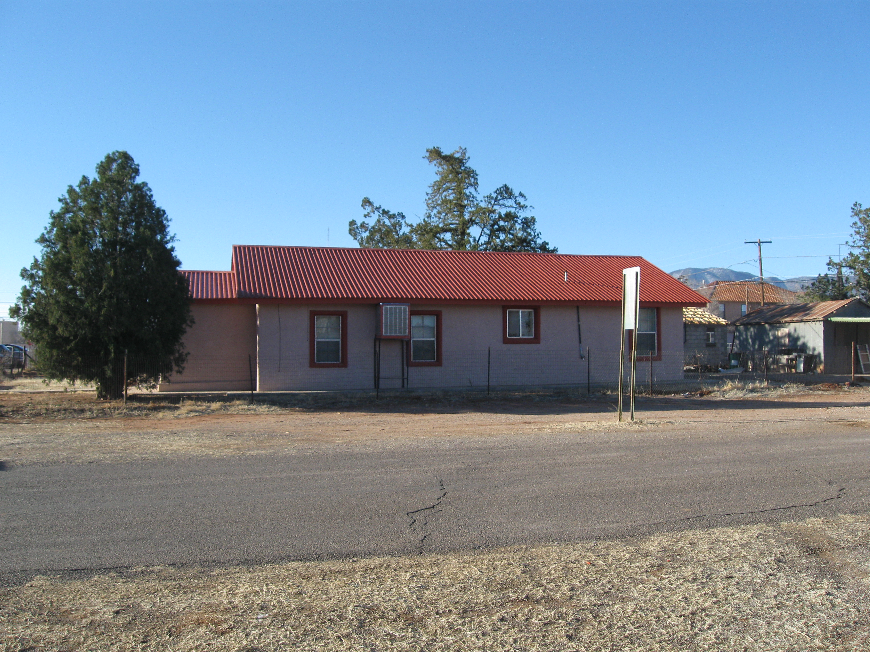
South view of the Yesca residence, seen from Valenzuela Street.

IV. NATURE OF REQUEST
The Applicant, Maria Yesca, has a home and accessory garage on her property. She has employed Ernest Rogers to convert the garage into a small dwelling. In late 2012, it came to staff’s attention that the construction was taking place, whereupon the Zoning Violation was opened.
Construction cannot continue, nor can a permit be issued, unless and until the property can be rezoned as the parcel is zoned TR-9, which allows one dwelling per 9,000-square feet. Because the property is smaller than the 18,000-square feet which would be required for two dwellings, a rezoning is required if the Applicant’s plans are to be realized. If the Applicant is successful, the Violation can be closed, a building permit issued, and construction of the new dwelling can be completed.

V. ANALYSIS OF IMPACTS

Mandatory Compliance
The subject property lies within a Category “C”–Rural Community Area and is considered a “High Density Residential” land use designation area per the Naco Community Plan. Section 402 of the County Zoning Regulations allows owners of property lying within this designation to request a rezoning to MR-1 (Multiple household, one dwelling per 3,600-square feet), as MR (Multiple Residential) serves as the County’s high-density residential District.

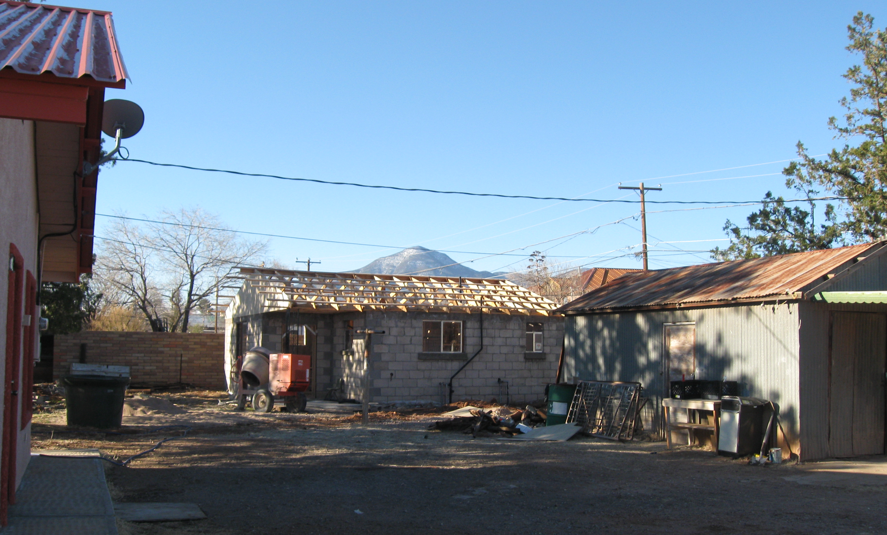
The proposed second dwelling and storage building. Existing residence at left.

Compliance with Rezoning Criteria
Section 2208.03 of the Zoning Regulations provides fifteen (15) criteria used to evaluate rezoning requests. Eleven of the criteria are applicable to this request, which, as submitted, complies with 10 of the 11 applicable factors.
1. Provides an Adequate Land Use/Concept Plan. Complies.
The attached Concept Plan is adequate for the proposed rezoning. Note that Section 2208.03.B.1 of the Zoning Regulations does not relate specifically to what is proposed.
That is, the rezoning would not facilitate a new residential subdivision development and so would not require a new subdivision plat submittal.

2. Compliance with the Applicable Site Development Standards—Does Not Comply.
The structures on the property, including the detached garage, were constructed in 1946, before the County adopted Zoning Regulations. The existing home and accessory building are thus considered legally-nonconforming. In 2012, when the Applicant demolished the garage, and began constructing a new masonry structure on the remaining concrete pad, the legal non-conforming status also ceased: any new structure built on the pad would have to conform to current Zoning regulations. The garage was sited four-feet, two-inches from the southern property line, and six-feet, eight-inches from the western property line. The setback for structures on the property today is 10-feet, the standard for the TR-9 District. If the property were rezoned to MR-1, the minimum setback would change to 20-feet along the south property line (due to the abutting TR-9 District), and five-feet from the west property line (due to the adjacent GB District).

In 2011, the Board of Supervisors approved changes to Article 22 of the Zoning Regulations to grant themselves the authority to deem existing structures as legal-nonconforming as part of a rezoning approval. In this case, the proposed second dwelling on the property would not be eligible for such consideration, as it is a new structure and a change from an accessory to a principle land use. The Applicant has submitted an application to the District 2 Board of Adjustment for a Variance to the setback along the south property line for the proposed dwelling. The Board will consider this request at their regular meeting of Wednesday, April 3, 2013.

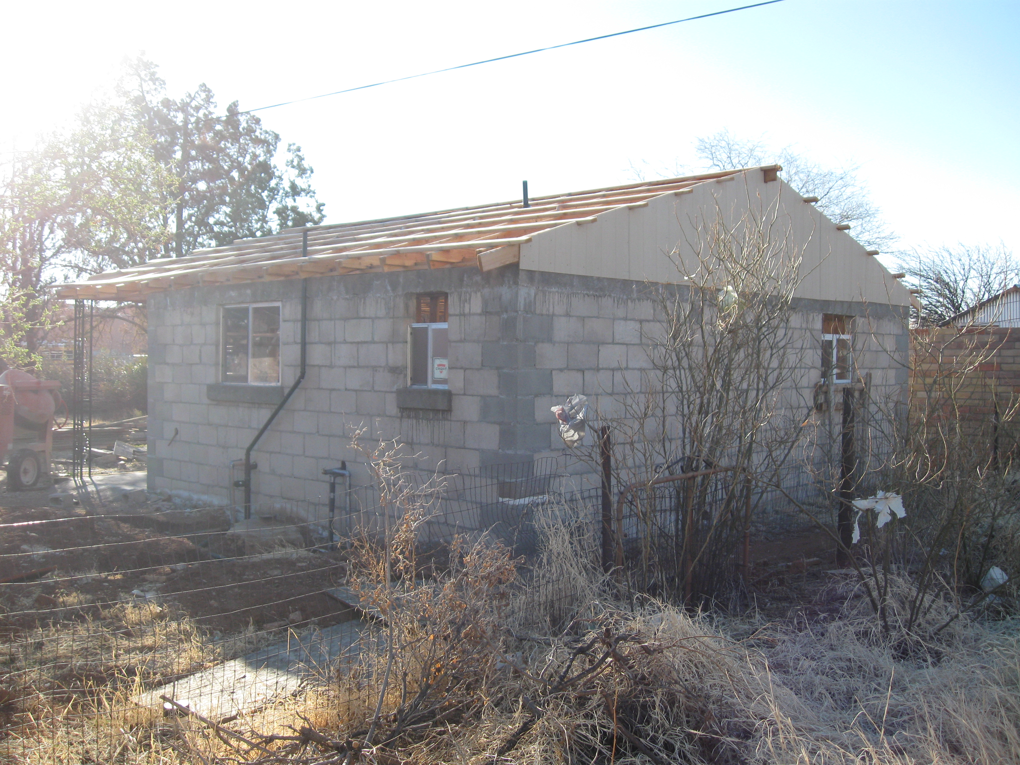
Southeast view of the partially-constructed second dwelling.

3. Adjacent Districts Remain Capable of Development – Complies.
The proposal would not affect the development prospects of any neighboring property.

4. Limitation on Creation of Nonconforming Uses—Complies.
The proposal would not create any non-conforming land uses.

5. Compatibility with Existing Development –Complies.

The immediate area is characterized by a variety of single family dwellings of various sizes on a variety of lot sizes and types. Small-scale commercial uses, as well as public facilities such as the adjacent Naco school are also within the neighborhood. A number of the parcels and land uses, in the Naco Townsite pre-date County regulations and are legal-nonconforming.

6. Rezoning to More Intense Districts—Complies.
The Zoning Regulations provide several criteria for compliance with this factor, including the extent to which the rezoning “provides a transition between an existing less intense district and a more intensive district.” The MR-1 District allows one dwelling per 3,600-square feet. The surrounding TR-9 District provides for one dwelling per 9,000 square feet; the General Business District, to the immediate west of this parcel, allows for high-density residential development (one dwelling per 3,600-square feet). Section 2208.02 of the Zoning Regulations provides a scale of intensity for established Districts within the County. On this scale, the MR Districts are considered to be of a similar intensity to the TR-9 District, with only the SR-8 (Single-Household Residential) between them. Moreover, as stated above, residential development at densities higher than one dwelling per 9,000-square feet already exists throughout the existing TR-9 District. The property immediately south, for instance, is a non-conforming TR-9 parcel of approximately 6,500-square feet.

7. Adequate Services and Infrastructure – Complies.
The home is served by community water and sewer services. APS provides electric power and the Naco Fire Department provides emergency services. The property is also served by County-maintained streets with adequate rights-of-way.

8. Traffic Circulation Criteria – Complies.
Rezoning to MR-1 to facilitate an additional dwelling on the property would result in a small increase in traffic. The parcel is bordered on two sides by County-maintained roads, with existing, wide rights-of-way for each. These streets are adequate for the proposed increase in residential use of the property. A right-of-way permit would be required to legitimize the existing driveway onto Valenzuela Street if the owner is allowed to move forward with a residential permit for the second dwelling.

9. Development Along Major Streets—Not Applicable.

The property does not border any major street.

10. Infill—Not Applicable.
This Factor applies only for rezoning requests to GB, LI or HI, and is therefore not applicable.

11. Unique Topographic Features – Complies.
There are no exceptional topographic features warranting consideration on or near the site.
12. Water Conservation—Not Applicable.
As a proposal to allow one additional dwelling on a parcel smaller than one acre, this factor is not applicable. The property is served by the Arizona Water Company.

13. Public Input—Complies.
The Applicant completed the required Citizen Review process and received positive responses by telephone from seven individuals, and one positive response in writing. Staff posted the property on February 26, 2013, and published a legal notice in the Bisbee Observer on February 14, 2013. The Department also mailed notices to property owners within 1,000-feet of the site. To date, staff has received two statements of support from neighboring property owners, and from two neighbors (one representing two parcels) opposing the request (See Attachment D – Citizen Review and Public Comment).

14. Hazardous Materials – Not Applicable.
No hazardous materials are proposed as part of the development plan.

15. Compliance with Area Plan - Complies
The property is within the boundaries of the Naco Community Plan area, and carries a Plan Designation of “High Density Residential.” High-density residential is defined, per the Area Plan, as a density of one dwelling unit per 3,100 to 9,000 square feet.
Allowing two dwellings on the 12,915-square foot property would result in a density of approximately 6,500-square feet per dwelling – a density compatible with Area Plan policies as well as the character of the Naco Townsite, which includes a number of non-conforming TR-9 parcels, some as small as 3,500-square feet.

VI. SUMMARY

The rezoning request is for a parcel of 12,915-square foot in the Naco Townsite. The rezoning is necessary in order for the Applicant to proceed with a building permit to complete a second, small dwelling on the property. This item has come forward due to a Zoning Violation for beginning construction of this dwelling without a permit.

The neighborhood is home to a large number of legal nonconforming properties, land uses, and lot sizes; many of the TR-9 parcels throughout the town are smaller than the 9,000-square foot minimum. The Naco Community Plan designates the site for High Density Residential; this designation essentially constitutes a recommendation on the part of the Area Plan for a rezoning to a higher-density District, constituting a major factor in favor. A rezoning to the MR-1 District would therefore reflect the policies of the Plan, as well as the character of the surrounding neighborhood. Additionally, residential densities allowed in the adjacent General Business District are the same as the MR-1 allows, and as such, the request is a reasonable extension of an existing Zoning District.

Staff’s recommendation is based upon the above analysis, as well as the following Factors in Favor and Against approval.

Factors in Favor of Approval

1. Allowing the request would be in keeping with the character of development in the area;

2. The Naco Community Plan policies prescribe a high density of residential development in this area, and the request would facilitate such a density;

3. The Applicant’s Citizen Review effort yielded eight positive responses from neighboring property owners;

4. The subsequent County mailing resulted in two neighboring property owners expressing support for the proposal; and

5. The Planning & Zoning Commission voted 7-1 to forward a recommendation of conditional approval.

Factors Against Approval

1. The request comes as a result of a Zoning Violation for building without a permit;

2. The rezoning, if approved, would result in increased setbacks, from the current TR-9 standard of 10-feet, to the MR-1 standard of 20-feet along abutting residential Districts The proposed second dwelling, built on the existing concrete pad, will be non-conforming with the setback standards along the south property line; and

3. Two neighboring property owners oppose the request.

VII. RECOMMENDATION

Based on the Factors in Favor of Approval, staff recommends conditional approval of Docket Z-13-01, subject to the following standard conditions:

- The Applicant shall provide the County with a signed Acceptance of Conditions and a Waiver of Claims form arising from ARS Section 12-1134 signed by the property owner of the subject property within thirty (30) days of Board of Supervisors approval of the rezoning; and

- It is the Applicants' responsibility to obtain any additional permits, or meet any additional conditions, that may be applicable to the proposed use pursuant to other federal, state, or local laws or regulations.

Madame Chair, I recommend we approve Docket Z-13-01 subject to the two conditions recommended by staff.

VIII. ATTACHMENTS

A. Rezoning Application
B. Concept Plan
C. Location Map
D. Citizen Review and Public Comment

