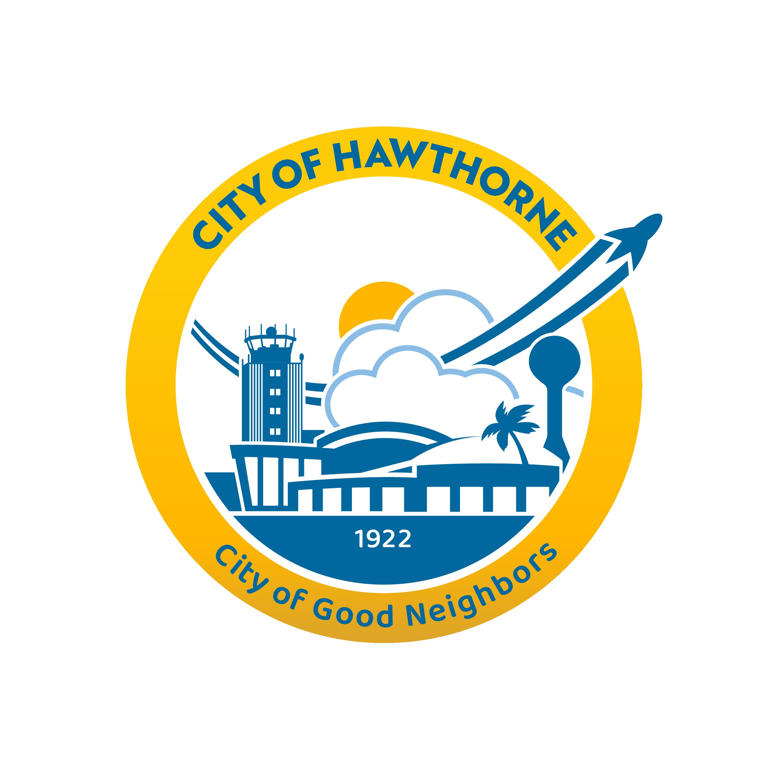

CITY OF HAWTHORNE 4455 W. 126th Street, Hawthorne, CA 90250

Chairperson Richard Huhn Commissioner Danielle Marquez
Vice Chairperson Herminia Balboa Commissioner Kevin Posey
Commissioner Solo Azuoma

PARKS & REC - FINE ARTS COMMISSION AGENDA
Regular Meeting
Tuesday, December 3, 2024
6:00 PM

MEETING INFORMATION
If you are an individual with a disability and need reasonable accommodation or modification pursuant to the Americans with Disabilities Act (ADA) please contact the Community Services department at parksrec@cityofhawthorne.org prior to the meeting for assistance.

PURSUANT TO GOVERNMENT CODE SECTION 54954, THE NOVEMBER 5, 2024 PARKS & RECREATION – FINE ARTS COMMISSION REGULAR MEETING AGENDA WAS POSTED AT CITY HALL, 4455 W. 126TH STREET AT 10:00 AM ON THURSDAY, OCTOBER 31, 2024.

- CALL TO ORDER
- ROLL CALL
- PLEDGE OF ALLEGIANCE
- APPROVAL OF MINUTES FOR NOVEMBER 5, 2024 MEETING
- WRITTEN COMMUNICATIONS – CITY COUNCIL MINUTES
- PARKS & RECREATION FOUNDATION REPORT
- ORAL COMMUNICATIONS – Pursuant to Government Code Section 54954.3, all remarks should be addressed to the Commission as a Body and not to any individual Members. During oral communications, speakers shall have three (3) minutes to state their business. The Brown Act prohibits the Commission from providing a detailed response or acting upon any items not contained on the agenda. The Commission as a Body shall have the discretion at the close of oral communications to refer any remarks to the City Clerk Department for study, investigation, report, and/or recommendations.

- DIRECTOR’S REPORT
- DODGER DREAMFIELD UPDATE
- SENIOR CENTER RENOCATION UPDATE
- MEMORIAL CENTER HVAC PROJECT UPDATE
- ZELA DAVIS PARK RENOVATION PROJECT UPDATE

- UPCOMING EVENTS
- HAWTHORNE HOLIDAY FESTIVAL – DECEMBER 20TH

- COMMISSIONER’S DICUSSION ACTION ITEMS

- ADJOURNMENT – NEXT MEETING JANUARY 7, 2025

