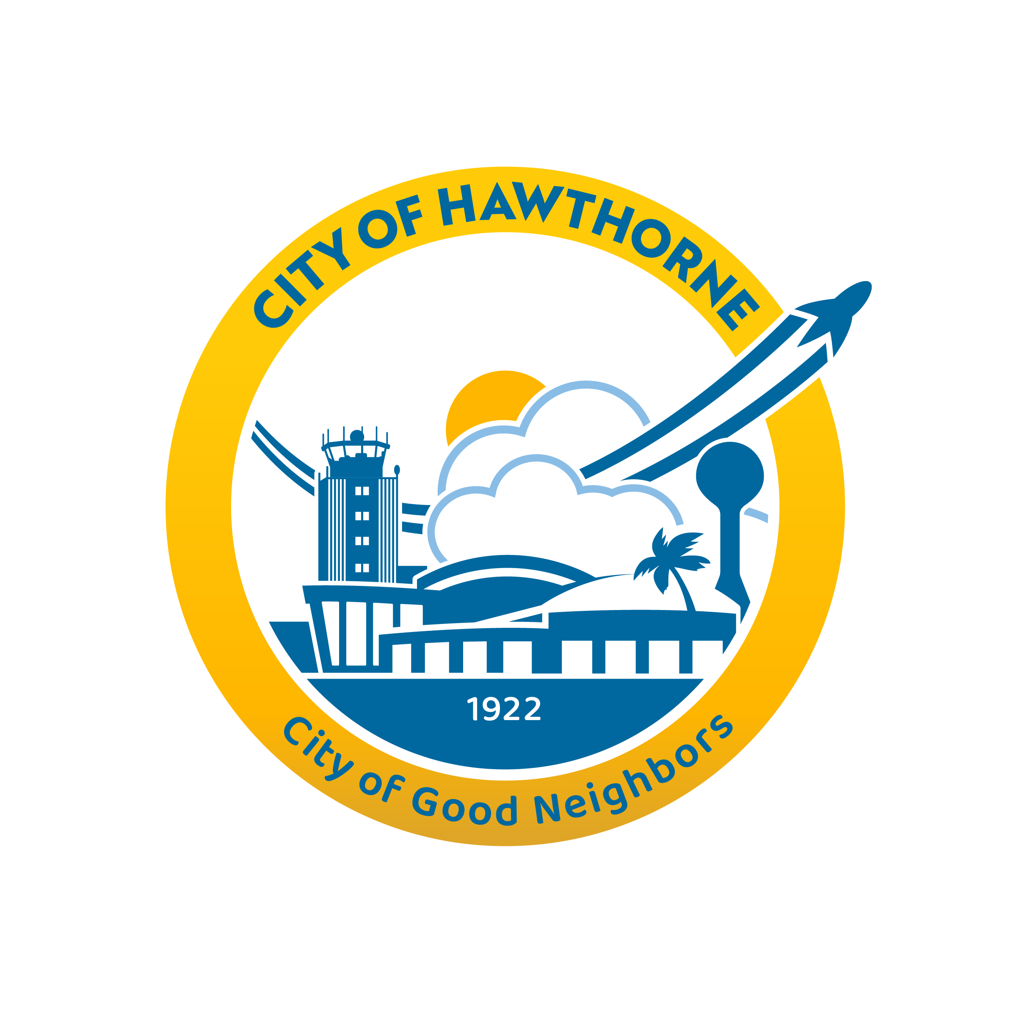
CITY OF HAWTHORNE 4455 W. 126th Street, Hawthorne, CA 90250

Senior Citizen Commission AGENDA
Commission/Member Kathleen De Mesa Commission/Chair Margaret Allen
Commission/Vice Chair Darvis Johnson Commission/Member Dr. Joseph Jackson
Commission/ Member Carol Maston
Regular Meeting
Wednesday, May 7, 2025
3:00 PM

MEETING INFORMATION

If you are an individual with a disability and need reasonable accommodation or modification pursuant to the Americans with Disabilities Act (ADA), please contact the Community Services Department at MPerez@CityofHawthorne.Org before the meeting for assistance.

PURSUANT TO GOVERNMENT CODE SECTION 54954, APRIL 2, 2025 SENIOR CITIZEN COMMISSION, REGULAR MEETING AGENDA WAS POSTED AT CITY HALL, 4455 W. 126TH STREET, AT 1:00 PM ON Wednesday, April 30, 2025

CALL TO ORDER AND ROLL CALL
- ROLL CALL: Margaret Allen
COMMISSIONER KATHLEEN DEMESA
VICE CHAIRPERSON DARVIS JOHNSON
COMMISSIONER Dr. JOSEPH N. JACKSON
COMMISSIONER CAROL MASTON
CHAIRPERSON MARGARET ALLEN

- FLAG SALUTE

- APPROVAL OF MINUTES FOR – April 2, 2025

- PRESENTATION

- WRITTEN COMMUNICATIONS – City Council Minutes

Pursuant to Government Code Section 54954.3, all remarks should be addressed to the Committee as a Body and not to any individual Members. During oral communications, speakers shall have three (3) minutes to state their business. The Brown Act prohibits the Committee from providing a detailed response or acting upon any items not contained on the agenda. The Committee as a Body shall have the discretion at the close of oral communications to refer any remarks to the 'Community Services Department' for study, investigation, report, and/or recommendations.

- ORAL COMMUNICATIONS

- SUPERVISOR REPORT
- Senior Trips/Events
  - AARP Drivers Safety Class –Session 1: Tuesday, May 6, 9:00am-1:00pm/Session 2: Wednesday, May 7, 9:00am – 1:00pm
  - Mother’s Day Luncheon – Friday, May 9, 1:00pm – 4:00
  - Line Dance Class: Every Wednesday at 3:00pm
  - Chair Yoga: Every Wednesday, 2:00pm – 3:30pm
- Senior Center Construction Update
- Senior Center Resource Guide

- COMMISSIONER’S DISCUSSION/ACTION ITEMS

- 2025 Event/Giveaway Calendar
- Senior Resource Guide
- Roundtable

- ADJOURN

Next Senior Citizen Commission meeting:
June 4, 2025
City Hall Chamber

