DATE: 3/5/2013
COUNTY 0 F HIDALGO

ARTURO GUAJARDO, }R. - COUNTY CLERK

DEPARTMENT HEAD: Arturo Guajardo, Jr DEPARTMENT NAME: Hidalgo County Clerk's Office ACCOUNT NUMBER 3-1100-415-40-180-001-0
SUBJECT: Budget Intradepartmental Transfer in Accordance with Local Government Code, Chapter 111, Subchapter C.

Honorable Commissioner's Court of Hidalgo County:

I would like to request the following Intradepartmental Budget Transfer/s in accordance with
Local Government Code, Chapter 111, Subchapter C.

FROM: |  | TO:
OBJECT | OBJECT | OBJECT | OBJECT
CODE | NAME | CODE | NAME | AMOUNT
432 | Equipment & Vehicle R&M Services | 431 | Bldg & Other Structures R&M Services | $750.00
432 | Equipment & Vehicle R&M Services | 671 | Bldg & Other Structure R&M Suppl | $750. 00
535 | POSTAGE | 743 | Office Furn & Equip | $3,450. 00
 |  |  | TOTAL | $4 950.00

REASON:

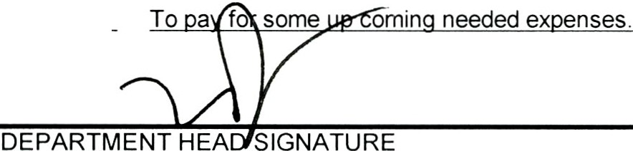APPROVED COMMISSIONERS COURT DATE ATTEST COUNTY CLERK

P.O. Box 58/ 100 N. Closner, Edinburg, Texas, 78540

956.318.2100- fax 956.318.2105

www . h idalgoco u ntyclerk. us

