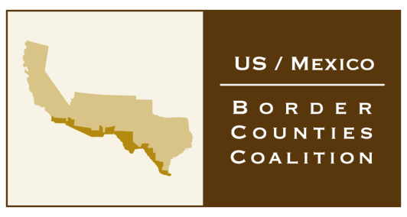

3414 Montana El Paso, Texas 79903
(915) 525-9040
www.bordercounties.org

June 10, 2013

Dear Coalition Member:

The By-Laws of the Coalition are being proposed to be changed to expand the size of the Executive Committee and to allow the appointment of non-elected officials to serve as duly appointed representatives to the Coalition.

In order to implement this change, a vote of the Membership is required, a majority in favor being required to adopt the proposed change.

I have previously emailed a copy of the proposed changes and a draft of the same is available on our website at www.bordercounties.org.

Please indicate your approval or non-approval of the proposed By-Laws changes and sign and return this page.

I, ____________________________, representing ______________________County, approve ___
(name) (county name)

or do not____ approve the proposed By-Law changes (dated April 2013) for the US/Mexico Border Counties Coalition.

Signed __________________________________________ Date _____________________________

Name (please print) __________________________________________________________________

Please mail an original signed copy to David Austin at 3414 Montana, El Paso, Texas 79903 and/or scan and email a copy to David at david@acr-dc.com or fax a copy to David at (915) 566-8286.

Your prompt response is appreciated!

Thanks,
