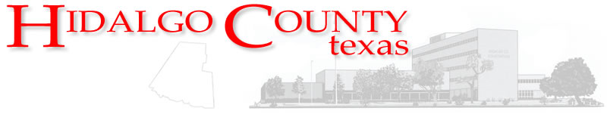 Memorandum
DEPARTMENT OF BUDGET & MANAGEMENT
2818 S. Business Hwy. 281
Edinburg, Texas 78539
Office: (956) 292-7025 ▪ Fax: (956) 292-7035
www.co.hidalgo.tx.us/budget

To: Raymundo Eufracio, CPA, County Auditor

From: Sergio Cruz, Budget Officer

Date: Wednesday, October 08, 2014

Subject: Certification of Revenues
Linda Fong, 1st Assistant Auditor
Becky Luna, Director of Accounting Division
Alvaro Chuc, Financial Accounting Supervisor

Cc:

On behalf of the Constable Precinct No. 4, please let this memorandum serve as formal request for the Certification of Revenues in the amount of $1,670.67. These revenues are proceeds from an insurance settlement (AI-46637 CC approval 09/23/14) for an accident that occurred on 08/15/14 and which were receipted and recorded on 09/25/14 in account no. 4-1100-360-00-000-005-0-000.

Additionally, be advised that the appropriation of these revenues will be presented to Commissioners Court for approval on 10/28/14 (AI- 46874).

Thank you for your attention on this matter. If you should have any questions, please do not hesitate to contact me at (956) 292-7025 ext. 5424.

