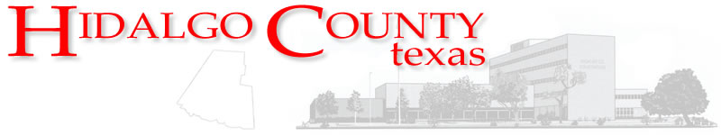 Memorandum
DEPARTMENT OF BUDGET & MANAGEMENT
2818 S. Business Hwy. 281
Edinburg, Texas 78539
Office: (956) 292-7025 ▪ Fax: (956) 292-7035
www.co.hidalgo.tx.us/budget

To: Raymundo Eufracio, CPA, County Auditor

From: Sergio Cruz, Budget Officer

Date: Tuesday, October 14, 2014

Subject: Certification of Revenues- Constable Precinct No. 4 (CCP59)
Linda Fong, 1st Assistant Auditor | Dina Treviño, Assistant Budget Officer
Becky Luna, Director of Accounting Division
Alvaro Chuc, Financial Accounting Supervisor

Cc:

On behalf of the Constable Precinct No. 4, please let this memorandum serve as formal request for the Certification of Revenues in the amount of $12,700. These revenues are proceeds from the sale of assets (seized vehicles) and which are currently recorded in account no. 4-1231-392-10-000-000-0-000 Const Pct4 CCP59-Sale of Capital Assets.

Additionally, be advised that the appropriation of these revenues will be presented to Commissioners Court for approval on 10/28/14 (AI- 46996).

Thank you for your attention on this matter. If you should have any questions, please do not hesitate to contact me at (956) 292-7025 ext. 5424.

