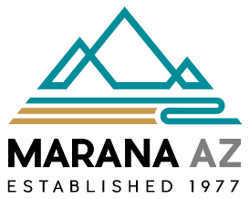

MARANA PUBLIC ART REVIEW COMMITTEE MEETING
NOTICE AND AGENDA
11555 W. Civic Center Drive, Marana, Arizona
Second Floor Conference Center
May 26, 2026, at or after 1:00 PM
Brett Wittenberg, Committee Member
Vic Hathaway, Committee Member
Fausto Burruel, Committee Member
Wayne Barnett, Committee Member
Elizabeth Horrigan, Committee Member
Jackie Craig, Committee Member
Andrea De La Cruz, Committee Member/Facilitator

SUMMARY MINUTES

CALL TO ORDER AND ROLL CALL

Facilitator Andrea De La Cruz called the meeting to order at 1:03 PM

ROLL CALL

Ms. De La Cruz called the roll. All Committee Members were present, constituting a quorum.

CALL TO THE AUDIENCE
APPROVAL OF AGENDA
Ms. De La Cruz asked for a motion to approve the agenda.
Committee Member Craig moved to approve the agenda as presented. Member Fausto seconded the motion. Motion passed, 7-0.
APPROVAL OF MINUTES
APPROVAL OF MINUTES FROM December 9, 2025
Ms. De La Cruz asked for a motion to approve the minutes of the December 9, 2025 meeting.
Committee Member Craig moved to approve the minutes as presented. Committee Member Barnett seconded the motion. Motion passed, 7-0.

ANNOUNCEMENTS
Facilitator Andrea De La Cruz introduced and welcomed Interim Development Services Director, Brett Wittenberg to the committee.
Committee Member Fausto Burruel provided an update on the rattlesnake art piece to be installed at Silverbell Road and Twin Peaks Road. The sculpture is complete and currently curing. It is expected to be complete and will be installed in early August, with a ribbon-cutting ceremony anticipated in late August or early September.
Committee Member Vic Hathaway announced that the Falcons Art piece was featured in Mayor Post’s State of the Town address during the bike scene along the Loop.
GENERAL ORDER OF BUSINESS
A. Discussion and feedback on proposed amendments to the Town of Marana Public Art Policy.
Ms. De La Cruz presented the amended Town of Marana Public Art Policy and asked the committee to review the proposed changes and provide comments and suggestions.
She noted that the amended policy clarifies how public art fees are calculated for provide development. She also highlighted the section addressing specific plans and how they may satisfy the public art requirement. Additionally, she explained that CIP projects determined to be solely operational, safety-related, or maintenance-related are not required to contribute to the public art fund. Ms. De La Cruz also noted that the policy allows for minor future revisions to be approved by the Town Manager without requiring review by the Town Council.
After some discussion, a motion was made by Committee Member Hathaway to approve the Town of Marana Public Art Policy amendments. Committee Member Craig seconded the motion. Motion passed 7-0
B. Discussion and feedback on potential public art projects.

Ms. De La Cruz proposed that the committee explore the possibility of a mural along the exterior wall of the MARC facing Bill Gaudette Drive to commemorate the Town of Marana’s 50th anniversary, which will be celebrated in 2027. She noted that the mural could be unveiled on Founder’s Day.

She shared an example of a mural from the Town of Gilbert that could serve as inspiration. The committee agreed and provided input on potential mural elements, including farming and ranching, mountains, and a hot air balloon. Committee Member Barnett also suggested using the artwork on the interior wall of the MARC as inspiration.
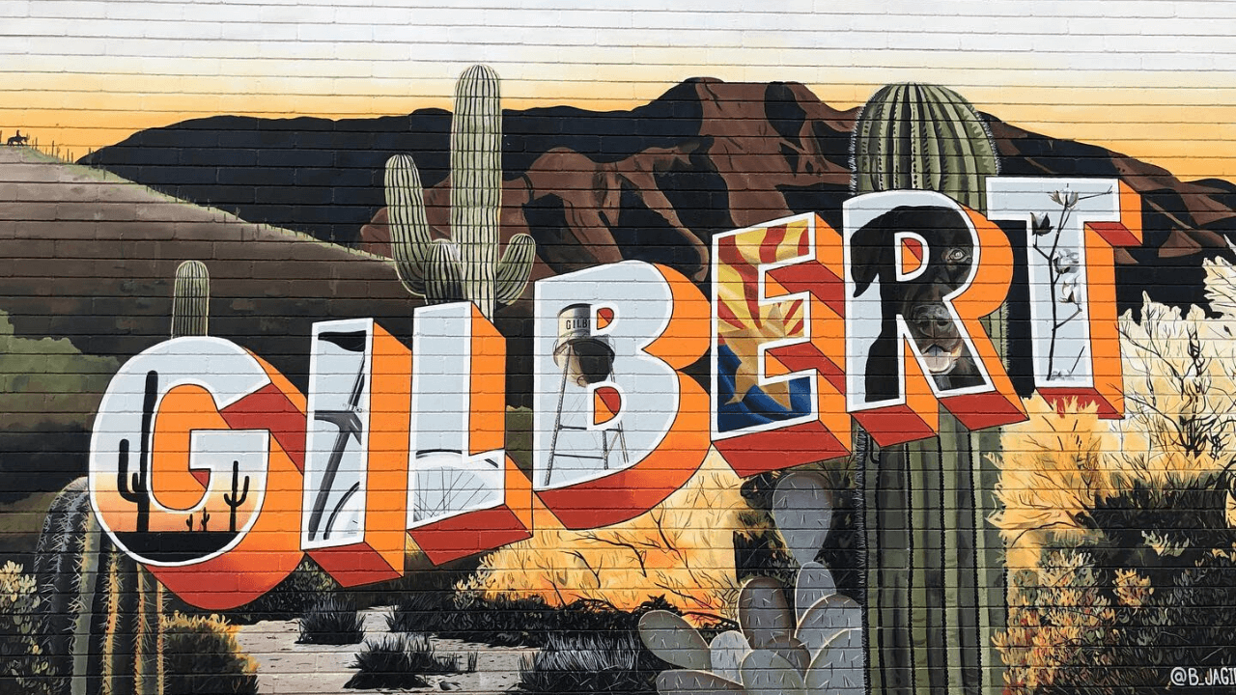

Ms. De La Cruz also asked the committee for feedback on funding artistic wayfinding signs for the El Rio Preserve. After discussion, the committee determined that wayfinding signage falls outside the purview and mission of the Public Art Policy. It was also noted that wayfinding signage will be addressed in the upcoming Town of Marana Parks and Recreation Master Plan update.

Ms. De La Cruz will work on scheduling a visit to the El Rio Preserve so the committee can explore the area and determine the best location for a future art installation.

FUTURE AGENDA ITEMS
- Discussion on the type of art the committee would like to fund through the TABY Grant, possibly for placement at the roundabout near Marana High School.
- Ideas for public art along The Loop.
ADJOURNMENT
Ms. De La Cruz asked for a motion to adjourn the meeting. Committee Member Barnett moved to adjourn the meeting. Committee Member Hathaway seconded the motion. The motion passed, 7–0. The meeting adjourned at 1:36 p.m.

