DRAFT

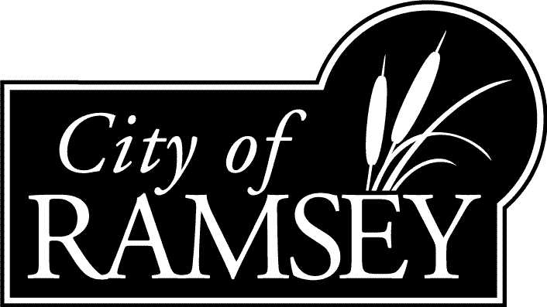

Full-Service Restaurant Subsidy Program Guidelines

The Program
The purpose of the program is to create an environment of contiguous, complementary retail activity along key transportation corridors of the City of Ramsey. This subsidy program is intended to serve as a catalyst for securing new restaurant concepts in Ramsey by providing financial assistance to qualified restaurant businesses. The full-service restaurant must be located in The Cor, along Armstrong Boulevard, on State Highway 10, or along County Highway 47 in the City of Ramsey (See Exhibit A).

To facilitate new full-service restaurants, the EDA would provide zero interest, forgivable loans to eligible full-service restaurants for the purpose of financing their water connection fees. The maximum loan amount would be 70% of the proposed restaurant’s Water Access Charge (WAC fee). The 70% cap would ensure that the businesses are covering some of the fixed capital costs for the City’s water system. The loan would be recorded as a subordinated mortgage and the principal would be forgiven if the restaurant remained in operation and in good standing with the City for five years. The loan principal would be forgiven at a rate of 20% per year.

In establishing the loan amount and the percentage of WAC subsidy, the EDA would advise the Ramsey City Council regarding several factors. The factors are (1) the size of the restaurant’s capital investment, (2) the financial need and potential for long-term viability, and (3) the quality of the restaurant’s concept. A full-service restaurant is defined as one that has washable plates, cups and utensils, and whose projected SAC/WAC fees are charged at a rate of one unit per eight seats.

Eligibility
Eligible applicants are for-profit restaurant businesses that are not currently operating in the designated areas shown on Exhibit A. Eligible businesses must devote a majority of their floor space to the restaurant concept. All applicants must be a permitted use in compliance with all laws, zoning ordinances, rules and regulations applicable to the business. The Ramsey EDA will review each application on a case-by-case basis and reserves the right to exclude activities not consistent with the City’s Comprehensive Plan, or if the concept does not benefit the health, safety and welfare of the community.

DRAFT

Application Process
The applicant must submit a completed Business Assistance Application and all required attachments to the City’s Community Development Department. City staff will make every effort to review completed applications within a three-week period of time. The Ramsey Economic Development Authority will make a recommendation on the full-service restaurant subsidy to the Ramsey City Council. Applicants will be notified of EDA and City Council meetings and may be asked to attend to present their request for assistance.

Implementation Procedures
The program does require the applicant pay upfront permit fees and all applicable Sewer Access Charge (SAC fees) that the City of Ramsey is required to pay on behalf of the project to the Metropolitan Council. To be in good standing with the City, applicant and/or landlords must be current on all municipal taxes, special assessments, utility bills, or EDA loans. Principal forgiveness will cease if the applicant and/or landlords fail to be current on these obligations. Principal forgiveness will cease if the applicant discontinues the business, moves the business, or fails to comply with any and all building, fire, health, or zoning codes or regulations.

