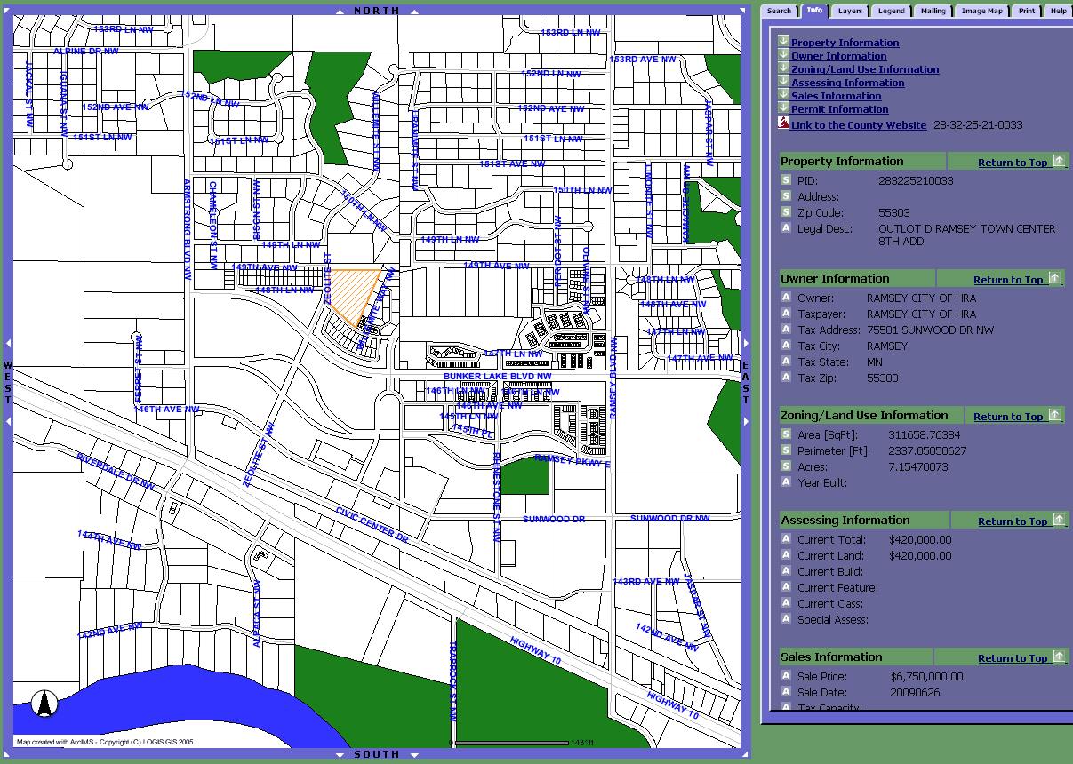
Location map - (Subject Property in ‘Hashing’)

