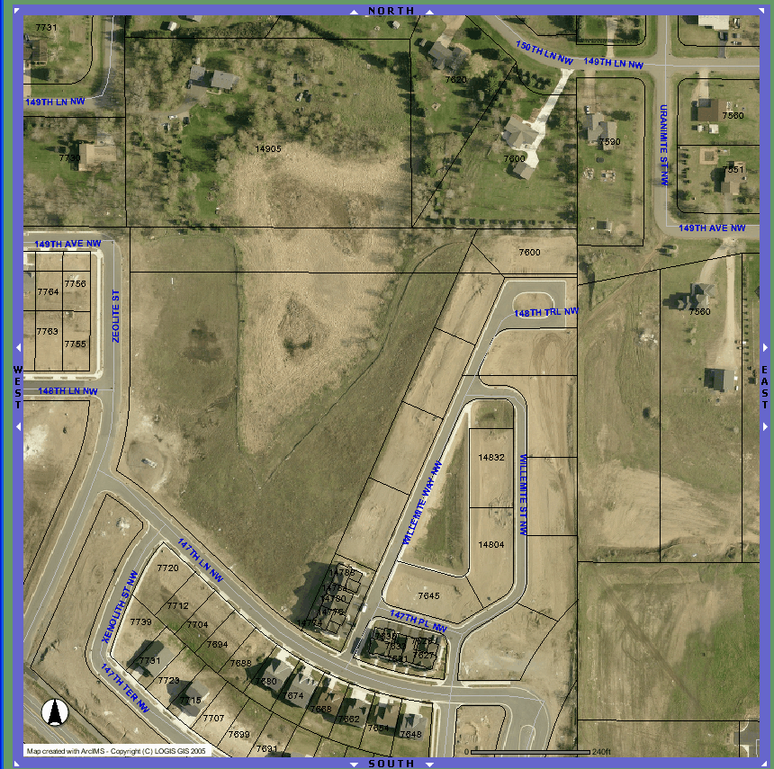
Municipal Well #8
Proposed trail connection
Wetland limits

